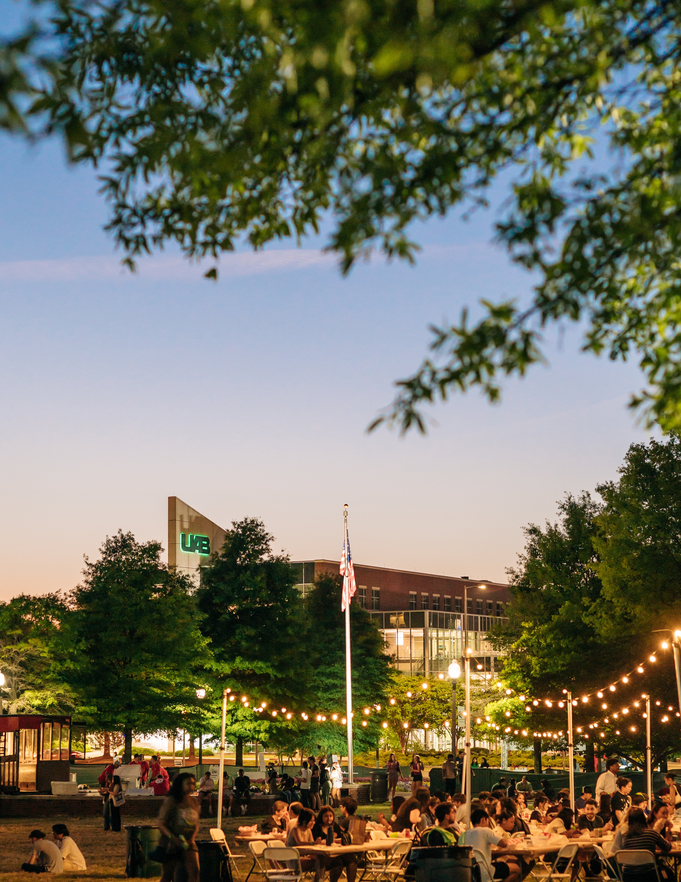
The University of Alabama at Birmingham
2026 Annual Security and Fire Safety Report

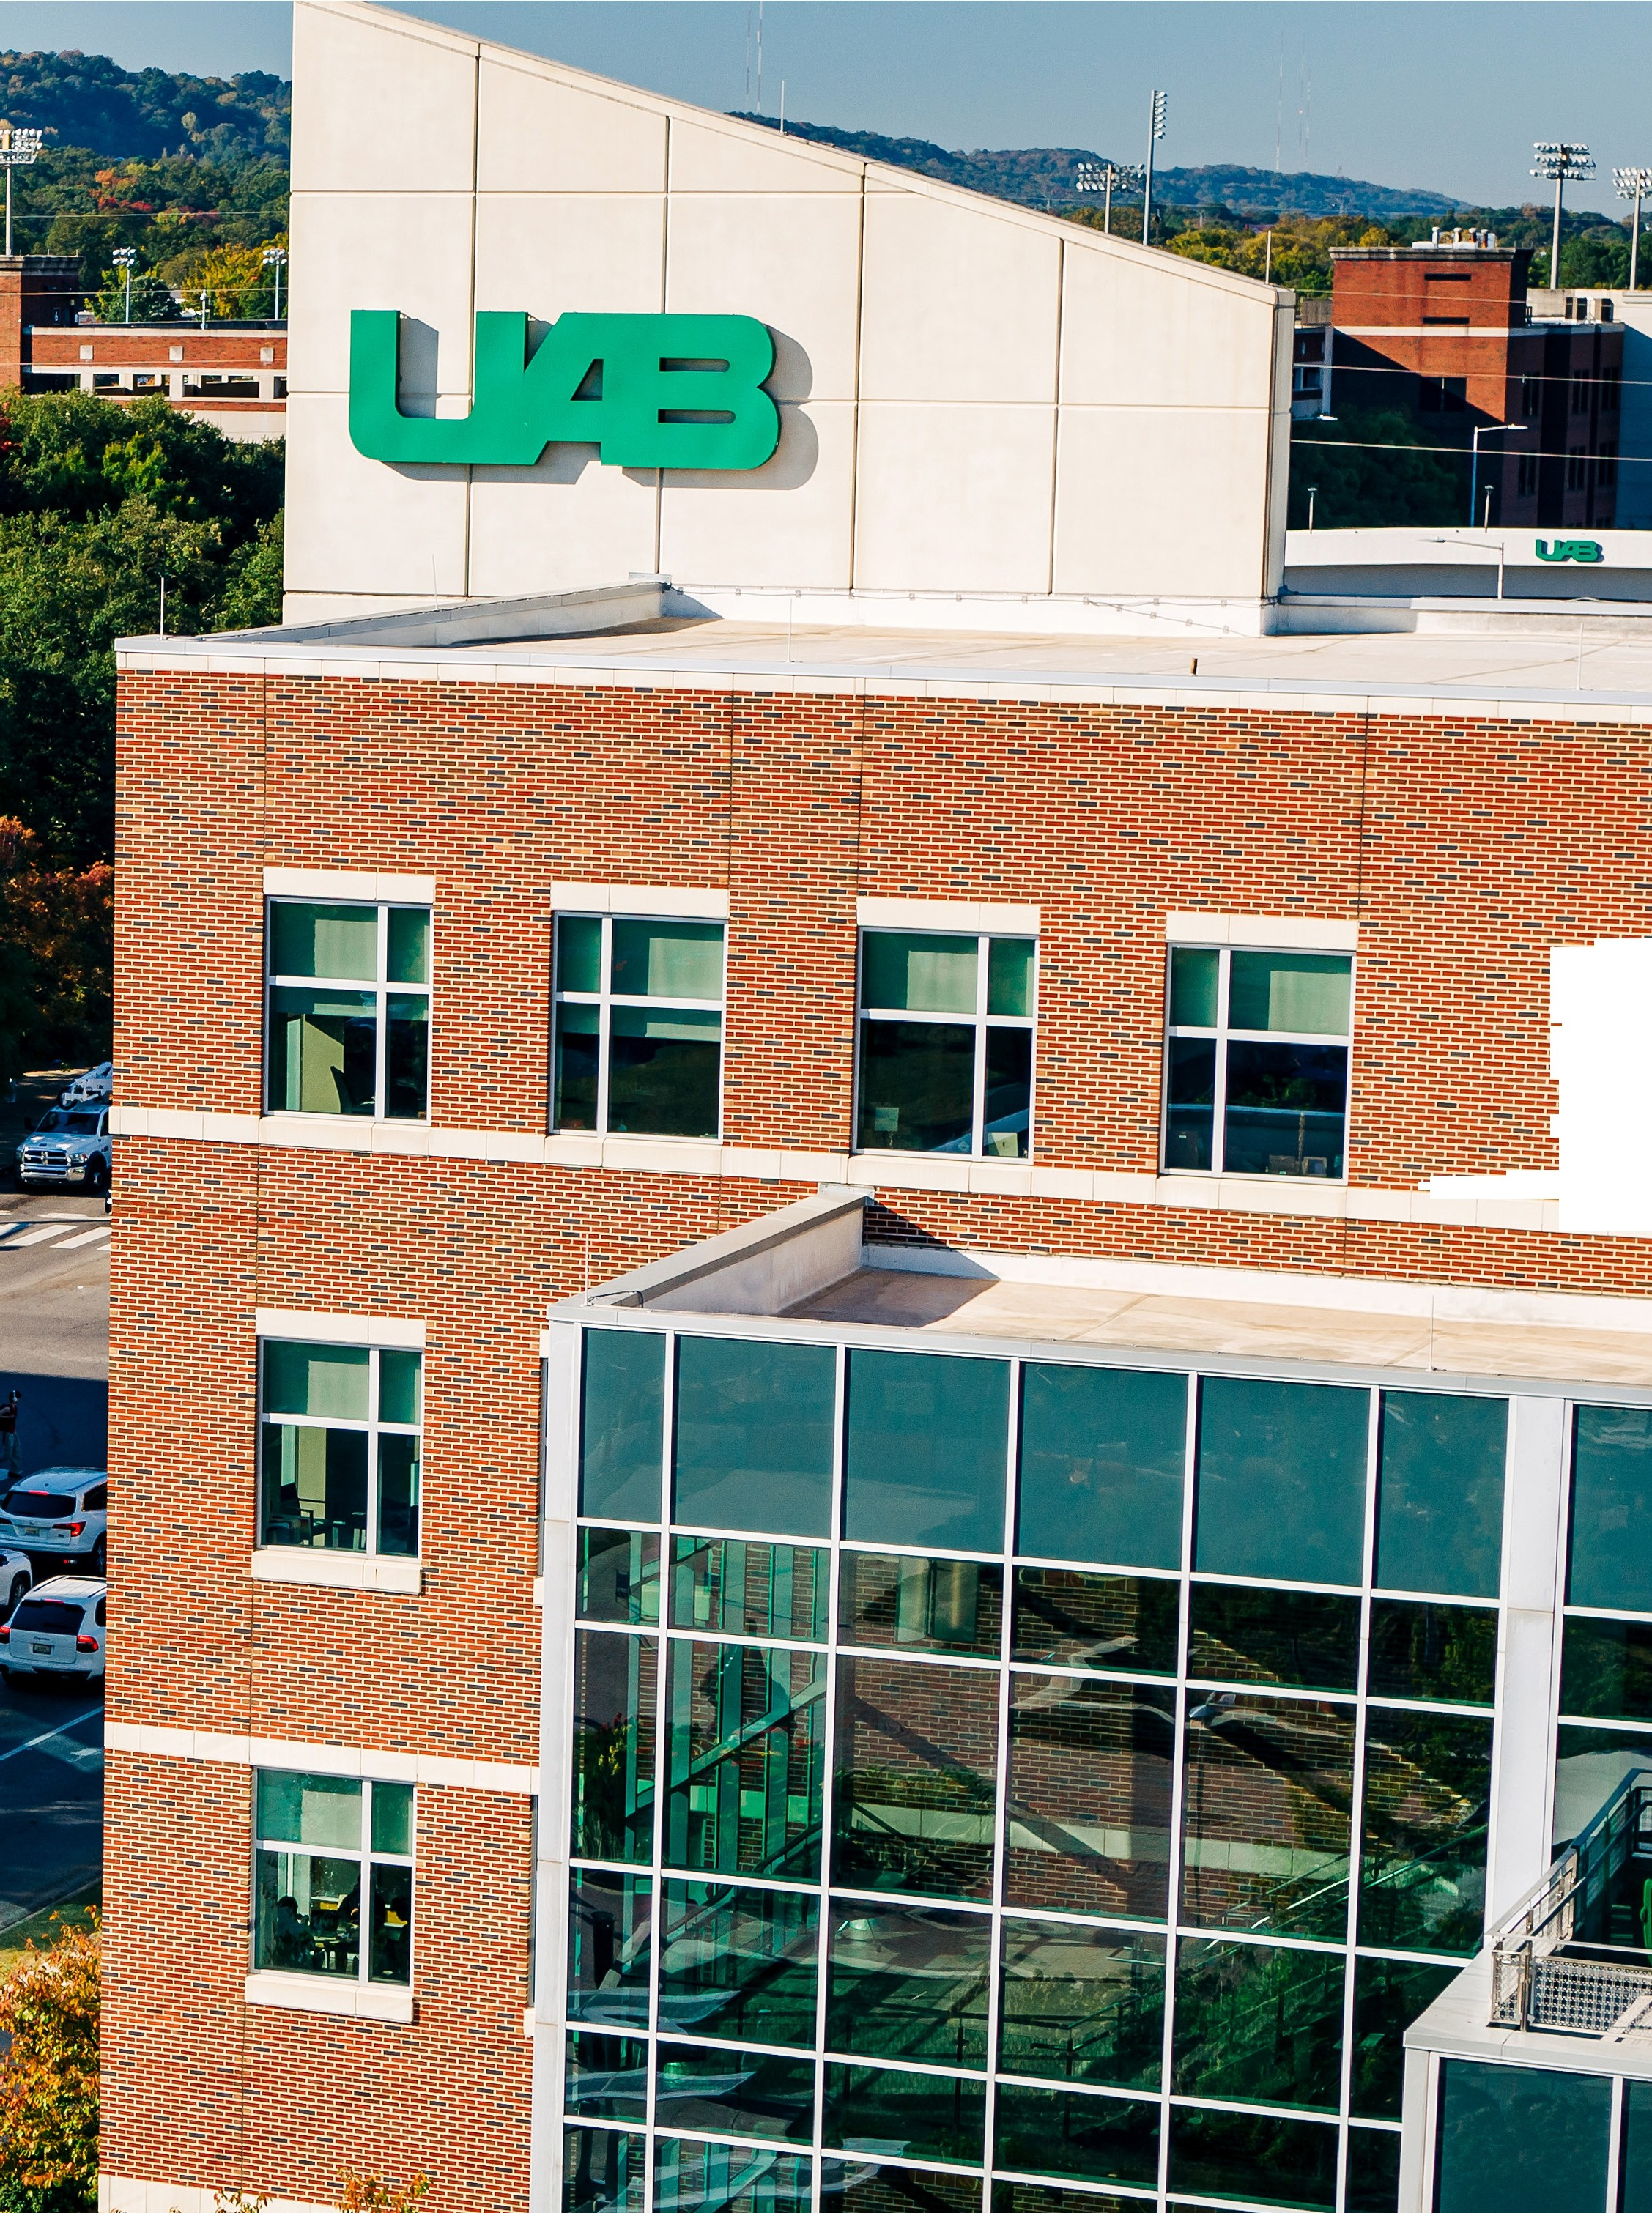

Contents
Overview 4
Campus Law Enforcement 5
Reporting Incidents 6
Access To Campus Facilities And Residence Halls 9
Campus Transportation 11
Missing Person Procedures 12
Hazing and Stop Campus Hazing Act 13
Programs To Prevent Domestic Violence, Dating Violence, Sexual Assault, And Stalking 17
Jeanne Clery Disclosure Of Campus Security Policy And Campus Crime Statistics Act, As Amended By The Violence Against Women Reauthorization Act Of 2013 (VAWA) 19
Relevant Definitions (VAWA) 20
Reporting Incidents Of Domestic Violence, Dating Violence, Sexual Assault, And Stalking 28
Procedures The University Will Follow When A Crime Of Domestic Violence, Dating Violence, Sexual Assault, And Stalking Is Reported 28
On And Off Campus Services For Victims 32
Types Of Disciplinary Proceedings Utilized In Cases Of Alleged Domestic Violence, Dating Violence, Sexual Assault And Stalking 36
Federal Campus Sex Crimes Prevention Act 53
Sex Offender Registration 53
Distribution Of Timely Warnings 54
Emergency Preparedness, Response, And Evacuation Procedures 55
Criminal Incidents On Campus 56
Crime Statistics (Chart On Page 50) 56
Definitions Of Reportable Crimes 61
Alcohol And Drug Use And Abuse 63
How To Be An Active Bystander 63
Risk Reduction 64
Fire Safety Report 66
UAB Help Phone Map 70
Campus Map With Patrol And Core Campus Boundaries 71


OVERVIEW

The University of Alabama at Birmingham (UAB) is committed to providing a safe and secure environment for all faculty, staff, students, patients, and visitors. Located in the City of Birmingham, AL, UAB is part of a greater urban community. Within campus boundaries, there is a mixture of public and private property. Our campus boundaries are I-65; 10th, 11th, 12th, Avenues South; 22nd Street South and 2nd Avenue South. Overall, the campus consists of approximately 636 acres and 200 academic, residential, and recreational buildings, which translates into over 17 million square feet of functional building space.

A city within a city, UAB has over 20,000 students and more than 27,000 employees. Campus residence halls can accommodate over 3,200 students. Numerous visitors come to campus, and during special events, the number of visitors can exceed 50,000.
UAB is an open and vibrant campus. Except for residence halls, which are locked twenty-four hours per day, and some research areas, University facilities are open to the public during regular business hours. At other times, facilities are locked and only persons authorized, or the individual departments within the building may have access to the facility.
UAB Facilities maintains the University’s buildings and grounds with a concern for public safety. Its staff regularly inspects the campus, evaluates lighting, landscaping, and makes repairs affecting safety and security hazards such as broken windows and locks. The UAB Police Department and other departments assist Facilities by reporting potential safety and security hazards.
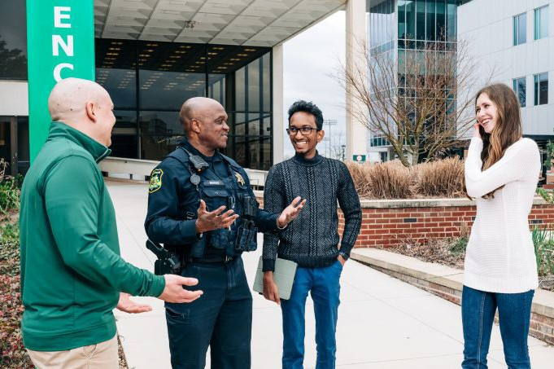
No campus is isolated from crime; however, UAB employs a variety of security measures to protect the campus community. All persons who come to campus are expected to obey all laws and University and department rules related to the use of each facility. Those who fail to comply are subject to arrest and/or disciplinary action through the University.


CAMPUS LAW ENFORCEMENT

Location
The UAB Police and Public Safety Department is located at 1117 14th Street South, Birmingham, AL. The Department is open twenty-four hours a day, seven days a week, including weekends, holidays, and semester breaks.
Responsibilities
Primarily responsible for protecting the life and property of people on the UAB campus, officers patrol the campus on a twenty-four hour basis and provide a full range of public safety services including: Investigating criminal incidents and traffic accidents, providing first response to emergencies, enforcing laws and University policies, completing criminal and traffic reports, and conducting crime awareness and prevention programs. When a criminal act is reported, the Department will investigate the incident and make every reasonable effort to identify the offenders. Depending on the wishes of the victim, nature of the offense, and the evidence gath-ered, the case may be presented for prosecution in the criminal courts of Alabama. If a member of the UAB community is identified as an offender in an incident, the UAB Police Department also will notify the appropri-ate University administrator so that administrative disciplinary action may be taken.
Training
Police officers are professionally trained and certified in accordance with the Alabama Peace Officer's Standards and Training Council and attend continuing in-service training programs to further their skills to include de-escalation and mental health training.
Authority Code of Alabama section 16-47-10
The President of the University may appoint or employ one or more suitable persons to act as police officers to keep off intruders and prevent trespass upon and damage to the property of the University. Such person shall be charged with all the duties and invested with all the powers of police officers. The officer may eject trespassers from the University buildings and grounds. The officer may, without warrant, arrest persons who commit disorderly conduct, or trespass on the property of the institution, or in any circumstance in which an arrest by a police officer without a warrant is authorized by law, and carry them before the nearest district court or municipal court charged with the trial of such offenders. Upon proper affidavit charging the offense, the person arrested may be tried by the court and convicted as in the case of persons brought before the court on a warrant.
Authority Code of Alabama section 16-47-11 - Extended jurisdiction
Any police officer appointed pursuant to Sections 16-47-10 or 16-22-1 is a peace officer whose authority extends to any place in the state, provided that the primary duty of such a peace officer shall be the enforcement of the law on property owned or leased, or licensed by the institution of higher education employing the peace officer. Such a peace officer may also enforce the law in all of the following circumstances: When in pursuit of any individual who is suspected of the commission of a crime while on property owned, leased, or licensed by the institution of higher education employing the officer. To make arrests for crimes committed, or for which there is probable cause to believe have been committed, within
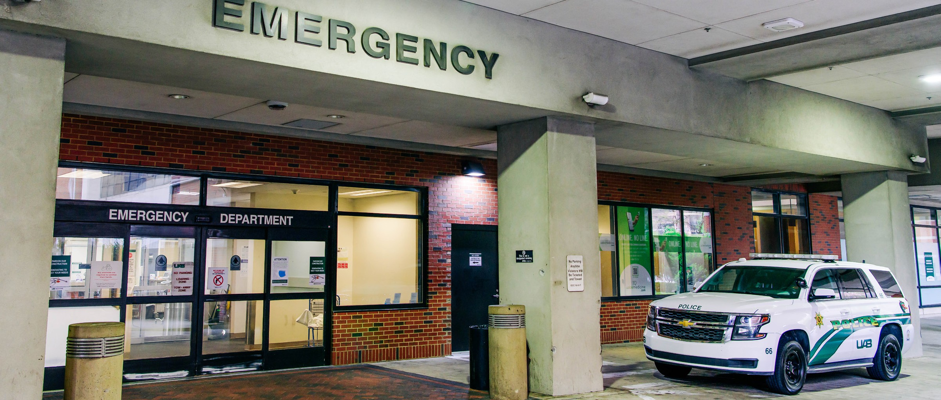
his or her presence or within the boundaries of any property owned, leased, or licensed by the institution of higher education employing the officer. Pursuant to an agreement with another law enforcement agency. The provisions of this section granting authority to peace officers at institutions of higher education in this state are not intended to limit or abridge any powers otherwise granted to the officers by law, and the provisions of this section are cumulative. Nothing in this section shall grant authority to any individual appointed under Section 16-47-10 to enter a classroom for the purpose of enforcing traffic or parking citations.

HOW YOU CAN HELP CREATE A SAFE CAMPUS
Safety, security, and crime prevention are the responsibilities of everyone. The cooperation and involvement of faculty, staff, and students are essential to having a safe campus. The safety and security of you and your belongings begin with your own awareness and commitment to the safety of the community. Further in the report there are resources you can use to help create a safe campus for yourself and others.

REPORTING INCIDENTS
Like any other community of 50,000 people, UAB experiences accidents, injuries, crimes, and other emergen-cies. To report voluntary incidents, potential criminal actions or suspicious incidents, UAB faculty, medical per-sonnel, staff, students, and visitors should notify the UAB Police Department at (205) 934-3535. The University has emergency two-way (blue light) phones throughout campus for use during emergencies. By pressing the red button, users can communicate directly with the UAB Police Communications Center. To report an inci-dent of a confidential nature, an individual should contact a Campus Security Authority (UAB Police, Athletics, Student Housing & Residential Life, Student Affairs, Provost, Student Services, Resident Coordinators, Resident Assistants, and Faculty Advisors to Student Organizations).

MONITORING AND RECORDING OFF-CAMPUS ACTIVITY
The University relies on its working relationships with the local law enforcement agencies to receive informa-tion about incidents involving students off-campus. The UAB Police Department will actively investigate any crime information it receives concerning or involving a member of the campus community. If the University is notified of a crime, the department may issue a crime alert, detailing the incident and providing tips so that other community members may avoid similar incidents.


STAY INFORMED
The UAB Police Department uses a variety of methods to keep the campus informed about incidents occurring on and near campus. The Department website uab.edu/police contains information about crime prevention, programs and services, Department news and events, links to outside resources, and much more.
STUDENT AND FACULTY/STAFF MEDIA OUTLETS
UAB Student Media’s newspaper, The Kaleidoscope, student Newsletter, GreenMail, and the faculty/staff Newsletter, the UAB Reporter, have access to incident summaries and publish stories covering serious incidents and crime awareness information. The Kaleidoscope and GreenMail are published weekly during the academic year, and the eReporter is published bi-weekly.
RAVE GUARDIAN
A variety of resources and services are available to UAB students and employees that contribute to the overall safety and security of the campus, reducing the success of criminals. Rave Guardian is a way to improve your personal safety and protect your friends by building your own private safety network. This free app provides instant communications with friends, family, co-workers, UAB Police, and even 911 in the event of an emergen-cy. The app can be downloaded from the Apple App Store and Google Play Store. See https://www.uab.edu/ emergency/rave-guardian for more information regarding Rave Guardian.
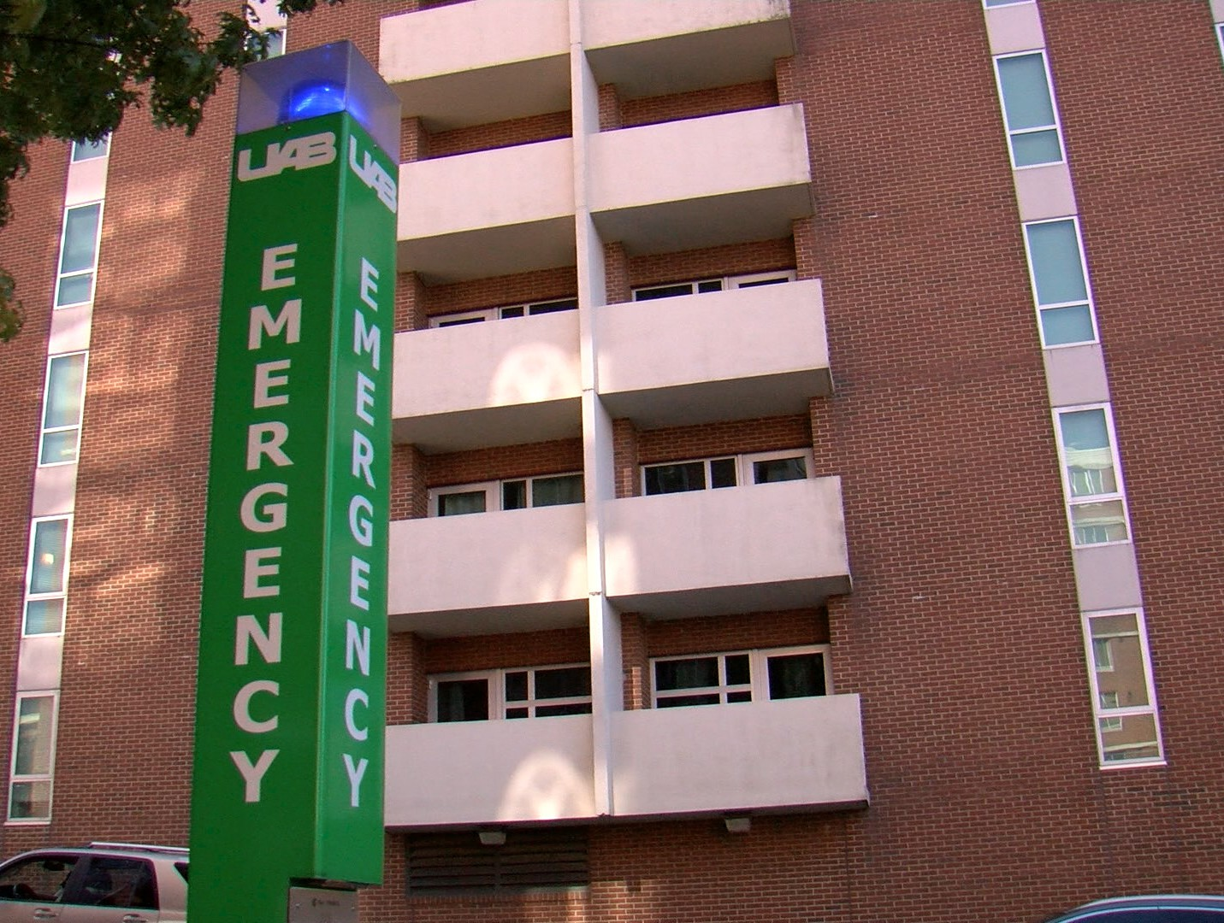
PUBLICATIONS
The UAB Police Department prepares and distributes numerous bro-chures and pamphlets covering topics such as sexual assault aware-ness, general crime prevention, bicycle safety and security, and traffic safety.
EMERGENCY/PUBLIC TELEPHONES
For the safety of the UAB community, 490+ emergency/ public tele-phones are strategically located across campus. These telephones may be used to make campus calls. For emergencies, press the red
emergency button, which will connect you directly with the UAB Police Department. Your location will be automatically identified for the po-lice dispatcher, and a UAB police officer will be dispatched to the area if necessary.



NEW STUDENT AND EMPLOYEE ORIENTATIONS
New students are provided crime awareness information through New Student Orientation. New employees receive information through the New Employee Orientation Program.
LOST AND FOUND
The UAB Police Department operates a lost and found area. You can stop by the UAB Police Department to drop off found property or inquire about lost property. Call (205) 934-4649 for more information.
OPERATION IDENTIFICATION
This program assists community in marking and tracking information (serial and model numbers, etc.) about valuable items such as calculators, computers, and televisions. Engravers for marking valuables are available, and participants in this program are provided with inventory cards. Call (205) 934-2409 for more information.
SECURITY SURVEYS
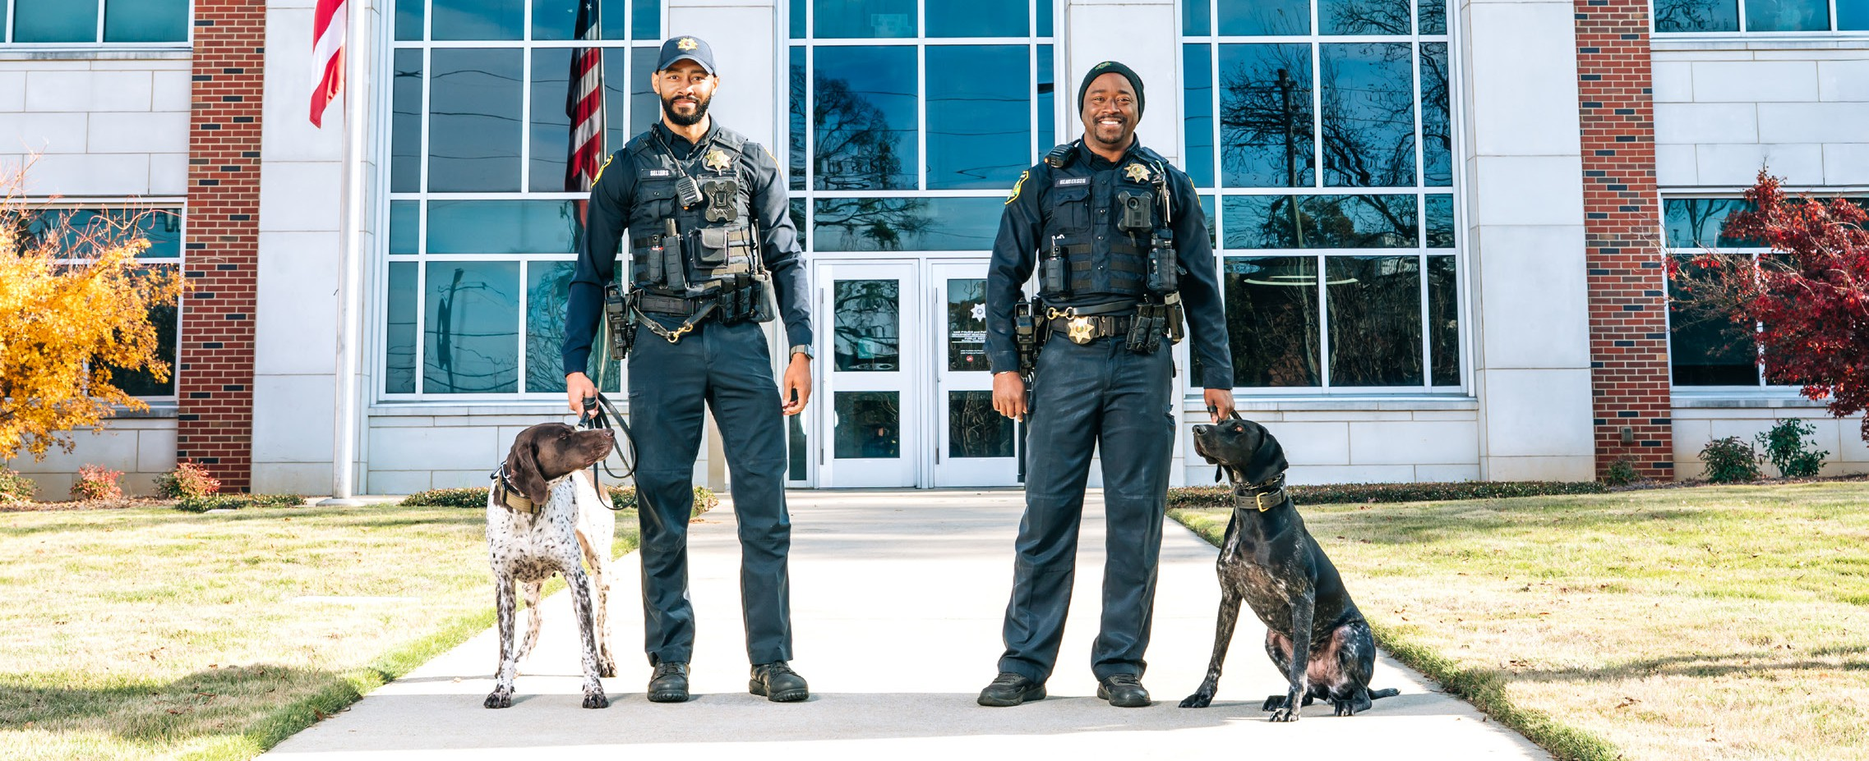
Free security surveys are offered by the UAB Police Department for campus buildings and on-campus resi-dents. For more information, call (205) 934-2409.

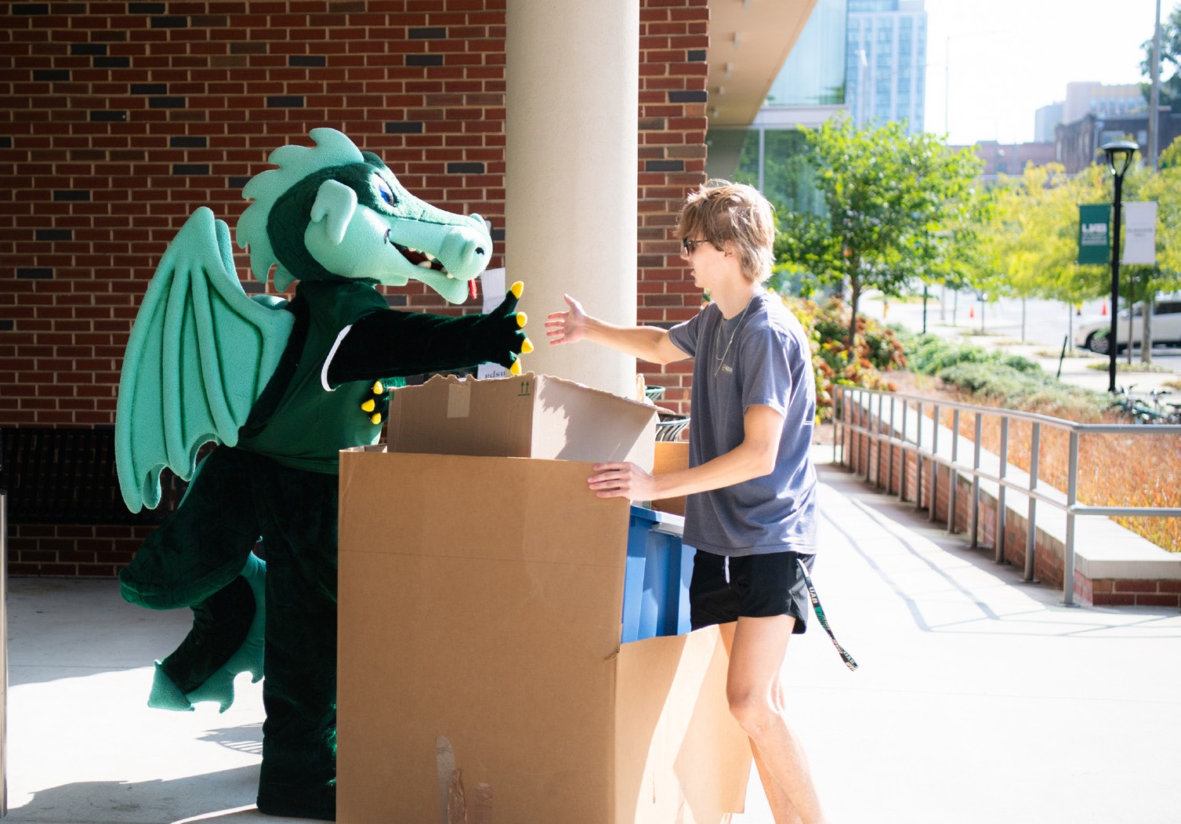
LIVING ON CAMPUS
UAB encourages its students who do not reside with their parents or families to live in the residence halls. The Housing Department supervises the assignment of rooms for single and married students. For a complete guide containing information about Housing facilities and
services, costs, priorities and policies, and residence hall safety, contact the UAB Housing Office at (205) 996-0400.

ACCESS TO CAMPUS FACILITIES AND RESIDENCE HALLS
Access to campus buildings and grounds is a privilege extended to students, faculty, staff, and authorized guests. The University
encourages an open environment with limited constraints to ensure the reasonable protection of all members of the community. Except for residence halls, most campus facilities are open during weekday business hours. Individuals who wish to access University buildings or property during non-business hours or for special events should contact the appropriate department administrator, Conference and Event Services, or the UAB Police Department.
Exterior doors of the residence halls are locked twenty-four hours a day. A resident's ONE card also unlocks the main door and they have a separate room key. All visitors must sign in and be escorted through the residence halls by a resident. In the event of a lost key, the student's room locks are changed.
STAFF TRAINING
All residence life staff members undergo thorough training in enforcing residence hall security policies. As part of the responsibility for residence hall security, all residence life staff members participate in lectures and seminars that are conducted by University administrators and police and associated with the safety and security of the campus.
SECURITY CONSIDERATIONS IN THE MAINTENANCE OF CAMPUS FACILITIES
The University is committed to campus safety and security. Exterior lighting and landscape control is a critical part of that commitment. Representatives from various departments continually conduct security surveys to ensure campus lighting is adequate and that the landscape is appropriately controlled. Department members conduct routine checks of lighting on campus during regularly assigned patrol duties. If lights are out or dim, officers will initiate an immediate work order, which is acted upon by a representative of the appropriate maintenance office, usually within 24 hours or the next business day. We encourage community members to report any deficiency in lighting to Facilities at (205) 934-2281. Any community member who has a concern about physical security should contact the Physical Security Department at (205) 934-3708.

Representatives from the police department and physical security work together to identify inoperative locking mechanisms on a continual basis. We encourage community members to promptly report any locking mechanism deficiency to Physical Security at (205) 934-3708, or to the UAB Police Department at (205) 934-4434. Maintenance staff is available to respond to calls for service regarding unsafe facility conditions or for personal safety and property protection. These conditions also may include unsafe steps or handrails, unsafe roadways on campus, and unsecured equipment.

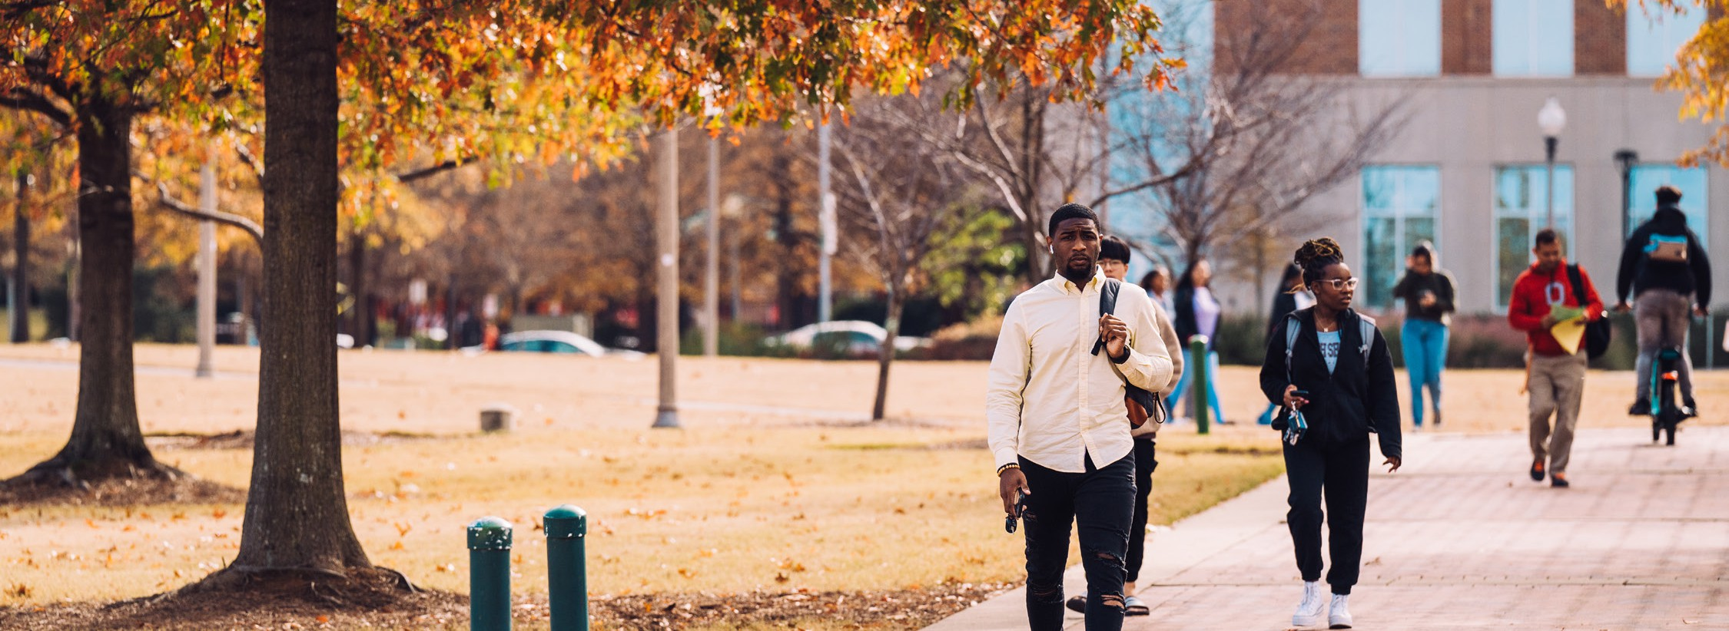
LIVING IN OFF-CAMPUS HOUSING, FRATERNITIES, AND SORORITIES
Neither the Housing Department nor UAB provides supervision for off-campus housing, apartments, and individual homes. Sororities and fraternities educate their members on safety and security in their houses and on campus. All students receive crime awareness information. Students, whether they live on or off campus, are encouraged to report all crimes to the appropriate police agency.
If community members report crimes or serious incidents to other University administrators, those administrators will notify the UAB Police Department. Representatives of these offices will promptly notify and collaborate with the UAB Police Department to issue a crime alert if one is appropriate.





CAMPUS TRANSPORTATION UAB BLAZER EXPRESS
The UAB Blazer Express Transit System is a service that provides transportation throughout the University cam-pus. With a valid UAB ID badge, students, employees, and authorized visitors can enjoy fare-free bus transporta-tion along six designated routes. All buses are ADA-accessible and can seat approximately 35 riders. Bus service is provided Monday – Friday from 5:20AM - 12:00AM. Late night, on-demand service is available seven nights a week from 9:00 PM – 5:30 AM by calling (205) 934-8772.
MOTORIST ASSISTANCE ROADSIDE SERVICE (MARS)
Motorist Assistance Roadside Service (MARS) is a free service available to all visitors, students, and employees parking on campus who need help with a dead battery, flat tire, or keys locked in a car. The service is available weekdays 7:30 AM - 10:00 PM, except University holidays. For assistance, call (205) 975-6277.


Campus Transportation Phone Numbers
Main Office | 205-934-3513
Lost and Found | 205-934-3513
Late Night On-Demand Service | 205-934-8772
Motorist Assistance Roadside Service (MARS) | 205-975-6277

MISSING PERSON PROCEDURES
Students who reside in on-campus housing facilities are encouraged to report a student that has been missing for 24 hours to the UAB Police Department (UABPD) or a campus security authority. The campus security authority (Athletics, Student Housing & Residential Life, Student Affairs, Provost, Student Services, Resident Coordinators, Resident Assistants, and Fac-ulty Advisors to Student Organizations) will be required to report any official missing student to the UABPD. Per the Clery Act, the University will give each student living in an on-campus housing facility the option to identify a contact person(s) who the institution shall notify if the student is determined to be missing by the UABPD.

Students contact information will be registered confidentially, and this information will be accessible only to authorized campus officials and the UABPD. This information may not be disclosed outside of a missing person investigation. Students under 18 years of age and not emancipated, the institution will notify a custodial parent or guardian within 24 hours of the determination that the student is missing, in addition to any additional contact person designated by the student.
If a student did not name a contact person to notify, and the UABPD receives a report that the student is missing, the UAB-PD will conduct an investigation to determine if the student is officially missing. If the student has designated a contact person, the UABPD will notify that contact person within 24 hours. If the student is under 18 years of age and is not eman-cipated, the UABPD will notify the student’s custodial parent or guardian and any other designated contact person within 24 hours. Regardless of whether the student has identified a contact person, is above the age of 18 or is an emancipated minor, UABPD will conduct an investigation to determine if the student is officially missing within 24 hours.

CRIME AWARENESS AND PREVENTION SPEAKERS
You can request a speaker from the UAB Police Department to come and talk with your group or organization about crime awareness and prevention. To request a speaker, call (205) 934-2409.
SAFETY AND SECURITY PROGRAMS
The UAB Police Department has a full-time crime prevention specialist that provides educational programming to the Uni-versity community. Educational programs include:
- Campus Watch- This program encourages the community to take an active role in the fight against crime.
- Police Advisory Council - Volunteers from within the community that listens to the needs of the people and presents those concerns to the Chief.
- Drug and Alcohol Abuse- This program is designed to educate our students on the cause and effect of drugs and alcohol abuse.
- Pedestrian Safety Campaign- Encourages safe habits and adherence to traffic policies.
- Operation ID- Property protection with the aid of an engraver. The engraver assists with the speedy recovery of lost or stolen property.
- Healthy Lifestyles - This program is designed and dedicated to helping young children understand the effects of their actions to themselves and to others.
- Domestic Violence Seminar- Teaches the signs and symptoms of abuse.
- Workplace Violence Seminar- Learn the different methods to identify and curtail workplace violence. Reviews the laws and employee rights and procedures to take when faced with this type of situation.
- Personal Safety Awareness Seminar- Informs the community of the possible dangers of unwanted/uninvited individuals that could be lurking in the area.
- Rape Aggression Defense- Program that teaches an individual how to become aware of potential aggressors and how to protect oneself from existing aggressors. UAB students and employees learn how to defend themselves if attacked.
- Active Shooter Response – this program teaches response options during a violent intruder and/or active shooter event.
Safety programs begin with orientation for incoming freshmen and their parents. Once school begins, the Crime Prevention Unit continues with educational programs throughout the year in the residence halls as requested. All programs are available to students, faculty, and staff upon request or if a need becomes apparent.
SGA: Students interested in improving campus safety should contact the Student Government Association (SGA) at (205) 934-8020.

HAZING AND THE STOP CAMPUS HAZING ACT
The Stop Campus Hazing Act was signed into law in 2024. The statistics for Hazing began being collected in 2025 to then be published in this 2026 Annual Security Report.
UAB is committed to maintaining a safe, healthy, and respectful environment and does not tolerate hazing in any form. No individual shall (directly or indirectly) engage in hazing or encourage, aid, or assist any other person in hazing. UAB’s hazing prevention and awareness program provides UAB community members with campus-wide hazing prevention resources, including training and education. In accordance with the Stop Campus Hazing Act, UAB shall disclose hazing incident statis-tics in its Annual Security Report and make publicly available a Campus Hazing Transparency Report if an established or rec-ognized student organization is found responsible for hazing. Information related to the hazing prevention and awareness program, both the Annual Security Report and the Campus Hazing Transparency Report, Alabama’s state law on hazing, and Frequently Asked Questions related to hazing are available here.

All members of the UAB community have a duty to promptly report good faith concerns about potential hazing impacting another member of the campus community. Any individual who has knowledge or any reasonable information about a hazing incident, whether that hazing incident has already occurred or is set to occur in the future, has a duty to make a reasonable effort to immediately report the hazing-related information as noted herein. Individuals who report potential hazing in good faith are protected from retaliation by UAB’s Duty to Report and Non-Retaliation Policy. UAB’s Medical Am-nesty Policy sets forth conditions under which students will not be subject to conduct action for alcohol or drug use while seeking medical assistance.

If the situation poses actual or imminent danger or threats of violence to people or property, contact the UAB Police Department immediately at (205) 934-3535. Other hazing-related information may be reported directly to the Office of Community Standards and Student Accountability or through the Student Conduct Code Alleged Violation Referral form. Reports may also be submitted to the UAB Hotline.
Hazing is defined as any intentional, knowing, or reckless act committed by a person (whether individually or in concert with other persons) against another person or persons regardless of the willingness of such other person or persons to participate, that:
- is committed in the course of an initiation into, an affiliation with, gaining a leadership position in, or the maintenance of membership in, a student organization; and
- causes or creates a risk, above the reasonable risk encountered in the course of participation in the institution of higher education or the organization (such as the physical preparation necessary for participation in an athletic team), of physical or psychological injury including but not limited to:
  - whipping, beating, striking, electronic shocking, placing of a harmful substance on someone’s body, or similar
activity;
  - causing, coercing, or otherwise inducing sleep deprivation, exposure to the elements, confinement in a small
space, extreme calisthenics, or other similar activity;
  - causing, coercing, or otherwise inducing another person to consume food, liquid, alcohol, drugs, or other sub-stances;
  - causing, coercing, or otherwise inducing another person to perform sexual acts;
  - causing unreasonable interference with a student’s academic performance;
  - forced actions or inactions that demean or disgrace an individual;
  - forced or coerced wearing of inappropriate apparel;
  - forced or coerced exclusion from social contact;
  - personal servitude;
  - undue financial expenditures;
  - any other activity that could reasonably be viewed as subjecting others to embarrassment, degradation, or humiliation;
  - any activity that places another person in reasonable fear of bodily harm through the use of threatening words
or conduct;
  - any activity against another person that includes a criminal violation of local, state, tribal, federal law, or the

Student Conduct Code; and
  - any activity that induces, causes, or requires another person to perform a duty or task that involves a criminal violation of local, state, tribal, federal law, or the Student Conduct Code.
Silent participation, knowledge of, being in the presence of, or observation of hazing is not a neutral act; they are consid-ered a violation of the hazing provision.
For purposes of this policy, a student organization means an organization at UAB in which two or more of the members are students enrolled at UAB, whether or not the organization is established or recognized by the University.
Allegations that a current UAB student or student organization has violated this policy will be addressed through the pro-cedures outlined in the Student Conduct Code.
Allegations that an employee or non-student individual has violated this policy will be investigated by Human Resources and addressed under this policy in addition to any other applicable UAB policies and procedures.
INVESTIGATION PROCEDURES
Once there is an allegation of hazing the Director or their designee typically decides within ten (10) business days whether to begin conduct procedures or restorative practices.
If the university moves forward with procedures, the student will receive a written notice of allegations, next steps, right to a support individual, and any required response deadlines.
Alternative options may include Restorative actions, an educational conversation, or an administrative no-contact order.
An administrative resolution may be used for minor violations when evidence supports reasonability, little additional infor-mation is needed, and the matter can be addressed in writing.
The student will receive written notice, education about the policy, and possibly a low-level sanction. The student has three (3) business days to accept or decline.
A no response means the resolution stands and the case is closed.
Joint Resolution
The student has three (3) business days to accept or decline.
They may accept findings and sanctions, accept findings but challenge sanctions, or reject both. Accepting findings and sanctions closes the case and cannot be appealed.
If Joint Resolution is declined or unavailable, the case proceeds to Hearing.
In Absentia Resolution
Failure to respond to a meeting request within seven (7) business days, or failure to respond to Joint Resolution offer with three (3) business days, may result in resolution without the student’s participation.
The student waives the right to a Hearing
The student may request rescission within three (3) business days of receiving the decision.
Hearing
If the case is not otherwise resolved, it proceeds to a Hearing before a University Conduct Board or Administrative
Hearing Officer.
Hearing notice must be provided five (5) business days beforehand.
Students may have a support individual and receive assistance from a Student Conduct Counselor.
The student may challenge a Board member/Hearing Officer for bias or a personal relationship, at least two (2) business days before the hearing.
Hearings are closed, recorded/transcribed by the University, and formal rules of evidence does not apply.
Both sides may be present relevant witnesses and information. The Board/ Hearing Officer determines responsi-bility based on the information presented.
If responsible, sanctions are recommended; the Director may affirm or adjust them. Written outcome must be provided within five (5) business days after the determination.
If found responsible, and there is hazing within an established or recognized student organization then it will be published on the University’s Transparency Report.

Appeal

The student(s) have five (5) business days after receiving the outcome to appeal in writing. The appeals are limited to:
- Significant Procedural error
- New Information that could affect the outcome
- Insufficient information supporting the finding
- / Unreasonable or grossly disproportionate sanctions
The Vice President/ designee may uphold the decision, modify sanctions without eliminating them, or send the

case back for a new reconsidered Hearing.
A decision affirming the findings is final and conclusive.

REPORTING INCIDENTS OF HAZING
Hazing reports can be made to:
UAB Police and Public Safety: (205) 934-3535; 1117 14th Street South
Student Conduct: (205) 996-1512; 1400 University Blvd Suite 336; student conduct@uab.edu
Title IX: (205)996-1340; 701 20 Street S Suite 330
UAB Student Affairs website: https://www.uab.edu/studentaffairs/home/end-hazing
PREVENTION PROGRAMS
The University’s Fraternity and Sorority Life host Hazing Prevention Week, which includes a variety of speakers and events focused on educating students about the risks of hazing and promoting a safe, supportive campus environment.
The Office of Community Standards and Student Accountability hosts an event called “Know the Code and your Re-sources” twice a year, once each semester. This event is designed to encourage and assist students, faculty, staff, and the broader UAB community in becoming familiar with university policies and procedures. The event also provides information about any applicable changes or updates to the Code. This event has assisted with providing information on Hazing and prevention practices.
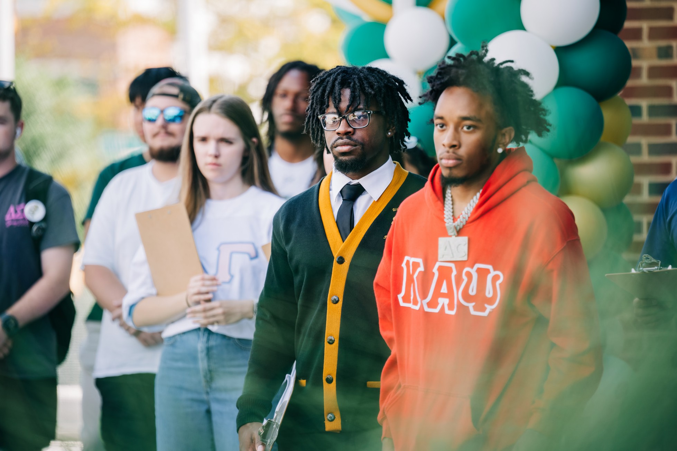

ALABAMA STATE LAW: HAZING PROHIBITED TITLE 16 SECTION 16-1-23
Any willful action taken or situation created, whether on or off any school, college, university, or other educational prem-ises, which recklessly or intentionally endangers the mental or physical health of any student, or
Any willful act on or off any school, college, university, or other educational premises by any person alone or acting with others in striking, beating, bruising, or maiming; or seriously offering, threatening, or attempting to strike, beat, bruise, or maim, or to do or seriously offer, threaten, or attempt to do physical violence to any student of any such educational institution or any assault upon any such students made for the purpose of committing any of the acts, or producing any of the results to such student as defined in this section.
The term hazing as defined in this section does not include customary athletic events or similar contests or competitions, and is limited to those actions taken and situations created in connection with initiation into or affiliation with any orga-nization. The term hazing does not include corporal punishment administered by officials or employees of public schools when in accordance with policies adopted by local boards of education.
No person shall engage in what is commonly known and recognized as hazing, or encourage, aid, or assist any other person thus offending.
No person shall knowingly permit, encourage, aid, or assist any person in committing the offense of hazing, or willfully acquiesce in the commission of such offense, or fail to report promptly his knowledge or any reasonable information within his knowledge of the presence and practice of hazing in this state to the chief executive officer of the appropri-ate school, college, university, or other educational institution in this state. Any act of omission or commission shall be deemed hazing under the provisions of this section.
Any person who shall commit the offense of hazing shall be guilty of a Class C misdemeanor as defined by Title 13A.
Any person who participates in the hazing of another, or any organization associated with a school, college, university, or other educational institution in this state which knowingly permits hazing to be conducted by its members or by others subject to its direction or control, shall forfeit any entitlement to public funds, scholarships, or awards which are enjoyed by him or by it and shall be deprived of any sanction or approval granted by the school, college, university, or other edu-cational institution.

PROGRAMS TO PREVENT DOMESTIC VIOLENCE, DATING VIOLENCE, SEXUAL ASSAULT, AND STALKING
The University engages in comprehensive, intentional, and integrated programming, initiatives, strategies, and campaigns intended to end dating violence, domestic violence, sexual assault and stalking that:
- Are culturally relevant, inclusive of diverse communities and identities, sustainable, responsive to community needs, and informed by research, or assessed for value, effectiveness, or outcome; and
- Consider environmental risk and protective factors as they occur on the individual, relationship, institutional, community, and societal levels.
Educational programming consists of primary prevention and awareness programs for all incoming students and new employees, and ongoing awareness and prevention campaigns for students and that:
- Identifies domestic violence, dating violence, sexual assault and stalking (as defined by the Clery Act) as
prohibited conduct;
- Defines what behavior constitutes domestic violence, dating violence, sexual assault, and stalking;
- Defines what behavior and actions constitute consent to sexual activity in the State of Alabama;
- Provides safe and positive options for bystander intervention that may be carried out by an individual to prevent harm or intervene when there is a risk of domestic violence, dating violence, sexual assault, or stalking against a person other than the bystander. Bystander intervention includes recognizing situations of potential harm, understanding institutional structures and cultural conditions that facilitate violence, overcoming barriers to intervening, identifying safe and effective intervention options, and taking action to intervene;
- Procedures information on risk reduction;
- Information regarding:
  - Procedures victims should follow if a crime of domestic violence, dating violence, sexual assault, and stalking occurs (as described in “Procedures Victims Should Follow if a Crime of Domestic Violence, Dating Violence, Sexual Assault and Stalking occurs” elsewhere in this document);
  - How the institution will protect the confidentiality of victims and other necessary parties (as described in “Assistance for Victims: Rights and Options” elsewhere in this document);
  - Existing counseling, health, mental health, victim advocacy, legal assistance, visa and immigration assistance, student financial aid, and other services available for victims, both within the institution and in the community (as described in “Assistance for Victims: Right and Options” elsewhere in this document);
  - Options for available assistance in, and how to request changes to academic, living, transportation, and working situations or protective measures (as described in “Assistance for Victims: Rights and Options” elsewhere in this document);
  - Procedures for institutional disciplinary action in case of alleged dating violence, domestic violence, sexual assault, or stalking (as described in “Adjudication of Violations” elsewhere in this document);
The University has developed an annual educational campaign consisting of presentations that include distribution of educational materials to new students; participating in and presenting information and materials during new employee orientations; presenting programs throughout the year at least on a quarterly basis, including sessions such as: skits, clothesline projects, a residence hall speaker series, and annual poster series and web-based training programs regarding the Role of Faculty in Assisting Students Who Disclose Abuse or an Assault (see page twelve for a list and short description of programs provided by the UAB Police Department).

PRIMARY PREVENTION AND AWARENESS PROGRAMS
The term primary prevention refers to programming, initiatives, and strategies intended to stop domestic violence, dating violence, sexual assault, or stalking before it occurs to prevent initial perpetration or victim-ization through the promotion of positive and healthy behaviors and beliefs. Efforts to change behavior and social norms, and promote healthy relationships, healthy sexuality and egalitarian gender roles, or efforts to understand risk factors and protective factors for bystander inaction and change social norms around bystand-er inaction are all examples of primary prevention.
Examples of prevention, education, and awareness programs offered by the University to address Prohibited Conduct include:
- Primary Prevention, Education, and Awareness Programs: The following prevention and awareness programs collectively communicate the University’s prohibition against Prohibited Conduct (defined in Relevant and Other Definitions section), describe safe and positive options for bystander intervention, provide information on risk reduction, and discuss other relevant matters contained within the this Policy for new students and employees.
  - New Student Training—All students who are new to the University are required to complete an online train-ing program that discusses sexual assault/rape, dating violence, domestic violence, and stalking. This program focuses on providing information regarding University policy, procedures, and resources and includes bystand-er intervention skills and empowering strategies.
  - Annual Employee Training—All new employees are required to complete training addressing sexual and oth-er forms of illegal harassment and University policies with regard to reporting, and all employees receive addi-tional training on an annual basis. In addition, potential members of a Conduct Body and investigators handling matters under this Policy are trained on issues specific to handling Prohibited Conduct matters.
  - Student Housing and Residence Life Training—Annual training is provided to Student Housing and Residence Life employees (Resident Advisors and Residence Life Coordinators) that focuses on University policies, proce-dures, and resources regarding Prohibited Conduct and addresses unique situations relevant to HRC employees who are also students.
  - Student Athlete Training – Annual training is provided to student athletes that focuses on University policies, procedures, and resources regarding Prohibited Conduct. This training addresses Prohibited Conduct, obtaining consent, how to report Prohibited Conduct, resources available, and bystander intervention techniques.


ONGOING PREVENTION AND AWARENESS PROGRAMS
The term ongoing awareness and prevention campaigns refer to campaigns that are sustained over time focus-ing on increasing awareness or understanding of topics relevant to Sexual assault, Domestic Violence, Dating Violence and stalking prevention. These programs will occur at different levels throughout the institution (i.e. faculty, athletics, incoming students) and will utilize a range of strategies. Ongoing awareness and prevention campaigns may include information about what constitutes sexual assault, dating violence/intimate partner abuse, and stalking, changing social norms, promoting recognition of perpetrator tactics, enhancing under-standing of consent, and advancing prosocial behaviors of individuals and communities. Effective ongoing awareness and prevention campaigns will include developmentally appropriate content for the specific audi-ence and their knowledge and awareness level and provide positive and concrete ways for individuals to get involved.

Safety Presentations: These address all issues of personal safety including: alcohol/drug use disorder, robbery, sexual assault, dating and domestic violence, stalking and hazing awareness; prevention of sexual offenses, such as sexual assault, dating and domestic violence, stalking, and property crimes; travel, holiday and spring break safety tips, state/local laws; fire, weather and workplace safety, etc. Safety Presentations accompanied by brochures and other printed materials, are made to the following groups:
Parents of New Students - annually New Student Orientation – annually Residence Hall Students - upon request
Other Campus Groups or Organizations - such as UAB employees, international students, student government, specific campus organizations and intercollegiate athletes, upon request.
UAB Police and Public Safety Department Resources - UABPD maintains website with safety resources to include RAVE Guardian, emergency communications, personal safety information, emergency management, parking, one card and building access policies, behavioral threat management, counseling services, and more. The UAB community is encouraged to review the website. If you have any questions, please contact UABPD 205-934-4434.
https://www.uab.edu/police/safety-resources

JEANNE CLERY DISCLOSURE OF CAMPUS SECURITY POLICY AND CAMPUS CRIME STATISTICS ACT, AS AMENDED BY THE VIOLENCE AGAINST WOMEN REAUTHORIZATION ACT OF 2013 (VAWA)

The University of Alabama at Birmingham prohibits the offenses of domestic violence, dating violence, sexual assault and stalking (as defined by the Clery Act) and reaffirms its commitment to maintaining a campus envi-ronment that emphasizes the dignity and worth of all members of the University community. As a result, UAB issues this statement of policy to inform the University community of our programs to prevent domestic vio-lence, dating violence, sexual assault and stalking as well as the procedures for institutional disciplinary action in cases of alleged dating violence, domestic violence, sexual assault, or stalking, which will be followed regard-less of whether the incident occurs on or off campus when it is reported to an appropriate University official.

For a complete copy of UAB’s policies governing Sexual Violence, visit https://www.uab.edu/titleix/policies/.

RELEVANT DEFINITIONS (VAWA)

INTIMATE PARTNER VIOLENCE: DATING VIOLENCE
UAB | Violence committed by a person who is or has been in a social or “dating” relationship of a romantic, intimate, and/or sexual nature with the victim. The existence of such a relationship shall be determined based on a consideration of the length of the relationship, the type of relationship, and the frequency of interaction between the persons involved in the relationship. Dating violence includes, but is not limited to, sexual or physical abuse or the threat of such abuse, but it does not include acts covered under the definition of domestic violence
FEDERAL | Violence committed by a person who is or has been in a social relationship of a romantic or intimate nature with the victim.  - The existence of such a relationship shall be determined based on the reporting party’s statement and with consideration of the length of the relationship, the type of relationship, and the frequency of interac-tion between the persons involved in the relationship.  - For the purposes of this definition—  - Dating violence includes, but is not limited to, sexual or physical abuse or the threat of such abuse.  - Dating violence does not include acts covered under the definition of domestic violence. 34 C.F.R. §  668.46(a)
ALABAMA | n/a
INTIMATE PARTNER VIOLENCE: DOMESTIC VIOLENCE
UAB | Violence committed by a current or former spouse or intimate partner of the victim, by a person with whom the victim shares a child in common, by a person who is cohabitating with or has cohabitated with the victim as a spouse or intimate partner, by a person similarly situated to a spouse of the victim under the domestic or family violence laws of Alabama, or by any other person against an adult or youth victim who is protected from that person’s acts under the domestic or family violence laws of Alabama.
FEDERAL | - A felony or misdemeanor crime of violence committed—  - By a current or former spouse or intimate partner of the victim;  - By a person with whom the victim shares a child in common;  - By a person who is cohabitating with, or has cohabitated with, the victim as a spouse or intimate  partner;  - By a person similarly situated to a spouse of the victim under the domestic or family violence laws of the jurisdiction in which the crime of violence occurred, or  - By any other person against an adult or youth victim who is protected from that person’s acts under the domestic or family violence laws of the jurisdiction in which the crime of violence occurred. 34  C.F.R. § 668.46(a)
ALABAMA | First Degree Domestic Violence- ALA. CODE § 13A-6-130(a)  A person commits the crime of domestic violence in the first degree if the person commits the crime of assault in the first degree pursuant to Section 13A-6-20; aggravated stalking pursuant to Section 13A-6-91; or burglary in the first degree pursuant to Section 13A-7-5 and the victim is a current or former spouse, parent, step-parent, child, step-child, any person with whom the defendant has a child in common, a pres-ent household member, or a person who has or had a dating relationship with the defendant.
Second Degree Domestic Violence - ALA. CODE § 13A-6-131(a)
A person commits the crime of domestic violence in the second degree if the person commits the crime of assault in the second degree pursuant to Section 13A-6-21; the crime of intimidating a witness pursuant to Section 13A-10-123; the crime of stalking pursuant to Section 13A-6-90; the crime of burglary in the second or third degree pursuant to Sections 13A-7-6 and 13A-7-7; or the crime of criminal mischief in the first degree pursuant to Section 13A-7-21 and the victim is a current or former spouse, parent, step-par-ent, child, step-child, any person with whom the defendant has a child in common, a present household member, or a person who has or had a dating relationship with the defendant.
Third Degree Domestic Violence - ALA. CODE § 13A-6-132(a)
A person commits domestic violence in the third degree if the person commits the crime of assault in the third degree pursuant to Section 13A-6-22; the crime of menacing pursuant to Section 13A-6-23; the
crime of reckless endangerment pursuant to Section 13A-6-24; the crime of criminal coercion pursuant to Section 13A-6-25; the crime of harassment pursuant to subsection (a) of Section 13A-11-8; the crime of criminal surveillance pursuant to Section 13A-11-32; the crime of harassing communications pursuant to subsection (b) of Section 13A-11-8; the crime of criminal trespass in the third degree pursuant to Section 13A-7-4;

CONTINUED
the crime of criminal mischief in the second or third degree pursuant to Sections 13A-7-22 and 13A-7-23; or the crime of arson in the third degree pursuant to Section 13A-7-43; and the victim is a current or former spouse, parent, step-parent, child, step-child, any person with whom the defendant has a child in common, a present household member, or a person who has or had a dating relationship with the defen-dant.
STALKING
FEDERAL | Stalking is:  - Engaging in a course of conduct directed at a specific person that would cause a reasonable person to—  - Fear for the person’s safety or the safety of others; or  - Suffer substantial emotional distress.  - For the purposes of this definition—  - Course of conduct means two or more acts, including, but not limited to, acts in which the stalker directly, indirectly, or through third parties, by any action, method, device, or means, follows, moni-tors, observes, surveils, threatens, or communicates to or about a person, or interferes with a person’s property.  - Reasonable person means a reasonable person under similar circumstances and with similar identi-ties to the victim.  - Substantial emotional distress means significant mental suffering or anguish that may, but does not necessarily, require medical or other professional treatment or counseling.  34 C.F.R. § 668.46(a)
ALABAMA | First Degree Stalking- ALA. CODE § 13A-6-90(a)  A person who intentionally and repeatedly follows or harasses another person and who makes a threat, either expressed or implied, with the intent to place that person in reasonable fear of death or serious  bodily harm is guilty of the crime of stalking in the first degree.
Second Degree Stalking - ALA. CODE § 13A-6-90.1(a)
A person who, acting with an improper purpose, intentionally and repeatedly follows, harasses, tele-phones, or initiates communication, verbally, electronically, or otherwise, with another person, any mem-ber of the other person’s immediate family, or any third party with whom the other person is acquainted, and causes material harm to the mental or emotional health of the other person, or causes such person to reasonably fear that his or her employment, business, or career is threatened, and the perpetrator was previously informed to cease that conduct is guilty of the crime of stalking in the second degree.
SEXUAL ASSAULT OFFENSES – CONSENT, SEXUAL ASSAULT & SEXUAL EXPLOITATION, FONDLING, INCEST, RAPE & STATUTORY RAPE
CONSENT
UAB | The term “consent” when describing different types of Prohibited Conduct (such as sexual assault) means a clear willingness to participate in the sexual act (e.g., clear communication through words or actions). While consent may be expressed by words or by actions, it is highly recommended that consent be ex-pressed and obtained verbally. Non-verbal consent expressed through actions may lead to confusion and potential for misunderstandings, which may lead to a violation of this Policy. It is the responsibility of the initiator of any sexual activity to obtain consent.  Consent to any sexual activity must be freely given. Consent to a sexual act is not freely given if an individ-ual is not capable of consenting, or if consent is obtained by force, threats, deception, or coercion. A lack of verbal or physical resistance does not grant consent. Previous consent does not grant consent to future sexual acts. Consent can be withdrawn at any time during a sexual act. Inability to give consent includes situations where an individual is:  - Incapacitated due to alcohol, drugs, or other substances including, but not limited to, prescription medication.  - Unconscious, asleep, or in a state of shock.  - Under the age of consent as defined by the jurisdiction in which the act occurred, which, in Alabama, is less than 16 years of age.  - Mentally or physically impaired and not reasonably able to give consent.
FEDERAL | The affirmative, unambiguous, and voluntary agreement to engage in a specific sexual activity during a sexual encounter. Note: This is a suggested draft DOE definition of consent.

ALABAMA | Lack of consent.  - Unless otherwise stated, an element of every offense defined in this article is that the sexual act was committed without the consent of the victim.  - Lack of consent results from either of the following:  - Forcible compulsion.  - Being incapable of consent.  - A person is deemed incapable of consent if he or she is either:  - Less than 16 years old.  - Incapacitated.  - Consent to engage in sexual intercourse, sodomy, sexual acts, or sexual contact may be communicated by words or actions. The existence of a current or previous marital, dating, social, or sexual relationship with the defendant is not sufficient to constitute consent. Evidence that the victim suggested, requested, or otherwise communicated to the defendant that the defendant use a condom or other birth control device or sexually transmitted disease protection, without additional evidence of consent, is not sufficient to constitute consent.
SEXUAL ASSAULT/SEXUAL CONTACT
FEDERAL | Sex offenses are any sexual act directed against another person, without the consent of the Complainant, including instances where the Complainant is incapable of giving consent. Sexual Assault is an offense that meets the definition of rape, fondling, incest, or statutory rape. 34 C.F.R. § 668.46(a)
ALABAMA | Alabama law includes definitions of the following in its sexual offenses category: rape, sodomy, sexual mis-conduct, sexual torture, sexual abuse, indecent exposure, enticing a child to enter vehicle, house, etc. for immoral purposes, sexual abuse of a child less than 12 years old. The following are definitions that apply to the Alabama sexual offense statutes (some of which are set forth below):  Sexual Intercourse. Such term has its ordinary meaning and occurs upon any penetration, however slight; emission is not required.  Sexual Contact. Any touching of the sexual or other intimate parts of a person done for the purpose of gratifying the sexual desire of either party. The term does not require skin to skin contact.  Mentally Defective. Such term means that a person suffers from a mental disease or defect which ren-ders him incapable of appraising the nature of his conduct.  Incapacitated. The term includes any of the following:  - A person who suffers from a mental or developmental disease or disability which renders the person incapable of appraising the nature of his or her conduct.  - A person is temporarily incapable of appraising or controlling his or her conduct due to the influence of a narcotic, anesthetic, or intoxicating substance and the condition was known or should have been reasonably known to the offender.  - A person who is unable to give consent or who is unable to communicate an unwillingness to an act because the person is unconscious, asleep, or is otherwise physically limited or unable to com-municate.  Forcible Compulsion. Use or threatened use, whether express or implied, of physical force, violence, confinement, restraint, physical injury, or death to the threatened person or to another person. Factors to be considered in determining an implied threat include, but are not limited to, the respective ages and sizes of the victim and the accused; the respective mental and physical conditions of the victim and the accused; the atmosphere and physical setting in which the incident was alleged to have taken place; the extent to which the accused may have been in a position of authority; domination, or cus-todial control over the victim; or whether the victim was under duress. Forcible compulsion does not require proof of resistance by the victim.
First Degree Sexual Abuse – ALA. CODE § 13A-6-66
- A person commits the crime of sexual abuse in the first degree if he or she does either of the following:
  - Subjects another person to sexual contact by forcible compulsion.
  - Subjects another person to sexual contact who is incapable of consent by reason of being incapaci-
tated.

Second Degree Sexual Abuse - ALA. CODE § 13A-6-67
- A person commits the crime of sexual abuse in the second degree if he or she does either of the fol-lowing:
  - Subjects another person to sexual contact who is incapable of consent by reason of some factor other than being less than 16 years old.
  - Being 19 years old or older, subjects another person to sexual contact who is less than 16 years old,
but more than 12 years old.
First Degree Sodomy – ALA. CODE § 13A-6-63
- A person commits the crime of sodomy in the first degree if he or she does any of the following:
  - Engages in sodomy with another person by forcible compulsion.
  - Engages in sodomy with another person who is incapable of consent by reason of being incapacitat-ed.
  - Being 16 years old or older, engages in sodomy with a person who is less than 12 years old.
Second Degree Sodomy – ALA. CODE § 13A-6-64
- A person commits the crime of sodomy in the second degree if, being 16 years old or older, he or she engages in sodomy with another person 12 years old or older, but less than 16 years old; provided, how-
ever, the actor is at least two years older than the other person.
Sexual Torture – ALA. CODE § 13A-6-65.1
- A person commits the crime of sexual torture if he or she does any of the following:
  - Penetrates the vagina, anus, or mouth of another person with an inanimate object, by forcible compulsion, with the intent to sexually torture, sexually abuse, or to gratify the sexual desire of either party.
  - Penetrates the vagina, anus, or mouth of a person who is incapable of consent by reason of being incapacitated, with an inanimate object, with the intent to sexually torture, sexually abuse, or to gratify the sexual desire of either party.
  - Penetrates the vagina, anus, or mouth of a person who is less than 12 years old, with an inanimate object, by a person who is 16 years old or older with the intent to sexually torture, sexually abuse, or to gratify the sexual desire of either party.
  - By inflicting physical injury, including, but not limited to, burning, crushing, wounding, mutilating, or assaulting the sex organs or intimate parts of another person, with the intent to sexually torture,
sexually abuse, or to gratify the sexual desire of either party.
Indecent Exposure - ALA. CODE § 13A-6-68
(a) A person commits the crime of indecent exposure if, with intent to arouse or gratify sexual desire of himself or herself, or of any person other than his or her spouse, he or she exposes his or her genitals
under circumstances in which he or she knows the conduct is likely to cause affront or alarm.
Enticing Child to Enter Vehicle, House, Etc. for Immoral Purposes – ALA. CODE § 13A-6-69
(a) It shall be unlawful for any person with lascivious intent to entice, allure, persuade, or invite, or attempt to entice, allure, persuade, or invite, any child under 16 years of age to enter any vehicle, room, house, office, or other place for the purpose of proposing to such child the performance of an act of sexu-al intercourse or an act which constitutes the offense of sodomy or for the purpose of proposing the fon-dling or feeling of the sexual or genital parts of such child or the breast of such child, or for the purpose of committing an aggravated assault on such child, or for the purpose of proposing that such child fondle or feel the sexual or genital parts of such person.
Sexual Abuse of a Child Less than 12 Years Old – ALA. CODE § 13A-6-69.1
(a) A person commits the crime of sexual abuse of a child less than 12 years old if he or she, being 16
years old or older, subjects another person who is less than 12 years old to sexual contact.
School employee engaging in a sex act with a student under the age of 19 years. – ALA. CODE §13A-6-81
(a) A person commits the crime of a school employee engaging in a sex act with a student under the age of 19 years if he or she is a school employee and engages in sexual intercourse or sodomy, as defined in Section 13A-6-60, with a student, regardless of whether the student is male or female. Consent is not a
defense to a charge under this section.

School employee having sexual contact with a student under the age of 19 years. - ALA. CODE §13A-6-82
(a) A person commits the crime of a school employee having sexual contact with a student under the age of 19 years if he or she is a school employee and engages in sexual contact, as defined by Section 13A-
6-60, with a student, regardless of whether the student is male or female. Consent is not a defense to a charge under this section. The crime of a school employee having sexual contact with a student is a Class C felony.
(b) A person commits the crime of a school employee soliciting a sex act with a student under the age of 19 years if he or she is a school employee and solicits, persuades, encourages, harasses, or entices a
student to engage in a sex act including, but not limited to, sexual intercourse, sodomy, or sexual contact, as defined by Section 13A-6-60. The crime of soliciting a student to perform a sex act is a Class A misde-
meanor.
FONDLING
FEDERAL | The touching of the private body parts of another person for the purpose of sexual gratification, without the consent of the victim, including instances where the victim is incapable of giving consent because of his/her age or because of his/her temporary or permanent mental incapacity. 34 C.F.R. § 668.46 Appendix A
ALABAMA | See Alabama definition of Sexual Abuse.
INCEST
FEDERAL | Sexual intercourse between persons who are related to each other within the degrees wherein marriage is prohibited by law. 34 C.F.R. § 668.46 Appendix A
ALABAMA | - A person commits incest if he marries or engages in sexual intercourse with a person he knows to be, either legitimately or illegitimately:  - His ancestor or descendant by blood or adoption; or  - His brother or sister of the whole or half-blood or by adoption; or  - His stepchild or stepparent, while the marriage creating the relationship exists; or  - His aunt, uncle, nephew or niece of the whole or half-blood.  - A person shall not be convicted of incest or of an attempt to commit incest upon the uncorroborated  testimony of the person with whom the offense is alleged to have been committed. Ala. Code § 13A-13-3
RAPE
FEDERAL | The penetration, no matter how slight, of the vagina or anus with any body part or object, or oral penetra-tion by a sex organ of another person, without the consent of the victim. 34 C.F.R. § 668.46, Appendix A
ALABAMA | First Degree Rape – ALA. CODE § 13A-6-61  - A person commits the crime of rape in the first degree if he or she does any of the following:  - Engages in sexual intercourse with another person by forcible compulsion.  - Engages in sexual intercourse with another person who is incapable of consent by reason of being incapacitated.  - Being 16 years old or older, engages in sexual intercourse with another person who is less than 12  years old.
Second Degree Rape– ALA. CODE § 13A-6-62
(a) A person commits the crime of rape in the second degree if, being 16 years old or older, he or she engages in sexual intercourse with another person who is 12 years old or older, but less than 16 years old;
provided, however, the actor is at least two years older than the other person.
STATUTORY RAPE
FEDERAL | Sexual intercourse with a person who is under the statutory age of consent. 34 C.F.R. § 668.46 Appendix A
ALABAMA | In Alabama, it is illegal for an adult (someone 18 or older) to have sex with a minor (someone younger than 16), even if the sex is consensual. See AL definition of consent.
HARASSMENT & SEXUAL HARASSMENT & SEXUAL EXPLOITATION
 | Sex discrimination prohibited by this Policy is defined as the exclusion from participation in, denial of ben-efits from, or subjection to unfavorable treatment in any University educational or employment-related program or activity on the basis of gender, sexual orientation, gender identity, or gender expression.

UAB | Sexual harassment prohibited by this Policy is defined as conduct based on gender, sexual orientation, gender identity or gender expression, which may include acts of aggression, intimidation, or hostility, whether verbal or non-verbal, graphic, physical, or otherwise, even if the acts do not involve conduct of a sexual nature, that satisfy one or more of the following:  - A University employee makes submission to or rejection of unwelcome sexual conduct, either ex-plicitly or implicitly, a term or condition of a person’s employment, academic standing, or participation in any University programs and/or activities or is used as the basis for University decisions affecting the individual (often referred to as “quid pro quo” harassment); or  - Unwelcome conduct based on sex, gender, sexual orientation, gender identity or gender expres-sion that is determined by a reasonable person to be so severe, pervasive, and objectively offensive that it effectively denies a person equal access to the University’s educational programs or activities or creates a hostile working environment 1 ; or  - Sexual assault, dating violence, domestic violence, or stalking as those terms are defined below.  Sexual Violence (which also constitutes sexual harassment under this Policy) is defined to include sexual assault, non-consensual sexual intercourse, non-consensual sexual contact, sexual exploitation, intimate partner violence (composed of dating violence and domestic violence), and stalking.  - Non-consensual sexual intercourse: Any sexual intercourse whether anal, oral, or vaginal (or an attempt to commit the same), no matter however slight, with any object, by a person upon another person, and, without that person’s consent or by physical force. Intercourse is vaginal penetration by a penis, object, tongue, or finger; anal penetration by a penis, object, tongue, or finger; and oral copula-tion (mouth to genital contact or genital to mouth contact).  - Non-consensual sexual contact: Any intentional sexual touching (or an attempt to commit the same), however slight, with any object, by person upon another person, and, without consent or by physical force. Sexual touching is any intentional contact with the breasts, buttocks, groin, or genitals; or touching another with any of these body parts; or making another touch you or themselves with or on any of these body parts; or any intentional bodily contact in a sexual manner not involving these body parts.  - Sexual exploitation: Taking non-consensual or abusive sexual advantage of another for one’s own advantage or benefit or to benefit a person other than the one being exploited. Examples of sexual exploitation include, but are not limited to:  - Exposing one’s genitals in non-consensual circumstances;  - Exceeding the boundaries of explicit consent, such as allowing others to hide in a closet to surveil one’s consensual sexual activity;  - Engaging in voyeurism (“Peeping Tom”) or facilitating voyeurism by others;  - Non-consensual video or audio recording of sexual activity;  - Prostituting another student or employee; and/or  - Knowingly transmitting a sexually transmitted disease/infection to another individual.
FEDERAL | Sexual harassment is unwelcome conduct of a sexual nature. It includes unwelcome sexual advances, requests for sexual favors, and other verbal, nonverbal, or physical conduct of a sexual nature. Sexual violence is a form of sexual harassment. Gender-based harassment, which may include acts of verbal, nonverbal, or physical aggression, intimidation, or hostility based on sex or sex-stereotyping, even if those acts do not involve conduct of a sexual nature, is also prohibited. When a student sexually harasses anoth-er student, the harassing conduct creates a hostile environment if the conduct is sufficiently serious that  it interferes with or limits a student’s ability to participate in or benefit from the school’s program. The more severe the conduct, the less need there is to show a repetitive series of incidents to prove a hos-tile environment, particularly if the harassment is physical. Indeed, a single or isolated incident of sexual harassment may create a hostile environment if the incident is sufficiently severe.  See April 4, 2011 Dear Colleague Letter, http://www2.ed.gov/about/offices/list/ocr/letters/col-league-201104.pdf; and Revised Sexual Harassment Guidance: Harassment of Students by School Em-  ployees, Other Students or Third Parties (January 2001), https://www2.ed.gov/offices/OCR/archives/pdf/  shguide.pdf.
ALABAMA | n/a

OTHER DEFINITIONS
- Actual Knowledge: UAB obtains “actual knowledge” of Prohibited Conduct when the Title IX Coordinator or a Deputy Title IX Coordinator receives a Report of Prohibited Conduct. For purposes of this Policy and its related procedures, the Title IX Coordinator and Deputy Title IX Coordinators are the only University officials who have authority to institute corrective measures under this Policy.
- Complainant: An individual who is alleged to be the victim of Prohibited Conduct and is participating in, or attempting to participate in UAB’s education programs or activities or is employed by UAB.
- Confidential Employee: (1) Any University employee who is a licensed medical, clinical, or mental health professional (e.g., physicians, nurses, nurse practitioners, physician’s assistants, psychologists, psychiatrists, professional counsel-ors, and social workers, and those performing services under their supervision), when acting in that professional role in the provision of services to a patient (“health care provider”), and (2) any University employee providing adminis-trative, operational, and/or related support to such health care providers in the performance of such services. Con-fidential Employees may not report any information about an incident to the Title IX Coordinator without obtaining written permission to do so by the person who disclosed the information. Confidential Employees may have reporting obligations under state of federal law. For instance, healthcare providers are required to notify law enforcement when a victim seeks treatment for injuries related to a violent crime, including sexual assault. Similarly, all University employ-ees are required to notify law enforcement when they receive a report of sexual abuse of a minor.
- Deputy Title IX Coordinators: The University has designated Deputy Title IX Coordinators who are trained to work with the Title IX Coordinator in assisting students and employees with concerns, Reports, and/or Formal Complaints of Prohibited Conduct, and directing them to needed resources. They notify the Title IX Coordinator of all concerns, Reports, and/or Formal Complaints of Prohibited Conduct they receive, and work closely with the Title IX Coordinator in investigating and promptly responding to all such concerns, Reports, and/or Formal Complaints. The Deputy Title IX Coordinators assist with identifying and providing Supportive Measures that a party may need during the investigation of a Report or Formal Complaint. The Deputy Title IX Coordinators may serve as a designee for the Title IX Coordinator in any case where a conflict of interest exists that may prohibit the Title IX Coordinator from providing fair and impar-tial oversight.
- Formal Complaint: An official document filed by a Complainant with the Title IX Coordinator or signed by the Title IX Coordinator alleging Prohibited Conduct against a Respondent and requesting that the University investigate and resolve the alleged Prohibited Conduct. To file a Formal Complaint, a Complainant must be participating in, or attempt-ing to participate in UAB’s education programs or activities or employed by UAB. Formal Complaints cannot be made anonymously except for Formal Complaints filed by the Title IX Coordinator when the Title IX Coordinator believes that with or without the Complainant’s willingness to participate in a grievance process, it would be clearly unreasonable in light of known circumstances not to address the Formal Complaint.
- Preponderance of the Evidence Standard: The standard of proof used to investigate and adjudicate Formal Complaints of Prohibited Conduct. This standard requires that “it is more likely than not” that the Prohibited Conduct occurred.
- Prohibited Conduct - gender-based assault, harassment, exploitation, dating and domestic violence, and stalking, as well as discrimination based on sex, gender, sexual orientation, gender identity, gender expression, pregnancy, and related retaliation.
- Report of Prohibited Conduct: An allegation made verbally or in writing by any person alleging Prohibited Conduct against a Respondent. The person making a Report of Prohibited Conduct need not be the alleged victim of the Prohib-ited Conduct. Reports may be made anonymously as outlined in Section VI of this Policy.
- Respondent: An individual who has been reported to be the perpetrator of Prohibited Conduct.
- Responsible Reporting Officials: Designated employees who are required to notify Title IX Coordinator if, in the course of their employment, they receive a Report of Prohibited Conduct. Responsible Reporting Officials include the follow-ing:
  - Division of Student Affairs
    - VPs, AVPS, and Directors
    - Resident Life Coordinators
  - UAB Police and Public Safety Department
  - UAB Human Resources
  - Office of Access and Engagement
  - Department of Athletics:
    - Director of Athletics
    - Senior Associate Athletic Directors

    - Head Coaches
    - Assistant/Associate Coaches
  - Deans, Assistant Deans, Department Chairs, Vice-Chairs, and Division Directors
  - The Director of Graduate Medical Education
- Responsible Reporting Officials do not have official authority to receive Formal Complaints of Prohibited Conduct or official authority to take corrective action on behalf of the University under this policy.
- Student: Any person who has applied for admission to, been admitted to, or is enrolled at the University, and is pursu-ing undergraduate, graduate, or professional studies, whether in a full-time or part-time status, as well as any person attending classes on campus, online, or off campus. A student is also:
  - Any person who is not officially enrolled for a particular term, but has a continuing relationship with the Univer-sity;
  - Any person who is admitted and participating in orientation;
  - Any person who has completed an academic term and can be reasonably expected to enroll the following term; and/or
  - Any person who attended the University during a previous academic term and who committed an alleged viola-tion of the Code during the time of enrollment.
- Student organization: Any group of students that has complied with the University’s requirements for registration as a student organization.
- Supportive Measures: Non-disciplinary, non-punitive individualized services offered as appropriate, as reasonably available, and without fee or charge to the Complainant or the Respondent before or after the filing of a Formal Com-plaint of Prohibited Conduct or where a Report has been made but no Formal Complaint has been filed. Supportive Measures are designed to restore or preserve equal access to UAB’s educational programs or activities for a Com-plainant or a Respondent without unreasonably burdening the other party, including measures designed to protect the safety of all parties or UAB’s educational or employment environment or deter Prohibited Conduct. Supportive Measures may include counseling, extensions of deadlines or other course-related adjustments, modifications of work or class scheduled, campus escort services, mutual restrictions on contact between the parties, changes in work or housing locations, leaves of absence, increased security and monitoring of certain areas of the campus and other sim-ilar measures.
- Title IX Coordinator: The University has a designated Title IX Coordinator who oversees the implementation and en-forcement of this Policy, including the implementation of Supportive Measures, compliance with applicable rules and regulations, and coordination of communications between campus and community partners.
The Title IX Coordinator will meet with any person, including a Complainant, Respondent, or third party, to discuss Supportive Measures, available resources, and procedural options for on-campus and off-campus reporting. Any stu-dent, faculty, or staff member who has concerns about Prohibited Conduct is encouraged to seek the assistance of the Title IX Coordinator.
- Title IX Investigator: A Title IX investigator is the Title IX Coordinator, a Deputy Title IX Coordinator, or other individual designated by the Title IX Coordinator who conducts the investigation of a Formal Complaint involving a potential vi-olation of this Policy. One or more investigators may be assigned to conduct the investigation. Investigations involving students may include assistance from the Office of Student Conduct. Investigations involving employees may include assistance from UAB Human Resources.

PROCEDURES VICTIMS SHOULD FOLLOW IF A CRIME OF DOMESTIC VIOLENCE, DATING VIOLENCE, SEXUAL ASSAULT AND STALKING OCCURS
After an incident of sexual assault and domestic violence, the victim should consider seeking medical attention as soon as possible at the Rape Response and the Sexual Assault Nurse Examiner (SANE) Facility, called Rape Response at (205) 323-7273. In Alabama, evidence may be collected even if you chose not to make a report to law enforcement. If you are on or near the UAB campus, you may contact the UAB Police at 205-934-3535, and the dispatcher will notify a police officer who will transport you to the local rape crisis center, SANE Facility. If you are off-campus and need assistance, contact local law enforcement by dialing 911. University personnel will assist the student in notifying these authorities if the student

requests the assistance of these personnel.
You may also contact Rape Response directly at 205-323-RAPE (7273). This is a 24-hour confidential hotline. At Rape Re-sponse/SANE, you will receive a range of free and confidential services, including a medical examination, forensic evidence collection, medical advocacy, crisis counseling, and legal advocacy services. A qualified physician or nurse will examine you for injuries and collect physical evidence that could be used in proceedings if you decide to prosecute. It is important that a victim of sexual assault not bathe, douche, smoke, change clothing or clean the bed/linen/area where they were assault-ed if the offense occurred within the past 96 hours so that evidence may be preserved that may assist in proving that the criminal offense occurred or may be helpful in obtaining a protection order. In circumstances of sexual assault, if victims do not opt for forensic evidence collection, health care providers can still treat injuries and take steps to address concerns of pregnancy and/or a sexually transmitted disease. Victims of sexual assault, domestic violence, stalking, and dating violence are encouraged to also preserve evidence by saving text messages, instant messages, social networking pages, other com-munications, and keeping pictures, logs or other copies of documents, if they have any, that would be useful to University hearing boards/investigators or police.

As time passes, evidence may dissipate or become lost or unavailable, thereby making an investigation, possible prosecu-tion, disciplinary proceedings, or obtaining protection from abuse orders related to the incident more difficult. If a victim chooses not to make a complaint regarding an incident, he or she nevertheless should consider speaking with UAB Police or other law enforcement personnel to preserve evidence in the event that the victim changes her/his mind later.
INVOLVEMENT OF LAW ENFORCEMENT AND CAMPUS AUTHORITIES
Although the University strongly encourages all members of its community to report violations of this policy to law enforce-ment, it is the victim’s choice whether to make such a report. Furthermore, victims have the right to decline involvement with the police. In Alabama, you may file a police report without providing your name. The Office of Student Conduct will assist any victim with notifying local police (if the victim so desire). UAB Police Department may also be reached directly by calling (205) 934-4434, in person at 1117 14th Street South. Additional information about the UAB Police Department may be found online at uab.edu/police.

REPORTING INCIDENTS OF DOMESTIC VIOLENCE, DATING VIOLENCE, SEXUAL ASSAULT, AND STALKING
If you have been the victim of domestic violence, dating violence, sexual assault, or stalking, you should report the inci-dent promptly to the Assistant Vice President and Senior Title IX Coordinator, Andrea McDew, Ed. D, or Title IX Coordinator Kasey M. Thomas, J.D. by phone (205) 996-1340, in writing, Amcdew@uab.edu; Kaseyr@uab.edu, or in person, Adminis-tration Building, Suite 330, 701 20th Street S and UAB Police at (205) 934-4434, 1117 14th Street South (if the victim so de-sires). Reports of all domestic violence, dating violence, sexual assault and stalking made to UAB Police will automatically be referred to the Title IX Coordinator for investigation regardless of if the complainant chooses to pursue criminal charges.

PROCEDURES THE UNIVERSITY WILL FOLLOW WHEN A CRIME OF DOMESTIC VIOLENCE, DATING VIOLENCE, SEXUAL ASSAULT, AND STALKING IS REPORTED
The University has procedures in place that serve to be sensitive to victims who report sexual assault, domestic violence, dating violence, and stalking, including informing individuals about their right to file criminal charges as well as the avail-ability of counseling, health, mental health, victim advocacy, legal assistance, visa and immigration assistance and other services on and/or off campus as well as additional remedies to prevent contact between a complainant and an accused party, such as housing, academic, transportation and working accommodations, if reasonably available. The University will make such accommodations, if the victim requests them and if they are reasonably available, regardless of whether the victim chooses to report the crime to the UAB Police Department (UABPD) (205) 934-4434 or local law enforcement.

In addition to reporting to UAB Police, any person (whether the person reporting is the person alleged to be the victim of sexual assault, domestic violence, dating violence, and stalking) may make a Report, including anonymously, of sexual assault, domestic violence, dating violence, and stalking to the persons below in person (during business hours) or by mail, by telephone, or by email using the contact information below at any time, including during non-business hours:

Assistant Vice President and Senior Title IX Coordinator:
Andrea McDew, Ed.D AB, Suite 330
701 20th St S.
(205) 996-1340
amcdew@uab.edu

Title IX Coordinator:
Kasey M. Thomas AB, Suite 330 701 20th St S.
(205) 996-1340
Kaseyr@uab.edu

Student Affairs:
Mary Wallace, PhD
Deputy Title IX Coordinator
Assistant Vice President for Student Experience Hill Student Center, Suite 401
1400 University Blvd.
(205) 934-4175
marywall@uab.edu

Community Standards & Student Accountability:
Shawra Rainer
Deputy Title IX Coordinator
Director, Community Standards & Student Accountability |
Student Assistance & Support Hill Student Center, Suite 336 1400 University Blvd.
(205) 996-1512
srainer@uab.edu

Human Resources:
Kandace Hamilton
Deputy Title IX Coordinator and Executive Director Investigations
AB, Suite 200
701 20th St S.
(205) 934-7562
hamiltkr@uab.edu

Office of Access and Engagement:
Holly Holliday-Jones
Deputy Title IX Coordinator
Assistant VP Institutional Equity & Excellence Administration Building, Suite 336
701 20th Street South
(205) 996-4686
hhj@uab.edu

UAB Medicine:
Angie Saia
Deputy Title IX Coordinator Daniel Building
15 20th St S
(205)731-9711
asaia@uabmc.edu

UAB Medicine:
Angela Waters
Deputy Title IX Coordinator Daniel Building
15 20th St S
(205)731-9711
amwalters@uabmc.edu

ASSISTANCE FOR VICTIMS: RIGHTS & OPTIONS
Regardless of whether a victim elects to pursue a criminal complaint, the University will assist victims of sexual assault, domestic violence, dating violence, and stalking and will provide each victim with a written explanation of their rights. In Alabama, a victim of domestic violence, dating violence, sexual assault or stalking has the following rights:
Within 72 hours after a victim files a crime report, the assisting local law enforcement agency shall provide the victim with the following:
- a list of local emergency and crisis services
- the name and phone number of the officer and the agency handling your report
- the procedural steps in a criminal prosecution
- the availability of victim’s’ compensation benefits

- a listing of your rights as a victim including a form to ensure you are given your rights
- the existence and eligibility requirements of restitution and compensation
- a recommended procedure if you are subject to threats or intimidation as a victim
A crime victim also has a right to:
- notification of all criminal proceedings and charges filed against the defendant, with the exception of initial appear-ance, and the right to be present at all proceedings
- necessary information regarding the appropriate agencies from which you may request information
- an explanation of the pre-sentence report and the right to make a written or oral statement to the probation officer, and a right to review the pre-sentence report
- be notified of the time and place of any sentencing hearing and to make a written or oral statement, or present any information at a sentencing proceeding or any other proceeding as authorized by law
- information regarding the return of any property taken
- be provided the date of conviction, acquittal or dismissal of charges against the defendant and the sentence imposed
- refuse an interview or other communication with the defendant, his attorney or anyone acting on his behalf
- the status and results of any post-conviction appeal
- be provided a waiting area separate from the defendant, his relatives, and defense witnesses if available and prac-tical
- submit a statement to be entered into the inmate’s records that you are to be notified of release, on bond, from
prison, escape, re-arrest, or death of the prisoner
- information regarding collection of restitution
- any release opinion by the Alabama Department of Mental Health
- be notified of any Pardon and Parole Board hearings and the right to be present and heard at such hearings
For more information, please see the State of Alabama, Office of the Attorney General’s website https://www.alabamaag. gov/victim-assistance or call the State of Alabama’s Victim Assistance Hotline (800) 626-7676.

Rights of Victims and the University’s Responsibilities for Orders of Protection, “No Contact” Orders, Restraining Orders, or Similar Lawful Orders Issued by a Criminal, Civil, or Tribal Court or by the University
UAB complies with Alabama law in recognizing protection from abuse orders. Any person who obtains an order of protec-tion from the State of Alabama or any other state should provide a copy to UAB Police and the Office of the Title IX Coor-dinator. A complainant may then meet with UAB Police to develop a Safety Action Plan, which is a plan for UAB Police and the victim to reduce the risk of harm while on campus or coming and going from campus. This plan may include but is not limited to: imposing a no contact order; residence hall room change for one or more involved parties; changes in academic schedules or assignments for one or both parties; and University-imposed leave, emergency removal, or separation for the Respondent. The University cannot apply for a legal order of protection, no contact order or restraining order for a victim from the applicable jurisdiction(s). To apply for a Protection From Abuse Order (PFA), you must file a petition, which can be obtained from the circuit clerk in your county, usually located at the county courthouse.

The University may issue an institutional no contact order if deemed appropriate or at the request of the victim or accused. If the University receives a report that such an institutional no contact order has been violated, the University may initiate disciplinary proceedings appropriate to the status of the accused (student, employee, etc.) and will impose sanctions if the accused is found responsible for violating the no contact order.

Protective/Supportive Measures Available for Victims
The term “Supportive Measures” refers to non-disciplinary, non-punitive individualized services offered by the University as appropriate, as reasonably available, and without fee or charge to the Complainant or the Respondent before or after the filing of a Formal Complaint or where no Formal Complaint has been filed. Such measures are designed to restore or preserve equal access to the employment or education program or activity without unreasonably burdening the other party, including measures designed to protect the safety of all parties or the University’s educational environment, or deter

Prohibited Conduct. Supportive measures cannot punish or discipline the Respondent.
Supportive Measures are available to involved parties including Complainant(s) and the Respondent(s), while the Univer-sity is addressing, investigating, adjudicating, and responding to an allegation of Prohibited Conduct. Supportive Measures may continue after the conclusion of an informal voluntary resolution process or the applicable grievance procedures, but they may also be modified or terminated as appropriate. Requests for Supportive Measures should be made to the Title IX Coordinator, who serves as the point of contact for Supportive Measures and will work with the appropriate office(s) to ensure that any necessary Supportive Measures are provided.

The Title IX Coordinator may consult, as needed, with Disability Support Services, or the AWARE Program. Information about any Supportive Measures will not be disclosed to persons other than the person to whom they apply, unless neces-sary to provide the Supportive Measures or restore preserve a party’s access to the employment or education program or activity. Supportive Measures may also be disclosed when the party (or someone with the legal right to consent to disclo-sure) has provided written consent; when the information is disclosed to a person with a legal right to receive disclosures on behalf of the party; to address conduct that reasonably may constitute sex discrimination under this policy; as required by Federal law; and as required by State or local law if not in conflict with Title IX or when permitted under the Family Ed-ucational Rights and Privacy Act.
The range of potential Supportive Measures includes:
- Imposition of a “No-Contact Order”;
- Extensions of deadlines;
- Rescheduling of exams and assignments;
- Providing alternative course completion options;
- Modification or change in class schedule, including the ability to drop a course without penalty or to transfer;
- Change in work schedule or job assignment;
- Change in student’s campus housing;
- Leaves of absence;
- Assistance from University support staff in completing housing relocation;
- Limiting access to certain University facilities or activities pending resolution of the matter voluntary leave of
absence;
- Providing academic support services, such as tutoring;
- Institutional resources pertaining to visa/immigrant status;
- UAB Blazer Express Safety Escort services;
- Increased security and monitoring of certain areas of the campus or similar measures;
- University-imposed leave, emergency removal, or separation for the Respondent; and
- Any other measure that can be tailored to the involved individuals to achieve the goals of this Policy.
Additional resources the University may offer include:
- Referral to counseling services both on and off campus;
- Resources on and off campus for trained advocates who can provide crisis response;
- Placing a healthcare provider on administrative leave;
- Arranging for a different healthcare provider for a patient;
- Offering supportive services to a patient;
- Assistance in identifying advocacy support to obtain orders of protection within the criminal justice system;
- Emergency numbers for on and off campus law enforcement, and, if desired, assistance with notifying law
enforcement;
- Seeking care for injuries, STI testing, etc.;
- Importance of and explanation of how to preserve evidence in case the alleged Prohibited Conduct is also a potential
criminal act;
- Information about where to get a rape kit/SANE exam; and
- Encouragement of prompt reporting of all crimes to the appropriate law enforcement agency, paired with a commitment from UAB that appropriate support will be offered in every case.

An individual’s failure to comply with restrictions imposed by Supportive Measures is a violation of this Policy and basis for disciplinary action.
The Title IX Coordinator will document the basis for the decision that the University’s response to a Report of Prohibited Conduct was not unreasonable in light of known circumstances and document that the University has taken measures to restore or preserve equal access to UAB’s educational program or activity or employment. If Supportive Measures are not provided, the Title IX Coordinator will document the reasons why such a response was not clearly unreasonable in light of the known circumstances.

On and Off Campus Services for Victims
Upon receipt of a report of domestic violence, dating violence, sexual assault or stalking, UAB will provide written notifica-tion to students and employees about existing assistance with and/or information about obtaining resources and services including counseling, health, mental health, victim, legal assistance, visa and immigration assistance, student financial aid and assistance in notifying appropriate local law enforcement. These resources include the following:

On-campus
Name | Address | Phone Number
UAB Police | 1117 14th Street South | 205-934-4434
Student Health and Wellness | 1714 9th Avenue South | 205-934-3580
Student Health and Wellness Counseling  Services | 1714 9th Avenue South | 205-934-5816
Student Assistance & Support | Hill Student Center, 1400 University Blvd Room 303 | 205-975-9509
Community Standards & Student Account-ability | Hill Student Center, 1400 University Blvd Room 303 | 205-996-1512
Employee Assistance and Counseling Center | Magnolia Office Park, Ste. 330 2112 11th Ave. S. | 205-934-2281
Office of Access and Engagement | Administration Building, 701 20th St S Room 336 | 205-934-0541
The Office of Employee Relations | Administration Building, 701 20th St S  Room 215 | 205-934-4458
VP and Senior Title IX Coordinator, Andrea McDew  Title IX Coordinator, Kasey M. Thomas | Administration Building, Suite 330, 701  20th St S | 205-996-1340
UAB Hospital Emergency Department | 1802 6th Avenue South | 205-934-5105
In the Birmingham Area
Name | Address | Phone Number
City of Birmingham Police | 1825 1st Avenue North | 205-254-1700
Birmingham Crisis Center (SANE) | 3620 8th Avenue South Suite 110 | 205-323-7777
One Place Metro Alabama Family Justice Center | 1135 14th Avenue South | 205-453-7261
Domestic Violence Services YWCA | 309 23rd Street North | 205-322-9922
Jefferson County Courthouse | 716 Richard Arrington Jr. Blvd. N. | 205-325-5300
Other resources available to persons who report being the victim of sexual assault, domestic violence, dating violence, or stalking, include:
https://www.rainn.org – Rape, Abuse and Incest National Network https://www.justice.gov/ovw/sex-assault - Department of Justice https://www.ed.gov/about/ed-offices/ocr - Department of Education, Office of Civil Rights

Confidentiality
Victims may request that directory information on file with the University be withheld by request through the UAB One Stop Student Services, (205) 934-4300.
Regardless of whether a victim has opted-out of allowing the University to share “directory information,” personally identi-fiable information about the victim and other necessary parties will be treated as confidential and only shared with persons who have a specific need-to-know, i.e., those who are investigating/adjudicating the report or those involved in providing support services to the victim, including accommodations and protective/supportive measures. By only sharing personally identifiable information with individuals on a need-to-know basis, the institution will maintain as confidential, any accom-modations or protective/supportive measures provided to the victim to the extent that maintaining such confidentiality would not impair the ability of the institution to provide the accommodations or protective/supportive measures.

The University does not publish the name of crime victims or other identifiable information regarding victims in the Daily Crime Log or in the annual crime statistics that are disclosed in compliance with the Jeanne Clery Disclosure of Campus Security Policy and Campus Crime Statistics Act. Furthermore, if a Timely Warning Notice is issued on the basis of a report of domestic violence, dating violence, sexual assault or stalking, the name of the victim and other personally identifiable information about the victim will be withheld.

If you would like the details of an incident to be kept confidential, you may speak with on-campus counselors, campus health service providers, off-campus rape crisis resources (such as advocates or peer advisors), or clergy/chaplains. Cam-pus counselors are available to help you free of charge and can be seen on an emergency basis during normal business hours. UAB Student Health and Wellness - Counseling Services can be contacted at (205) 934-5816. For emergency coun-seling available after normal business hours, please contact the Crisis Center (205) 323-7777 or Rape Response at (205) 323-7273. These counselors are not required to report any information about an incident to the Title IX coordinator with-out the victim’s permission.

Confidential Reporting to Pastoral and Professional Counselors/Voluntary Confidential Re-porting
Under the law, campus pastoral and professional counselors, when acting as such, are not considered a campus securi-ty authority and are not required to report crimes for inclusion in the annual disclosure of campus crime statistics. The University of Alabama at Birmingham encourages its counselors at Student Counseling Services and Employee Assistance and Counseling Center; if and when they deem it appropriate, to inform the persons they are counseling of procedures to report crimes on a voluntary, confidential basis for inclusion in the annual disclosure of crime statistics. All verified and unverified confidential reports of offenses that meet the reporting criteria as determined by UABPD and that are made to Student Counseling Services and Employee Assistance and Counseling Center staff are included in UABPD campus crime statistics. Crimes reported to campus pastoral and other professional counselors, including but not limited to those at the Student Counseling Services and Employee Assistance and Counseling Center are not included unless the victim chooses to report to one of the other campus security authorities.

Resolution of Violations
The University’s disciplinary process includes a prompt, fair, and impartial investigation and resolution process. In all in-stances, the process will be conducted in a manner that is consistent with the institution’s policy and that is transparent to the accuser and the accused. The University will seek to conclude the investigation of domestic violence, dating violence, sexual assault, and stalking complaints within sixty (60) business days from the issuance of the Notice of Investigation. The time frame for completion of the investigation, or any designated time frames of steps in the investigation, may be extend-ed for good cause as necessary to ensure the integrity and completeness of the investigation, to comply with a request by external law enforcement, to accommodate the availability of witnesses, to account for University breaks or vacations, to account for complexities of a case (including the number of witnesses and volume of information provided by the parties), or to address other legitimate reasons. Any extension of the time frames, and the reason for the extension, will be shared with the parties in writing. Best efforts will be made to complete the process in a timely manner by balancing principles of thoroughness and fundamental fairness with promptness.

In addition to the above, the Procedures for the Resolution of Title IX Sexual Harassment and Sexual Violence Complaints Policy allows both the complainant and respondent to have the following rights:
- To receive information about available Supportive Measures and community support resources (including, but not limited to, a no-contact order, academic modifications, living, transportation, or working arrangements to avoid a hostile environment; and available health and mental health counseling, victim advocacy, safety planning, infor-mation about possible legal assistance, visa and immigration assistance, student financial aid, and, if applicable, disability accommodations);
- To receive Supportive Measures;
- To a thorough and impartial investigation if and when one is initiated;
- To written notice of the date, time, location, participants and purposes of all hearings, investigative interviews, or other meetings with sufficient time for the party to prepare to participate;
- To receive an objective evaluation of all relevant evidence – including both inculpatory evidence (evidence that may support a finding or conclusion that Respondent engaged in Prohibited Conduct) and exculpatory evidence (evi-dence that may support a finding or conclusion that a Respondent did not engage in Prohibited Conduct);
- To an opportunity to inspect and review and receive a copy of any evidence obtained as part of the investigation that is directly related to the allegations raised in a Formal Complaint, including the evidence upon which the University does not intend to rely in reaching a determination regarding responsibility and inculpatory or exculpatory evidence whether obtained from a party or other source; and a right to respond to this evidence;
- To review and receive a copy of the draft and final investigative report that summarizes relevant evidence;
- To participate in a live grievance hearing except as outlined herein;
- To be accompanied by an advisor person at all University proceedings relevant to the investigation and hearing pro-cess, subject to the limitations outlined herein;
- If a party does not have an advisor, to receive an advisor (to conduct cross-examination at a live hearing) of the Uni-versity’s choice provided without fee or charge;
- To inspect and review the transcript of the live grievance hearing;
- To be notified of the appeal process and whether an appeal is available;
- To receive a statement of, and rationale for, the Hearing Officer’s decision as to each allegation, including a determi-nation regarding responsibility, any disciplinary sanctions the University imposes on the Respondent, and whether remedies designed to restore or preserve equal access to the University’s education program or activity will be pro-vided by the University to the Complainant;
- To have access to published policies regarding Prohibited Conduct and University disciplinary procedures, including the possible range of sanctions;
- To be notified that information and materials the University obtains during its investigation into allegations of Pro-hibited Conduct may be disclosed to law enforcement or others in response to a valid subpoena; and
- To be notified that he or she is not required to make a statement or otherwise provide information relevant to the investigation. However, the investigation may continue and a decision regarding responsibility will be made based on the available statements and evidence.
Additional Rights of Complainants
- To be informed of available options for making a report;
- To an explanation of the grievance process, including any informal resolution process, for resolving complaints of sexual harassment;
- To be advised of the right to simultaneously file a criminal complaint and a Title IX complaint with UAB and to be advised of the University‘s prohibition on retaliation against an individual who exercises their rights under Title IX, Title VII, the Campus SaVE Act, or the Title IX Policy;
- To decline to notify law enforcement authorities in cases of domestic violence, dating violence, sexual assault, and stalking cases; and
- To be assisted by campus authorities, if requested, when reporting a crime to law enforcement.
Additional Rights of Respondents
- Upon receipt of a Formal Complaint, to receive written notice of the Title IX grievance process including any informal resolution process, and notice of the allegations of sexual harassment including sufficient details known at the time and with sufficient time to prepare a response before any initial interview; and
- To a presumption that the Respondent is not responsible for the alleged conduct until a determination regarding

responsibility is made at the conclusion of the grievance process.
For a complete copy of UAB’s policies governing Procedures for Title IX Procedures for the Resolution of Sexual Harassment Complaints (https://uab-public.policystat.com/policy/18587934/latest/



TYPES OF DISCIPLINARY PROCEEDINGS UTILIZED IN CASES OF ALLEGED DOMESTIC VIOLENCE, DATING VIOLENCE, SEXUAL ASSAULT AND STALKING
Faculty, Staff, and Students Title IX Policy
Title IX Procedures for the Resolution of Title IX Sexual Harassment Complaints https://
uab-public.policystat.com/policy/18587934/latest/
- How to File a Disciplinary Complaint Under this Policy
Any person should immediately report domestic violence, dating violence, sexual assault, and stalking to the UAB Police Department (UABPD) (205) 934-3535. The UABPD will also inform the University Title IX Coordinator of the incident. Any criminal investigation by UABPD or other law enforcement agency is independent from any disci-plinary investigation undertaken by the University under this policy. Any person (whether the person reporting is the person alleged to be the victim of Prohibited Conduct) may make a Report, including anonymously, of Prohib-ited Conduct to the persons below in person (during business hours) or by mail, by telephone, or by email using the contact information below at any time, including during non-business hours:

Assistant Vice President and Senior Title IX Coordina-  tor:  Andrea McDew, Ed. D AB, Suite 330  701 20th St S.  (205) 996-1340  amcdew@uab.edu | Community Standards & Student Accountability:  Shawra Rainer  Deputy Title IX Coordinator  Director, Community Standards & Student Accountabil-ity | Student Assistance & Support  Hill Student Center, Suite 336 1400 University Blvd.  (205) 996-1512  srainer@uab.edu
Title IX Coordinator: Kasey M. Thomas AB, Suite 330  701 20th St S.  (205) 996-1340  Kaseyr@uab.edu | Human Resources:  Kandace Hamilton  Deputy Title IX Coordinator Executive Director of Investigations  Ab, Suite 200  701 20th St S.
Student Affairs:  Mary Wallace, PhD  Deputy Title IX Coordinator  Assistant Vice President for Student Experience Hill Student Center, Suite 401  1400 University Blvd.  (205) 934-4175  marywall@uab.edu | Office of Access and Engagement:  Holly Holliday-Jones  Deputy Title IX Coordinator  Assistant VP Institutional Equity & Excellence Administration Building, Suite 336  701 20th Street South  (205) 996-4686  hhj@uab.edu
UAB Medicine:  Angie Saia  Deputy Title IX Coordinator Daniel Building  15 20th St S  (205)731-9711  asaia@uabmc.edu | UAB Medicine:  Angela Waters  Deputy Title IX Coordinator Daniel Building  15 20th St S  (205)731-9711  amwalters@uabmc.edu

The University encourages Complainants to pursue criminal action for incidents of Prohibited Conduct that may also be crimes under applicable federal or state laws. The University will assist a Complainant in making a criminal report and will cooperate with law enforcement agencies if a Complainant decides to pursue the criminal process to the extent permitted by law.
The filing and processing of a Formal Complaint of Prohibited Conduct is separate from and independent of any criminal investigation or proceeding. The University will not wait for the conclusion of any criminal investigation or proceedings to begin its own investigation although the University may delay temporarily the fact-finding com-ponent of the investigation while the police are gathering evidence. Neither law enforcement’s determination as to whether or not to prosecute a Respondent nor the outcome of any criminal prosecution is determinative of whether Prohibited Conduct occurred under the University’s Policy.
- How the University Determines Whether This Policy will be Used
The University has jurisdiction to address, investigate and adjudicate Reports and Formal Complaints of Prohibited Conduct when the University has control over the Respondent and the conduct occurs in the course of a UAB em-ployment or educational program or activity, including UAB’s academic, research, athletic, and clinical operations. This Policy applies to all UAB students, residents, employees, post-doctoral researchers, patients, visitors, and to others, as appropriate, with respect to education programs and activities occurring on University premises or property and/or in University-related activities occurring off-campus (but does not apply to University programs or conduct occurring outside the United States). This Policy also applies to the activities of University-recognized student organizations, including, but not limited to, fraternities, sororities, social clubs, and organizations includ-ing any building owned or controlled by a recognized student organization. It also applies to persons conducting business with or visiting the University, even though such persons are not directly affiliated with the University.
This Policy applies to acts of Prohibited Conduct committed by or against students, employees, and third parties of which the University has Actual Knowledge and when:
  - The conduct occurs on campus or property owned or controlled by the University;
  - The conduct occurs in the context of the University’s employment or education programs or activities, includ-ing, but not limited to, research, on-line, academic or professional conferences, or internship programs; or
  - The conduct occurs outside the context of the University’s employment or education programs or activities, but the Complainant has to interact with the Respondent while on campus or property owned or controlled by the University or in any employment or education program or activity or where the effects of the underlying Prohibited Conduct creates a hostile environment in the Complainant’s workplace or educational environ-ment.
Even if this Policy does not apply to the Prohibited Conduct because of its location, the University will provide Supportive Measures and when possible take prompt action to provide for the safety and well-being of the Com-plainant and the broader campus community.
If deemed appropriate, any conduct that does not rise to the level of Prohibited Conduct under the Title IX Policy, and/or falls outside the jurisdiction of this policy, may be investigated and addressed pursuant to other applicable, non-Title IX policies, including but not limited to UAB’s Equal Opportunity and Discriminatory Harassment Policy, Student Conduct Code, UAB’s Duty to Report and Non-retaliation Policy, and the UAB Enterprise Code of Conduct. Alleged violations of non-Title IX policies that arise out of the same facts and circumstances as allegations of Prohibited Conduct under the Title IX Policy may be investigated by the Title IX Office, in collaboration with the appropriate department (i.e. Community Standards and Student Accountability, Human Resources) and resolved under the appropriate procedures as described in the policy. Under these circumstances, the relevant definitions of conduct outlined in any other applicable, non-Title IX policy will apply to the non-Title IX allegations. If the Title IX allegations are dismissed for any reason, the non-Title IX allegations may be investigated and adjudicated under any other applicable, non-Title IX UAB policies or procedures.
- Steps in the Disciplinary Process
- Initial Assessment and Dismissal Process

Responses to a Report of Prohibited Conduct
When a report of Prohibited Conduct is made, the Title IX Coordinator or their designee will assess the nature of the report; contact the Complainant, if any, for a preliminary discussion of the alleged prohibited conduct; address the immediate needs of the Complainant and the UAB community; implement or recommend Sup-portive Measures, as appropriate; discuss available options for resolution, including formal and informal reso-lution; and provide the Complainant information about both on and off campus resources.
During the preliminary discussion with the Complainant, the Title IX Coordinator or designee will gather facts that will enable the Title IX Coordinator or their designee in consultation with other offices as appropriate, to:
  - Assess the nature and circumstances of the allegation(s);
  - Address any immediate concerns about the physical safety and emotional well-being of the par-ties and the campus community;
  - Notify the Complainant of the option to notify law enforcement and to be assisted in doing so, as well as the option to decline to notify law enforcement;
  - Discuss available options for resolution with the Complainant, including the right to file a Formal Complaint;
  - Notify the Complainant of the availability of medical treatment to address any physical and mental
health concerns and to preserve evidence;
  - Provide the Complainant with resources, both on and off campus;
  - Discuss the Complainant’s expressed preference for manner of resolution and any barriers to pro-ceeding;
  - Explain the University’s policy prohibiting Retaliation;
  - Explain the right and role of an advisor; and
  - Assess the reported conduct for the need for a timely warning or entry in the crime log under federal law.
If a Complainant wants to maintain anonymity and/or request that no investigative or disciplinary measures be taken, the Title IX Coordinator will advise the Complainant that the University will consider the request but cannot guarantee that the University will be able to honor the request if the Title IX Coordinator determines it would be clearly unreasonable in light of known circumstances not to investigate the allegations. The Uni-versity will conduct a thoughtful and intentional assessment and will weigh such a request in light of the Uni-versity’s obligation to provide a safe, non-discriminatory environment. In determining whether it can honor a request for confidentiality, the following factors will be considered:
  - The nature and scope of the alleged conduct, including whether the reported misconduct involves the use of a weapon;
  - The respective ages and roles of the Complainant and Respondent;
  - The risk posed to any individual or to the campus community by not proceeding, including the risk
of violence;
  - Whether there have been other reports of misconduct involving the Respondent;
  - Whether the report reveals a pattern of misconduct (e.g., via illicit use of drugs or alcohol) at a given location or by a particular group
  - The Complainant’s wish to pursue disciplinary action;
  - Whether the University possesses other means to pursue the investigation and obtain relevant

evidence without participation from the Complainant; and
  - Considerations of fundamental fairness and due process with respect to the Respondent should the course of action include disciplinary action against the Respondent.
The University’s ability to fully investigate and respond to a report may be limited if the Complainant re-quests that their name not be disclosed to the Respondent or declines to participate in an investigation.
- The Initial Assessment
A Title IX investigation will not be initiated unless and until a Formal Complaint is filed by either the Com-plainant or the Title IX Coordinator, and if that Formal Complaint is not dismissed by the Title IX Coordinator. A Formal Complaint is a document filed by a Complainant or signed by the Title IX Coordinator alleging Prohib-ited Conduct against a Respondent and requesting that the recipient investigate the allegation of Prohibited Conduct. To file a Formal Complaint, a Complainant must be participating in, or attempting to participate in, UAB’s employment or educational programs or activities, including those participating in UAB’s employ-ment, research, athletic, and clinical operations. Formal Complaints cannot be anonymous except for Formal Complaints filed by the Title IX Coordinator when the Title IX Coordinator believes that with or without the Complainant’s desire to participate in a grievance process, it would be clearly unreasonable in light of known circumstances not to investigate the allegations.
The assessment will determine whether the alleged conduct could present a potential violation of the Title IX Policy and whether further action is warranted based on the alleged conduct, including whether the Formal Complaint must be or may be dismissed.
- Filing a Formal Complaint
Where a Complainant desires to file a Formal Complaint to initiate a grievance process, the Complainant can-not remain anonymous or prevent their identity from being disclosed to the Respondent. The Complainant may request to withdraw a Formal Complaint at any time. The University reserves the right to make a determi-nation whether to approve or deny this request, but will strongly consider the Complainant’s wishes.
The Title IX Coordinator may consolidate Formal Complaints against more than one Respondent or by more than one Complainant against one or more Respondents or by one party against the other party where the allegations of Prohibited Conduct arise out of the same facts or circumstances. Arising out of the same fact and circumstances means that the multiple Complainants’ allegations are so intertwined that their allegations directly relate to all the parties. Parties shall have the opportunity to request or object to the consolidation; however, the Title IX Coordinator shall have the authority to make the final determination as to consolidation. When Complaints are consolidated, a single investigatory and adjudicatory process will be used. In such cas-es, each party will independently and simultaneously receive notification and information. The Investigator will issue one Investigation Report. All parties to a consolidated complaint will also receive the same Hearing Outcome Letter, although the determination of responsibility may be different with respect to each allegation depending on the facts. The Hearing Outcome Letter will be provided simultaneously to the parties.
- Mandatory Dismissal of Formal Complaints
The Title IX Coordinator has the ability to dismiss a formal complaint and is required to do so in some cas-es. The Title IX Coordinator must dismiss a Formal Complaint based on the following grounds:
  - The Prohibited Conduct would not constitute sexual harassment even if proved;
  - The Prohibited Conduct did not occur in UAB’s education program or activity (as defined in Section IV (Jurisdiction) of the Title IX Policy; or
  - The Prohibited Conduct did not occur against a person in the United States.
- Permissive Dismissal of Formal Complaints
The Title IX Coordinator may dismiss a Formal Complaint based on the following grounds:

  - If at any time during the investigation or hearing, a Complainant notifies the Title IX Coordinator in writing that the Complainant would like to withdraw the Formal Complaint or any allegations therein;
  - The Respondent is no longer enrolled or employed by UAB; or
  - Specific circumstances prevent UAB from gathering evidence sufficient to reach a determination as to the Formal Complaint or allegations therein.
Upon a mandatory or permissive dismissal, the Title IX Coordinator will promptly send written notice of the dismissal and the reason(s) for the dismissal simultaneously to the parties. A mandatory or permissive dismiss-al does not preclude UAB from investigating and addressing the alleged conduct pursuant to other applicable non- Title IX policies, including but not limited to, UAB’s Equal Opportunity and Discriminatory Harassment Policy, Student Conduct Code, and UAB Enterprise Code of Conduct. If the dismissed allegations arise out of the same facts and circumstances as other Title IX allegations that are not dismissed by the Title IX Coordina-tor, the University has discretion to continue to investigate both the Title IX and the non-Title IX allegations using these procedures. For the non-Title IX allegations, the relevant definitions of conduct outlined in the other applicable, non-Title IX policy will be used. Either party may appeal the dismissal of a formal complaint in accordance with of these procedures. The Title IX Coordinator will continue to offer reasonable supportive measures even after the dismissal of the formal complaint and will take appropriate prompt and effective steps to ensure that the alleged sexual harassment does not continue to recur within UAB’s employment or education programs or activities.
- Informal Voluntary Resolution
Informal Voluntary Resolution is a path designed to stop the conduct at issue, prevent its recurrence, and remedy its effects in a manner that meets the expressed preference of the Complainant and preserves the safety and welfare of the campus community. Informal voluntary resolution does not involve an investigation, adjudication hearing, or disciplinary action against a Respondent and is not appropriate for all forms of con-duct under the Title IX Policy. Informal Voluntary Resolutions available only if a Formal Complaint is filed and both parties voluntarily agree in writing to participate. A Respondent is not required to accept responsibility to participate in Informal Voluntary Resolution.
To proceed with Informal Voluntary Resolution, the Title IX Coordinator must provide the parties with written notice that includes the following information:(1) a description of the allegations in the formal complaint; (2) the requirements of the informal voluntary resolution process, including the circumstances under which UAB precludes the parties from resuming a formal complaint arising from the same allegations; (3) any conse-quences resulting from participating in the Informal Voluntary Resolution process, including the records that will be shared and maintained; and (4) any party’s right to, at any time prior to agreeing to a resolution , to withdraw from the informal voluntary resolution process and resume the grievance process with the respect to the formal complaint.
Informal Voluntary Resolution will be facilitated by University sanctioned trained professionals. The time frame for completion of Informal Voluntary Resolution may vary, but the University will seek to complete the process within sixty (60) business days of the Complainant’s or Respondent’s request.
Informal Voluntary Resolution will not be used in cases involving allegations that an employee sexually ha-rassed a student. The University retains the discretion to determine which other cases are appropriate for Informal Voluntary Resolution. The University may gather information necessary through interviewing individ-uals and other evidence gathering to determine if the case is appropriate for Informal Voluntary Resolution. Factors the University will consider when determining whether a report of Prohibited Conduct is suitable for Informal Voluntary Resolution include, but not limited to, the following:
  - The nature of the alleged offense;
  - The dynamics of power or control commonly associated with the alleged offense and/or with the parties involved;
  - The Respondent’s prior known conduct; Whether there would be continuing safety threat to the campus community after resolution of the specific report of Prohibited Conduct;

  - Whether mulitple parties are involved;
  - Whether the resolution proposed is designed to eliminate, prevent, and address the reported Prohibited Conduct;
  - and any other factor deemed relevant by the Title IX Coodinator in the interest of overall campus safety or safety of the parties involved.
Informal Voluntary Resolution may result in the following remedies: establishing supportive measures; conduct-ing targeted on broad-based educational programming or training for relevant individuals or groups; providing increased monitoring, supervision, or security at locations or actiites where the misconduct occurred; restric-tions on contact; restrictions on the Respondent’s particpation in one or more of UAB’s employment or educa-tion programs or activities; and any other remedy that can be tailored to the involved individuals to achieve the goals of the Title IX Policy.
Informal Resolution may also include restorative principles that are designed to allow a Respondent to accept responsibility for misconduct and awknowledge harm to the Complainant or the University community. Informal Voluntary Resolution may also include mediation.
Participation in Informal Voluntary Resolution is a choice, and either party can request to end this manner of resolution and pursue an investigationat any time, including if Informal Voluntary Resolution is unsuccessful at resoliving the report. Similarly, a Complainant may request to end an invesigation and pursue Voluntary Resolu-tion at any time if the Respondent also consents to Informal Voluntary Resolution. In addition, either party may request supportive measures regardless of whether any particular course of action is sought.
The University may also decide to proceed with a formal investigation and withdraw its approval for the Informal Voluntary Resolution at any time during the process. If additional potential policy violations are revealed during the Informal Voluntary Resolution process, the Univeristy may withdraw its approval for the process and proceed with a formal investigation or the Univeristy, with the consent of the parites, may continue the Informal Volun-tary Resolution process and informally resolve the additional potential policy violation(s).
Information disclosed by any party during the Informal Voluntary Resolution process will not be considered during a subsequent investigation or adjudication hearing.
Because the outcome of the Informal Voluntary Resolution process is mutually developed and agreed upon by the parties, an appeal of the process and its result is not permitted. Entering into an Informal Voluntary Resolu-tion Agreement precludes the parties from initiating or resuming the grievance procedures arising from the same allegations on which the agreement is based.


- Notification
The Title IX Coordinator or Deputy Title IX Coordinator will send the Complainant and the Respondent and if applicable, the Respondent’s appropriate supervisor, a written Notice of Investigation, which constitutes the formal charge. The Notice of Investigation will contain the following information: Summary o the alle-gation or conduct at issue.
- Notice of the alleged conduct at issue, including the identities of the parties involved
- Notice of the specific section(s) of the Title IX Policy allegedly violated, and the date and loca-tion of the incident(s);
- Notice of the grievance process, including information about Voluntary Informal Resolution;
- A statement that the Respondent is presumed not responsible for the alleged conduct and that a determination regarding responsibility is made at the conclusion of the grievance process and that prior to the determination, the parties will have an opportunity to present relevant and not otherwise impermissible evidence to a trained, impartial decision maker;
- Notification of the provision of the Title IX policy prohibiting knowingly making false statements or knowingly submitting false information during the grievance process;
- Range of potential violations under the Title IX Policy;
- On and off campus resources;
- Rights of the Respondent, including the right to an advisor of their choice who may be an at-torney.
The Notice of Investigation must allow the Respondent sufficient time to prepare a response before any initial interview. Upon receipt of the Notice of Investigation, or at any stage in the process, the Respondent may choose to accept responsibility for the Title IX Policy violation(s). Once the Notice of Investigation has been delivered to the parties, the investigation phase begins. If, during an investigation, the investigator decides to investigate new allegations of Prohibited Conduct that are not included in the initial Notice of Investigation, the Title IX Coordina-tor will provide notice of the additional allegations to the parties.
- Conducting the Investigation
The Title IX Coordinator will oversee the investigation. The investigation is designed to provide a fair and reliable gathering of the facts by a trained and impartial investigator(s). All individuals, including the Complainant, the Respondent, and any third-party witnesses will be treated with appropriate sensitivity and respect throughout the investigation. The investigation will safeguard the privacy of the individuals involved in a manner consistent with federal law and University policy.
During the investigation, the Complainant and Respondent will have an opportunity to be heard, to submit infor-mation, and to identify witnesses who may have relevant information, including fact and expert witnesses, and other inculpatory and exculpatory evidence. The investigator(s) will speak separately with the Complainant, the Respondent, and any other individuals who are willing to participate and have information relevant to the deter-mination of responsibility. The investigator(s) will also endeavor to gather any available physical or documentary evidence, including prior statements by the parties or witnesses, and communications between the parties, email messages, social media materials, text messages, and other records as appropriate, available, and feasible.
The investigator(s) has the discretion to determine the relevance of any witness or other evidence to the finding of responsibility and may exclude information if the investigator(s) determines that the information is irrelevant. The parties will have the right to inspect and review any evidence obtained as part of the investigation that is directly related to the allegations, including evidence upon which the investigator(s) does not intend to rely and inculpatory or exculpatroy evidence whether obtained from a party or other source. The investigator(s) may not access, consider, disclose or otherwise use a party’s records maintained by a physician, psychiatrist, psychologist, or other recognized professional or paraprofessional which are made and maintained in connection with the pro-vision of treatment to the party unless the party holding such privilege has waived the privilege. This is also true

for any other evidence protected under a privilege recognized by Federal or State law or evidence provided to a confidential employee.
Additionally, evidence of the Complainant’s sexual history or behavior is not relevant if it is offered to prove the Complainant engaged in other sexual behavior or to prove the Complainant’s sexual encounters between the Complainant and the Respondent offered to prove consent; or That a person other than the Respondent was the source of semen, injury, or other physical evidence.
Timing of the Investigation The University will seek to conclude the investigation within sixty (60) business days from the issuance of the Notice of Investigation. The time frame for completion of the investigation, or any des-ignated time frames of steps in the investigation, may be extended for good cause as necessary to ensure the in-tegrity and completeness of the investigation, to comply with a request by external law enforcement, to accom-modate the availability of witnesses, to account for University breaks or vacations, to account for complexities of a case (including the number of witnesses and volume of information provided by the parties), or to address
other legitimate reasons. Any extension of the time frames, and the reason for the extension, will be shared with the parties in writing. Best efforts will be made to complete the process in a timely manner by balancing princi-ples of thoroughness and fundamental fairness with promptness.
Relationship to Criminal proceedings the filing and processing of a formal complaint is separate from and inde-pendent of any criminal investigation or proceeding. Where the University is made aware that there is concur-rent criminal investigation, the Title IX Coordinator or their designee will coordinate with law enforcement to reduce the potential interference with the law enforcement investigation. At the request of law enforcement, the University may agree to defer its investigation until after the initial stages of a criminal investigation. The Title IX Coordinator or their designee will nevertheless communicate with the parties regarding supportive measures and accommodations, procedural options, anticipated timing, and well-being of all affected individuals. The identity of the Complainant will remain confidential unless disclosing the Complainant’s identity is necessary to provide the supportive measures for the Complainant.
If the University defers the Title IX investigation, the investigator(s) will promptly resume fact gathering as soon as law enforcement has released the case for review following the initial criminal investigation. Neither law en-forcement’s determination as to whether to prosecute a Respondent nor the outcome of any criminal prosecu-tion is determinative of whether sexual misconduct occurred under the Title IX policy. If, however, a Respondent is later convicted of a crime, that Respondent could be subject to other policies and procedures that could result in discipline up to and including dismissal.
Cooperation in the Investigation
All community members, including students, faculty and staff, are strongly encouraged and expected to cooper-ate with the Title IX Coordinator, Deputy Title IX Coordinator(s), and/or Investigator(s). The Title IX Coordinator or Deputy Title IX Coordinator may request the appearance of persons from the University community who can provide relevant evidence. Both a Complainant and a Respondent may decline to participate in proceedings under the Policy. The Title IX Coordinator will determine whether the investigation and any adjudication will pro-ceed without any Complainant(s) pursuant to the factors set out in Title IX policy.

- Adjudication by a Hearing Officer
- Initiation of the Hearing - The Title IX Coordinator (or designee) will appoint a Hearing Officer who has received appropriate training.
- Hearing Requirements
  - The Hearing Officer’s role is to conduct an independent and objective review of all of the evidence, including inculpatory and exculpatory evidence, directly related to the allegations, and determine if the Respondent violated the Title IX policy based on a preponderance of the evidence standard (and, if yes, to determine an appropriate sanction).
  - The hearing will be scheduled and will proceed according to the guidelines set forth below:
    - Notice and Timing of Hearing
The Title IX Coordinator (or designee) will issue a written Notice of Hearing to the parties and their advisors with information regarding the hearing including the date, time, and location of the hearing; the name of the Hearing Officer; and how to challenge the Hearing Officer for bias or conflict of interest. The Title IX Coordinator (or designee) will have sole discretion to deter-mine whether the Hearing Officer has bias or conflict of interest, and if so, the responsibility to appoint another Hearing Officer.
The hearing will usually be scheduled within fifteen (15) business days from the date of the Notice of Hearing, subject to extension for good cause at the discretion of the Title IX Coordina-tor. If a party is requesting an extension, the party must provide the rationale for the extension request in writing to the Title IX Coordinator. Good cause for extension may include the un-availability of the parties, the schedule of the Hearing Officer, the timing of semester breaks or University holidays, concurrent law enforcement activity, or other extenuating circumstances. Any extension, including the reason for the extension, will be shared with the Complainant and Respondent and their advisors in writing.
If, despite being notified of the date, time, and location of the Hearing, either party is not in attendance, the hearing may proceed subject to the limitations set forth herein.
    - Administration of the Hearing Process
The Hearing Officer is responsible for the administration of the hearing process, including pro-cedural matters and decisions leading up to the hearing, determinations about information that will be considered or not, appropriate and inappropriate lines of questioning, and the overall decorum and conduct of the proceedings. The Hearing Officer is not bound by strict rules of legal evidence and may admit evidence that is of probative value (evidence that is useful in proving or disproving a fact) in determining the issues involved.
The Hearing Officer will apply the preponderance of the evidence standard (more likely than not) when determining whether the Title IX policy has been violated. A transcript of the of the hearing will be available to the parties for inspection and review within twenty- one (21) busi-ness days after the conclusion of the hearing.
    - Hearing Format
The Hearing is an opportunity for the Complainant and Respondent to address the Hearing Officer in person. The parties may address any information in the Final Investigation Report and supplemental statements submitted in response to the Final Investigation Report. The Com-plainant and the Respondent have the right to make an opening and a closing statement. The Complainant shall give the first opening statement. The Respondent shall give the final closing statement. The Complainant and the Respondent may each include a statement of the impact of the alleged offense as part of their respective closing statements.
Each party must notify the Title IX Coordinator (or designee) at least ten (10) business days pri-

or to the hearing if they will be accompanied by an advisor. If a party does not have an advisor, UAB will assign the party an advisor of the University’s choice provided without fee or charge. 6 Each party has the opportunity to be heard and to identify and secure witnesses, including expert witnesses, for the Hearing Officer’s consideration. Each party must provide a list of po-tential hearing witnesses and to the Title IX Coordinator (or designee) at least four (4) business days prior to the hearing.
All materials that the Complainant or Respondent want the Hearing Officer to consider must be submitted to the Title IX Coordinator (or designee) at least four (4) business days prior to the hearing. All evidence each party wishes to be considered by the Hearing Officer should be presented to the Investigator(s) during the investigation process. If a party does not provide some piece of evidence to the Investigator during the investigation process, that party may only present such evidence during the hearing if the Hearing Officer permits the party to do so in the Hearing Officer’s sole discretion. Generally, evidence not presented during the investigation process will only be allowed in the hearing if it is new information not known and not available during the investigation process.
The Title IX Coordinator (or designee) will provide the witness lists and submitted materials to the Hearing Officer and make copies available to the Complainant and Respondent at least three (3) business days prior to the hearing, consistent with FERPA or other laws and regula-tions governing the disclosure of education records.
All participants in the hearing are expected to behave with decorum and may be asked to leave if they do not.
At the request of either party, the University will conduct the entire hearing (including cross-ex-amination) with the parties located in separate rooms, utilizing technology enabling the parties to see and hear each other.
    - Questioning of Parties/Witnesses and Relevancy Determinations
The Hearing Officer may independently question the parties, witnesses, and/or the investiga-tor(s) to elicit relevant information. The Hearing Officer is barred from drawing any inference about the determination of responsibility based solely on a party’s refusal to answer the Hear-ing Officer’s questions.
Each party and all witnesses, including the investigator(s), are subject to cross-examination by the party’s respective advisor. The party’s advisor may ask the other party and any witnesses all relevant cross-examination questions and follow-up questions, including those challenging credibility. Such questioning must be conducted directly, orally, and in real time by the party’s advisor and never by the parties personally. The parties and advisors are prohibited from ques-tioning parties and witnesses in an abusive, intimidating, or disrespectful manner.
All admissible relevant evidence will be evaluated for weight or credibility (the quality of being reliable, trusted and believed in). Evidence that is deemed duplicative of other evidence may not be relevant.
The party’s advisor may otherwise not make statements, challenge relevancy determinations, or otherwise directly participate in the proceedings. The Hearing Officer may remove or dismiss an advisor who becomes disruptive or who does not abide by the limitations on their participa-tion and require the party to use a different advisor.
Neither party is required participate in the hearing for the hearing to proceed. The Hearing Officer cannot draw an inference about the determination regarding responsibility based solely on a party’s or witness’s absence from the live hearing or refusal to answer cross-examination or other questions.
A party’s advisor may appear and conduct cross-examination even when the party whom they are advising does not appear. Similarly, when one party does not appear and that party’s advi-

sor of choice does not appear, a UAB- provided advisor will cross-examine the other, appearing party “on behalf of” the non- appearing party.
The Hearing Officer, in his or her sole discretion, will determine the relevance of all cross-exam-ination questions presented. If the Hearing Officer deems the question irrelevant, the Hearing Officer must explain the basis for such decision. A question is relevant if it tends to prove or disprove the issue of responsibility. The Hearing Officer’s relevancy decision may not be chal-lenged during the hearing by parties or their advisors.
Where are cross-examination question or piece of evidence is relevant but concerns a par-ty’s character or prior bad acts, the Hearing Officer cannot exclude or refuse to consider the relevant evidence but may objectively evaluate that relevant evidence by analyzing whether that evidence warrants a high or low level of weight or credibility. The Hearing Officer will not make credibility determinations based on a person’s status as a Complainant, Respondant, or witness. Additionally, credibility determinations shall not be based solely on observations of the demeanor of a party or a witness when questioned but also on other factors including but not limited to specific details, inherent plausibility, internal inconsistency, and corroborating evidence. A party’s answers to cross-examination questions must be evaluated in context, in-cluding taking into account that a party may experience stress while trying to answer questions.
- Notice of Hearing Outcome
  - The Hearing Officer will provide the parties with the final hearing decision (“Hearing Outcome Let-ter”) no later than seven (7) business days after the conclusion of the hearing. The Hearing Outcome Letter must include the following information:
    - Identification of the allegations potentially constituting sexual harassment as defined in the Title IX Policy;
    - A description of the procedural steps taken from the receipt of the Formal Complaint through the determination, including any notifications to the parties, interviews with parties and wit-nesses, site visits, methods used to gather other evidence, and hearings held;
    - Findings of fact supporting the determination;
    - Conclusions regarding the application of UAB’s Title IX Policy to the facts;
    - A statement of and rationale for the result as to each allegation in the Formal Complaint, includ-ing a determination regarding responsibility, any disciplinary sanctions the University imposes on the Respondent, and whether remedies designed to restore or preserve equal access to the University’s education program or activity will be provided by the University to the Com-plainant; and
    - UAB’s procedures for the Complainant and Respondent to appeal.
  - The Hearing Officer will simultaneously issue the “Hearing Outcome Letter” to both the Complainant and the Respondent within seven (7) business days following the hearing (or such longer time as the Title IX Coordinator (or designee) may for good cause determine). The Hearing Outcome Letter may also identify protective measures implemented with respect to the Respondent or the broader Uni-versity community. The Hearing Outcome Letter will not disclose any remedial measures provided to the Complainant.
  - The hearing decision will not be final and, if the Respondent is found responsible, sanctions will not be imposed until the appeal process is completed or the deadline to file an appeal has passed and no appeal was filed.
- Appeal Process
Both the Complainant and Respondent have a right to seek a review of the dismissal of a formal com-

plaint or the Hearing Officer’s decision with regard to a finding of responsibility or non-responsibility and/ or the
imposed sanctions. Appeals must be submitted to the appropriate appeals officer as outlined below:
- Student appeals are submitted to the Vice President of Student Affairs or his or her designee
- Staff appeals are submitted to the Chief Human Resources Officer or his or her designee.
- Faculty appeals are submitted to the Provost or his or her designee.
- The Complainant and Respondent have the right to appeal solely on the following grounds:
  - The existence of a procedural irregularity and the materially affected the outcome of the mat-
ter;
  - The existence of new evidence that was not reasonably available at the time the determination regarding responsibility or dismissal was made that could affect the outcome;
  - The Title IX Coordinator, investigator, or Hearing Officer had a conflict of interest or bias that affected
the outcome;
  - And/or the recommended sanction(s) is too severe or lenient.
In any request for an appeal, the burden of proof lies with the party requesting the appeal, because the Title IX Coordinator’s and/ or Hearing Officer’s decision will be presumed to have been decided reasonably and appro-priately. Appeals are not intended to be a rehearing of the matter. The scope of the appeal will be limited only to the permissible grounds outlined above that have been accepted for review. In most cases, appeals are confined to a review of the written documentation or record of the original hearing and pertinent documentation regard-ing the grounds for appeal. The appeals officer may speak to the Title Ix Coordinator, Investigator, the Hearing Officer, or the parties as appropriate. The appeals officer will defer to the original Title IX Coordinator’s and/ or Hearing Officer’s decision, making changes to the findings only where there is a clear error.
Written requests for appeal must be submitted within three (3) business days following delivery of the notice of the written appeal. Written requests for appeal submitted by one party will be shared with the other party.
If the appeal of a dismissal of a formal complaint is granted, the formal complaint will be reinstated and the Title IX Coordinator will initiate an impartial investigation of Prohibited Conduct in accordance with the Investigation procedures outlined. The decision of the appeals officer will be final and not subject to further appeal under the Title IX policy.
If the appeal of a dismissal of a formal complaint is denied, the matter is closed, and the Title IX Coordinator’s decision stands as final. The appeals officer will issue a written decision describing the result of the appeal and the rationale for the result. The appeal decision will be provided simultaneously to both parties no later than fifteen (15) business days after all written responses are received.
If an appeal of a determination of responsibility and/or imposed disciplinary sanction(s) is granted, the appeals officer may remand the case to the Hearing Officer and provide instructions regarding the nature and extent of reconsideration, the finding of the Hearing Officer or the sanction imposed by the Hearing Officer will be finals and not subject to further appeal under the Title IX Policy.
Alternatively, the Appeals Officer may modify the Heating Officer’s decision and/or sanction in accordance with the Title IX Policy and these procedures.
If the appeal of a determination of responsibility and/or imposed sanction(s) is denied, the matter is closed, and the Hearing Officer’s decision stands as final. The Appeals Officer will issue a written decision describing the
result of the appeal and the rationale for the result. The appeal decision will be provided simultaneously to both parties no later than fifteen (15) business days after all written responses are received.
In the event of a determination that the Title IX Policy was violated by an employee, the Hearing Outcome Letter and Appeal decision will be provided to the Dean of the Respondent’s School or College and/or Department Chair (if the Respondent is a faculty member), the Provost (if the Respondent is a Dean), or relevant Vice Pres-

ident and/or appropriate supervisor (if the Respondent is a staff member or third-party). UAB may also have reporting obligations to the National Science Foundation, National Institutes of Health, other research sponsors, and/or the U.S. Department of State.
- Anticipated Timelines
The University will seek to conclude the investigation within sixty (60) business days from the issuance of the No-tice of Investigation. The time frame for completion of the investigation, or any designated time frames of steps in the investigation, may be extended for good cause as necessary to ensure the integrity and completeness of the investigation, to comply with a request by external law enforcement, to accommodate the availability of witness-es, to account for University breaks or vacations, to account for complexities of a case (including the number of witnesses and volume of information provided by the parties), or to address other legitimate reasons. Any exten-sion of the time frames, and the reason for the extension, will be shared with the parties in writing. Best efforts will be made to complete the process in a timely manner by balancing principles of thoroughness and fundamental fairness with promptness.
- Decision-Making Process
- The Complainant and Respondent have the right to discuss or write about the allegations under investigation and to gather and present evidence. While a party has a right to communicate with witnesses or potential witnesses, witness tampering and intimidation is prohibited. If a Respondent reacts to a written notice of allegations by intimidating witnesses, such conduct constitutes Retaliation and will be investigated and adju-dicated pursuant to these procedures. At the conclusion of the Investigation, the investigator will prepare a written report that summarizes the information gathered, synthesizes the areas of agreement and disagree-ment between the parties with any supporting information or accounts, and includes an Investigative Finding regarding whether a Title IX Policy violation occurred. However, before the report is finalized, the Complainant and Respondent will be given the opportunity to review a draft Investigation Report, which will not include the Investigative Finding, and may be presented in redacted format. The parties will not receive an electronic or written copy, nor may they photograph or copy the draft Investigation Report, but they will be permitted to take notes on the content.
- The Complainant and Respondent will be provided the opportunity to submit a written Impact Statement. These written Impact Statements will not be considered in the determination of responsibility, but will be con-sidered in the determination of potential sanctions and/or remedies. The Impact Statement may be submitted at any time in the process, provided that it is received no later than five (5) business days after the parties have received a copy of the Final Investigative Report. The Impact Statement(s) will be shared with the parties, but may be redacted at the discretion of the Title IX Coordinator or Deputy Title IX Coordinator, or in accordance with FERPA.
- At the conclusion of the investigation, the Investigator(s) will provide the Complainant and Respondent and their advisors, if any, a copy of the evidence that has been obtained as part of the investigation that is directly related to the allegations in the Formal Complaint, including inculpatory and exculpatory evidence whether obtained from a party or another source, and evidence that the University do not intend to rely in reaching a determination of responsibility. The evidence will be provided with any redactions if required by applicable federal and/or state law and/or information that is not directly related to the allegations. The parties will re-ceive a copy of the evidence electronically but as a precondition of receiving a copy of the evidence, all parties, and their respective advisors (if any) must sign and agree to abide by a non-disclosure agreement.
- A Complainant and Respondent may submit any additional evidence, comment, or information to the Investi-gator(s) within ten (10) business days of the date of receipt of the evidence. This is the final opportunity for the parties to identify any additional information or witnesses. In the absence of good cause shown, information discoverable through the exercise of due diligence that is not provided to the Investigator within ten (10) busi-ness days of receipt of the evidence will not be considered by the Investigator(s) or Hearing Officer.
- Upon receipt and consideration of any additional information from the Complainant or Respondent, or after the ten (10) business days comment period has lapsed without comment, the Investigator(s) will complete a Final Investigation Report that objectively summarizes the relevant evidence based on a preponderance of the evidence standard. The parties and their advisors will simultaneously receive a copy of the Final Investigation

Report (which is also subject to the non-disclosure agreement) at least ten (10) business days prior to an ad-judication hearing.
- Standard of Proof
At all stages of the process, UAB will apply the preponderance of the evidence standard of proof (more likely than not) when determining whether the Title IX Policy has been violated.
- Possible Sanctions

Student Respondent Sanctions
One or more of the following sanctions actions may be imposed on a student Respondent found responsible for a violation(s) of the Title IX Policy:
  - Formal Written Warning – Formal written warning that the student’s behavior violated Title IX.
  - Probation – A status in which the student is deemed not to be in good conduct standing with the University for a specified period of time. Probation does not affect the student’s academic standing (i.e., the student may continue attending the University), is not shared with instructors, and is not notated on the student’s permanent academic record. If the student is subsequently found responsible for a violation(s) of the Title IX policy while on Probation, more severe sanctions, including Suspension or Expulsion, may result. Conditions restricting the student’s participation in University activities may also be imposed.
  - Suspension – Separation of the student from the University for a specified period of time. During the suspen-sion period, the student is administratively banned from the University and may not be present on University premises (excluding UAB Medicine and UAB Health System Foundation facilities unless otherwise specified); attend or participate in classes; access various University electronic systems; or participate in Student Organi-zations or any University-sponsored activity. Violation of the terms of Suspension may subject the student to additional sanctions or criminal action. The student will be automatically withdrawn from registered courses based upon the effective date of the suspension. The student will be responsible for any financial obligations to the University but may be eligible for a refund of tuition and fees based upon the effective date of the Suspension and the University’s Institutional Refund Policy. Notation of the Suspension will appear on the Student’s permanent academic record and will remain until the end of the Suspension period.
  - Expulsion – Permanent separation of the student from the University. The student is administratively banned from the University and may not be present on University premises (excluding UAB Medicine and UAB Health System Foundation facilities unless otherwise specified); attend or participate in classes; access various Uni-versity electronic systems; or participate in Student Organizations or any University-sponsored activity. Vio-lation of the terms of Expulsion may subject the student to criminal action. The student will be automatically withdrawn from registered courses based upon the effective date of the Expulsion. The student will be respon-sible for any financial obligations to the University but may be eligible for a refund of tuition and fees based upon the effective date of the Suspension and the University’s Institutional Refund Policy. Notation of the Expulsion will appear on the student’s permanent academic record. Notation of the Expulsion will appear on the student’s permanent academic record.
  - Housing Reassignment or Removal from University Housing – Reassignment to another University housing facility and/or loss of the privilege of living in University housing. Removal may be for a definite period of time not less than the remainder of the semester in which the removal is imposed or for an indefinite period of time. If the removal is for an indefinite period, the student may petition the Director of Residence Life and the Title IX Coordinator in writing for restoration of University housing privileges, but not earlier than one (1) cal-endar year from the effective date of the removal. The student will be responsible for any financial obligations to the University as set forth in the student housing contract between the University and the student.
  - Additional Sanctions – The following sanctions may also be imposed: exclusion and/or administrative ban from all or a portion of any University Premises or any University-sponsored activity, as specified in the sanc-tion, for a definite or indefinite period of time; an administrative no contact order with an individual(s); alco-hol/substance use assessment and education; anger management assessment and education; essay/reflection or research paper; mandatory assessment with a licensed counselor; community service and/or participation

in educational programs; removal from intercollegiate athletic team and loss of athletic scholarship.

Faculty, Staff, Affiliates, and Non-Affiliates (non-students) Respondents Sanctions
Sanctions for non-student Respondents may include formal written warning, suspension without pay (vacation, holiday, or sick time benefits will be paid by UAB during suspension), imposed Probation, reassignment of job responsibilities or duties, mandatory counseling, mandatory attendance at the Employee Assistance Program, de-motion, ineligibility to receive raise or promotion, suspension of annual merit increase, decrease in salary, transfer, campus ban/no trespass warning from UABPD, prohibition on further employment at the University, loss of Uni-versity benefits for retirees, and referral to proper law enforcement authorities for prosecution.
- Range of Protective/Supportive Measures Available to a Victim Alleging Misconduct
The term Supportive Measures refers to non-disciplinary, non-punitive individualized services offered by the Uni-versity as appropriate, as reasonably available, and without fee or charge to the Complainant or the Respondent. Such measures are designed to restore or preserve equal access to the employment or education program or activity without unreasonably burdening the other party, including measures designed to protect the safety of all parties or the University’s educational environment, or deter Prohibited Conduct.
Supportive measures cannot punish or discipline the Respondent. Supportive Measures are available to the Com-plainant and the Respondent while the University is addressing, investigating, adjudicating, and responding to an allegation of Prohibited Conduct. Supportive Measures may be continued after the conclusion of an informal voluntary resolution process or the applicable grievance procedures, but they may also be modified or terminated as appropriate. Requests for Supportive Measures should be made to the Title IX Coordinator, who serves as the point of contact for Supportive Measures and will work with the appropriate office(s) to ensure that any necessary Supportive Measures are provided. The Title IX Coordinator may consult, as needed, with Disability Support Ser-vices, or the AWARE Program. Information about any Supportive Measures will not be disclosed to persons other than the person to whom they apply, unless necessary to provide the Supportive Measure or restore or preserve a party’s access to the employment or education program or activity. Supportive Measures may also be disclosed when the party (or someone with the legal right to consent to disclosure) has provided written consent; when the information is disclosed to a person with a legal right to receive disclosures on behalf of the party; to address conduct that reasonably may constitute sex discrimination under this Policy; as required by Federal law; and as required by State or local law if not in conflict with Title IX or when permitted under the Family Educational Rights and Privacy Act.
The range of potential Supportive Measures includes:
- Imposition of a “No-Contact Order”;
- Extensions of deadlines;
- Rescheduling of exams and assignments;
- Providing alternative course completion options;
- Modification or change in class schedule, including the ability to drop a class without penalty or to
transfer;
- Change in work schedule or job assignment;
- Change in student’s campus housing;
- Leaves of Absence;
- Assistance from University facilities or activities pending resolution of the matter voluntary leave of
absence ;
- Providing academic support services, such as tutoring;
- Institutional resources pertaining to visa/immigrant status;

- UAB Blazer Express Safety Escort;
- Increased security and monitoring of certain areas of the campus or similar measures;
- University imposed leave, emergency removal, or separation for the Respondent;
- And any other measure that can be tailored to the involved individuals to achieve the goals of the policy Additional resources the University may offer include:
- Referral to counseling services both on and off campus;
- Resources on and off campus for trained advocates who can provide crisis response;
- Placing a healthcare provider on administrative leave;
- Arranging for a different healthcare provider for a patient;
- Offering support services to a patient
- Assistance in identifying advocacy support to obtain orders of protection within the criminal justice
system;
- Emergency numbers for on and off campus law enforcement, and if desired, assistance with notifying law en-forcement
- Seeking care for injuries, STI testing, etc.;
- Importance of and explanation of how to preserve evidence in case the alleged Prohibited Conduct is also a potential criminal act;
- Information about where to get a rape kit/SANE exam;
- And Encouragement of prompt reporting of all crimes to the appropriate law enforcement agency, paired with a commitment from UAB that the appropriate support will be offered in every case.
An individual’s failure to comply with restrictions imposed by Supportive Measures is a violation of this policy and basis for disciplinary action. The Title IX Coordinator will document the basis for the decision that the University’s response to a Report of Prohibited Conduct was not unreasonable in light of known circumstances and document that the University has taken measures to restore or preserve equal access to UAB’s educational program or activ-ity or employment. If Supportive Measures are not provided, the Title IX Coordinator will document the reasons why such a response was not clearly reasonable in light of known circumstances.

STUDENT RIGHTS IN THE STUDENT CONDUCT PROCESS (DUE PROCESS)
In all University conduct proceedings under the Student Conduct Code, students have the following rights to confidentiality and due process.

Rights to Due Process
Responding Party: A student accused of violating the Student Conduct Code (the “responding party”) has certain rights. These include the right to:
- To be provided a fair, impartial, and efficient process;
- To be presumed not responsible until determined otherwise through the Conduct Procedures;
- To be given written notice of any alleged violation(s) of the Code;
- To present relevant information on their behalf, including witnesses and documentary information;
- To respond to information presented against them;
- To accept responsibility for any or all alleged violation(s) of the Code;
- To decline to make statements against themselves;
- To have a Support Individual present during the Conduct Procedures;
- To receive reasonable accommodations as a qualified student with a disability under Section 504 of the Reha-bilitation Act and the Americans with Disabilities Act;
- To examine the documentary information that will be presented in the Conduct Procedures, provided that the information may be available only in a redacted format;
- To have a reasonable period of time to prepare for a Hearing;
- To obtain the list of witnesses who have been called to present information at a Hearing;
- To request a delay of a Hearing due to extenuating circumstances, provided that the granting of such request is in the discretion of the Director or designee pursuant to the Code;
- To challenge the objectivity of a University Conduct Board member or an Administrative Hearing Officer if they believe that a bias or conflict of interest may exist pursuant to Section VII.G.2.c. of the Code;
- To hear and pose relevant questions to any witness appearing at a Hearing in a manner consistent with the Code;
- To present an Impact Statement as part of the sanctioning phase of a Hearing;
- To be notified in writing of the outcome of the Conduct Procedures;
- To appeal the determination of a Hearing within the time limits and conditions specified in Section VII.G.3. of the Code; and
- To have any conduct records protected to the extent permitted under Section VIII. of the Code, the University’s Student Records Policy, and applicable privacy laws.
See the entire Student Conduct Policy at https://www.uab.edu/students/one-stop/policies/student-records-policy.
The University of Alabama at Birmingham student records policy complies with the Family Educational Rights and Privacy Act of 1974, as amended. All students enrolled or previously enrolled at UAB have certain rights with regard to information included in their education records. These rights are the subject of this policy. See the entire Student Records Policy at
https://www.uab.edu/students/one-stop/policies/student-records-policy.

NOTIFICATION TO VICTIMS OF CRIMES OF VIOLENCE
The University will, upon written request, disclose to the alleged victim of a crime of violence, or a non-forcible sex offense, the report on the results of any disciplinary proceeding conducted by such institution against a student who is the alleged perpetrator of such crime or offense. If the alleged victim is deceased as the result of such crime or offense, the next of kin of such victim shall be treated as the alleged victim for purposes of this paragraph.

FEDERAL CAMPUS SEX CRIMES PREVENTION ACT

The Federal Campus Sex Crimes Prevention Act, (section 1601 of Public Law 106-386) enacted on October 28, 2000, went into effect October 28, 2002. It is a law that provides for the tracking of convicted, registered sex offenders en-rolled as students at institutions of higher education, or those working or volunteering on campus. The law requires institutions of higher education to issue a statement advising the campus community where law enforcement agency information provided by a State concerning registered sex offenders may be obtained. It also requires sex offenders already registered in a State to provide notice to the appropriate state agency, as required under state law, of each institution of higher education in that State at which the person is employed, carries on a vocation, or is a student. Information on registered sex offenders can be obtained on the Alabama Law Enforcement Agency’s website: http://www.alea.gov/node/270, located under the Sexual Offenders link.

SEX OFFENDER REGISTRATION
The Federal Campus Sex Crimes Prevention Act, enacted on October 28, 2000, requires institutions of higher education to issue a statement advising the campus community where law enforcement agency information provided by a State con-cerning registered sex offenders may be obtained. It also mandates sex offenders already required to register in a State to provide notice, as required under State law, of each institution of higher education in that State at which the person is employed, carries on a vocation, volunteers services or is a student.
In Alabama, convicted sex offenders must register with the sheriff of the county of his or her legal residence. Information on Registered Sex Offenders can be obtained at the UAB Police Department or on the Alabama Law Enforcement Agency’s
website: http://www.alea.gov/node/270, located under the Sexual Offenders link.

DISTRIBUTION OF TIMELY WARNINGS
The department distributes timely warnings via the University’s B-ALERT emergency notification system to communicate through voice calls, SMS text messages and emails to the entire campus all at the same time. B-ALERT also integrates with Facebook and Twitter. Timely Warnings are issued to alert the University community to certain crimes in a manner that is timely and will aid in the prevention of similar crimes. Once the University determines that an alert will be issued, the Information Technology Department e-mails the announcement and the police department posts it on its website at uab. edu/police. The department may also post alerts on bulletin boards throughout campus and send “Be On the Look Out” (BOLO) to local law enforcement agencies.
DAILY CRIME LOG
The UAB Police Department maintains a Daily Crime Log that records, by the date the incident was reported, all crimes, and other serious incidents that occur on campus, in a non-campus building or property, on public property, or within the department’s patrol jurisdiction. It is our policy to prepare an annual disclosure of crime statistics via our Annual Security and Fire Safety Report, our Daily Crime Log and on our department’s website. The Daily Crime Log is available for public inspection at the department’s headquarters. The Daily Crime Log includes the nature, date, time, and general location of each crime reported to the department, as well as the disposition of the complaint if this information is known at the time the log is created. The department posts specific incidents in the Daily Crime Log within two business days of receiving a report of an incident and reserves the right to exclude reports from the log in certain circumstances.

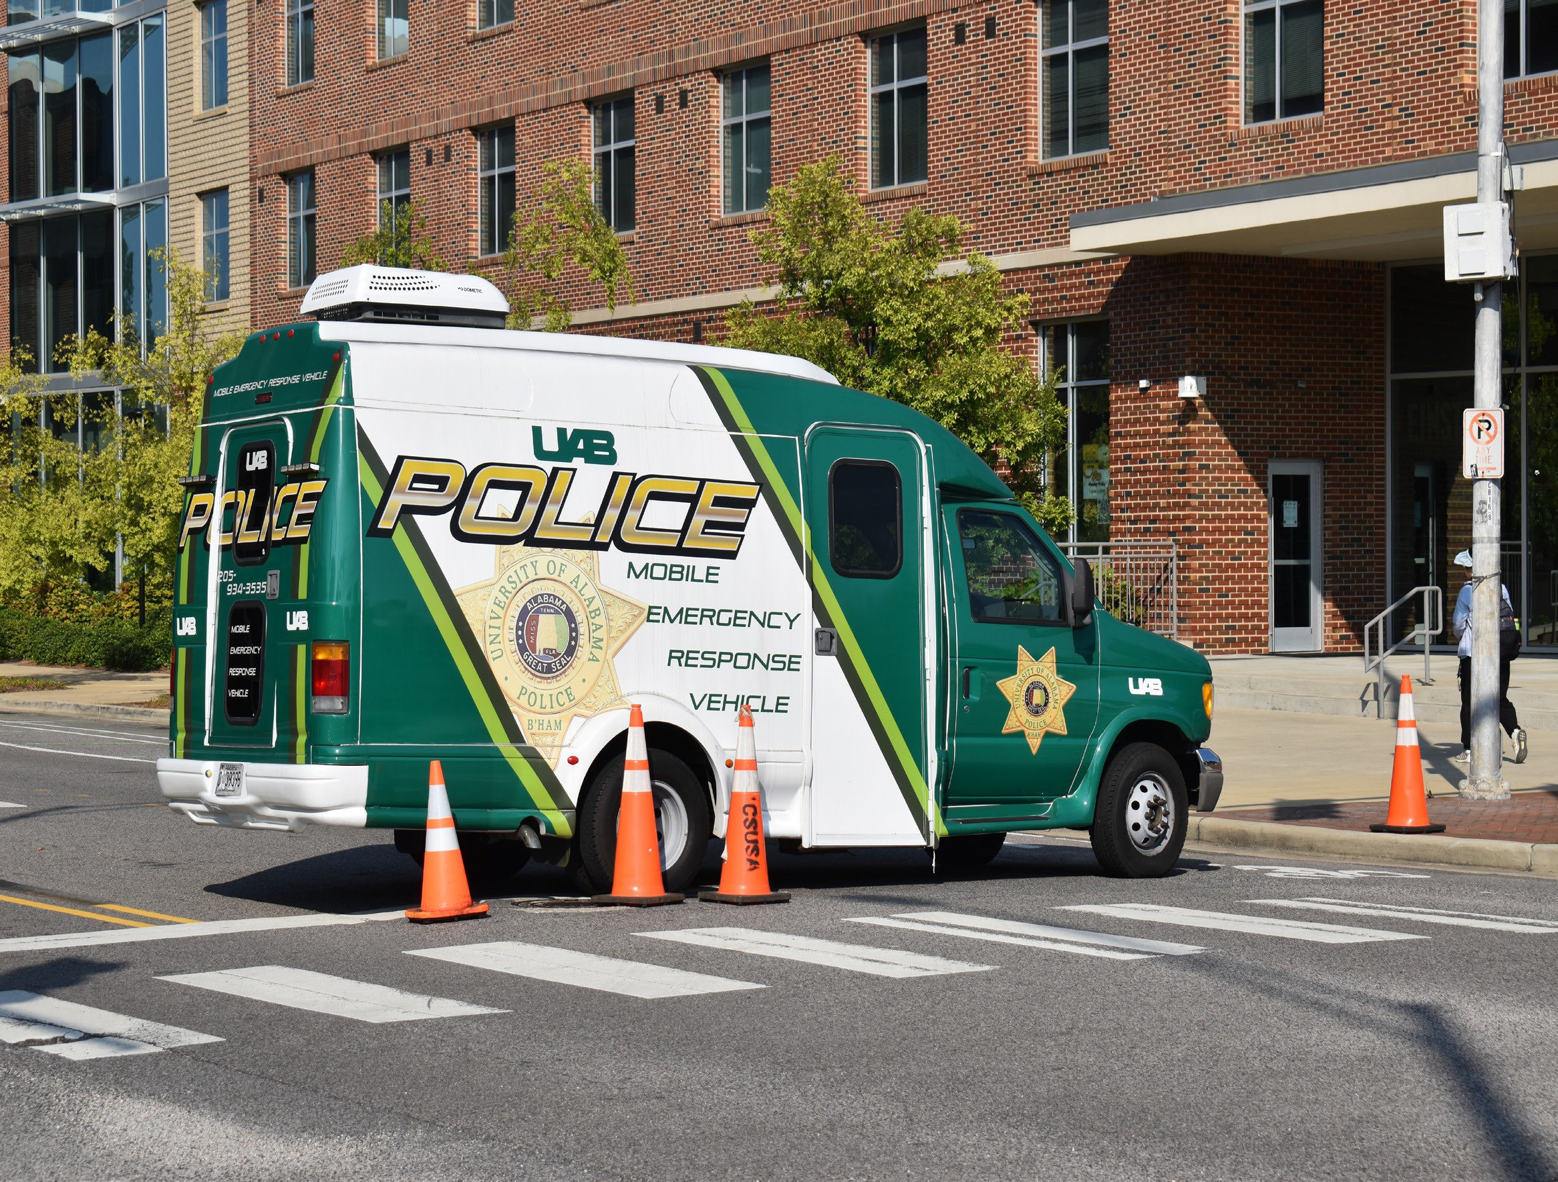

EMERGENCY PREPAREDNESS, RESPONSE, AND EVACUATION PROCEDURES

The University of Alabama at Birmingham has long recognized the need to be prepared for critical incidents. Un-der the guidance of the University Safety Committee, various department and offices work together to ensure the University is doing all it can to prepare for, prevent, respond to, and recover from emergencies. In conjunction with local first responders, such as the Birmingham Police Department and Birmingham Fire and Rescue, the University is well prepared to respond to a full range of critical incidents.

The Office of Occupational Health and Safety (OH&S) and the University Police Department work together to en-sure our emergency protocols and plans are updated, as needed, and are applicable as new risks are identified. The University’s emergency planning website, located at www.uab.edu/emergency, not only contains important information about what to do during an emergency, but it also outlines the various initiatives underway to enhance preparedness. One such initiative is the University of Alabama at Birmingham Emergency Notification System. This system is used to send text messages to cell phones and pagers when urgent information needs to be communicat-ed quickly to the University community.

Upon immediate confirmation by the University Police Department or other University administrators (President, President’s Cabinet, and Emergency Management) that an emergency incident has occurred on campus, the Uni-versity will immediately issue an emergency notification to the campus community via the University’s B-ALERT emergency notification system to communicate through voice calls, SMS text messages and emails to the entire campus all at the same time. Face-to-face communication might be utilized as well, if appropriate. B-ALERT also integrates with Facebook and Twitter. However, if issuing a notification, in the professional judgment of responsible authorities, compromise efforts to assist a victim or to contain, respond to, or otherwise mitigate the emergency, the University may decide not to issue the notification immediately. Appropriate University administrators (Uni-versity Police, or President, President’s Cabinet, or Emergency Management) will determine the necessary seg-ment or segments of the campus community to receive an emergency notification(s): such as the entire campus community, or the affected residence hall or halls, or the affected campus building or buildings, or the affected hospital(s); determine the content of the notification, such as the University Police Department will determine how much information is appropriate to disseminate at different points in time to the entire campus community, or the affected area(s); part of this information may tell the residents, students, and/or employees to shelter in place or to tell commuter students and employees to stay away from campus; and initiate the notification system. The UAB administrators responsible for carrying out the above actions are as follows: The President, The President’s Cabinet, the University Police Department, and Emergency Management.

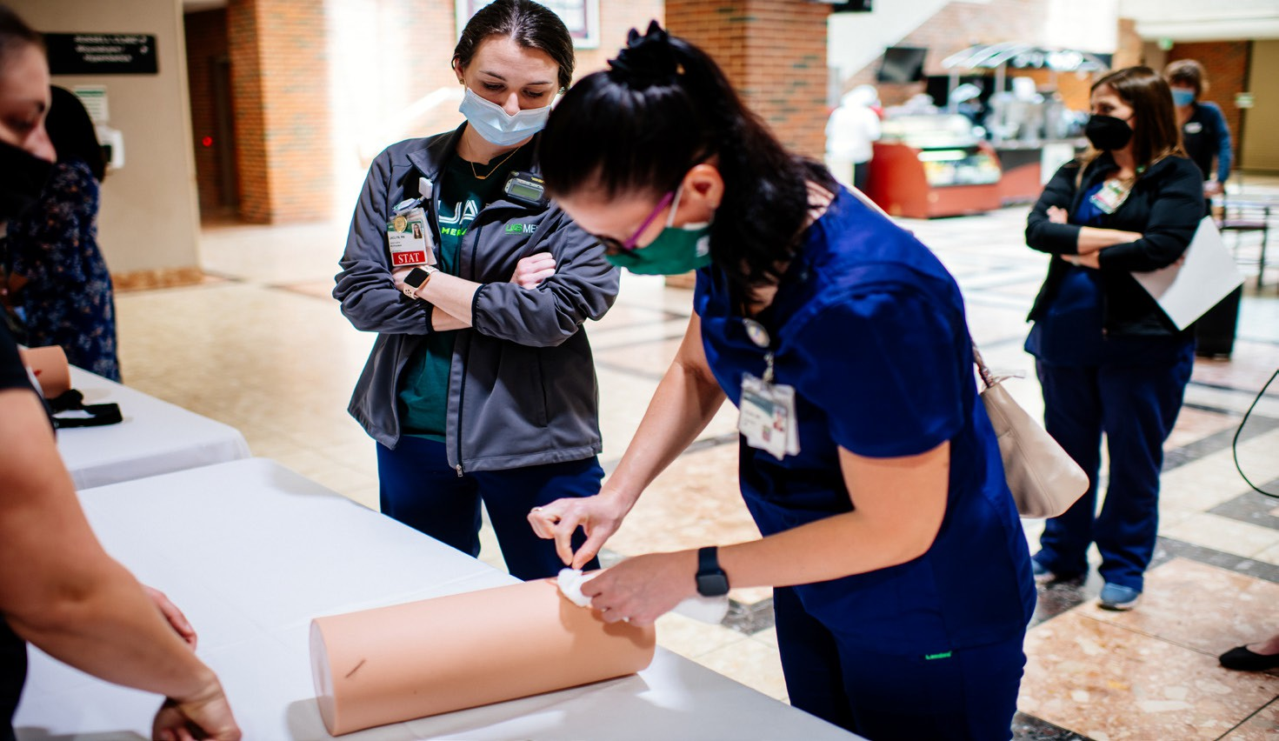
The larger community is highly encouraged to go to the University’s emergency planning website, located at uab. edu/emergency, to obtain emergency information. UAB will test (announced or unannounced) the emergency noti-fication system on an annual basis and publicize its emergency response and evacuation procedures in conjunction with its annual test per calendar year. UAB will document each annual test, including a description of the exercise, the date, time, and whether it was announced or unannounced.

CRIMINAL INCIDENTS ON CAMPUS

The University Police prepares this report to comply with the Jeanne Clery Disclosure of Campus Security Policy and Crime Statistics Act. The full text of this report can be located on our website at uab.edu/police. This report is prepared in cooperation with the local law enforcement agencies surrounding our campus, Student Housing and Residential Life, the Office of Student Conduct, and the Office of Financial Affairs and Administration. Each entity provides updated information on their educational efforts and programs to comply with the Act.

Campus crime, arrest and referral statistics include those reported to the UAB Police, designated campus officials (including but not limited to directors, deans, department heads, student conduct, advisors to students/student organizations, athletic coaches), and local law enforcement agencies.

Each year, an email link is made available via the Kaleidoscope, GreenMail, eReporter, undergraduate and graduate admissions, and human resources management in reference to the website to access the Annual Security & Fire Safety Report. Copies of the report may also be obtained at the University Police Department Headquarters located at 1117 14th Street South Birmingham, AL or by calling 205-934-4649.
UNFOUNDED CRIMINAL INCIDENTS

“Unfounded” means that an investigation by a sworn law enforcement officer has shown that the incident or of-fense did not occur. An offense or incident cannot be “unfounded” just because stolen property was recovered and/ or the victim refuses to prosecute, or an arrest was not made.
CRIME STATISTICS (chart on page 58)

Major crimes reported to the UAB Police Department for January through December of the most recent three-year period are listed in the following chart. UAB Police Incident Reports are subject to Alabama’s Uniform Crime Report-ing Program and the Alabama Open Records Act. The Code of Alabama (Section 36-12-40) states that every citizen has a right to inspect and take a copy of any public writing of this state, except as otherwise expressly provided by statute. Disciplinary referrals for violations of the Student Code of Conduct, which may include some criminal offenses specified for this report, are sometimes made directly to the Office of Student Conduct by individuals or campus organizations other than the UAB Police.

Note: Any incidents that may have been reported only to pastoral and professional counselors of the University are generally protected by privacy rights of the client or patient and are not included in any of the following statistics, nor for any timely warning notifications to the campus.
ADDITIONAL SOURCE OF STATISTICAL INFORMATION
UABPD has developed, and periodically reviews, procedures to include in reported crime statistics and for the purpose of making timely crime alerts, reports of required crimes made to campus security authorities. Campus Security Authorities (CSAs) at UAB include employees of the UABPD; other individuals and third party vendors who are responsible for cam-pus security; the University’s Title IX Coordinator; Title IX Investigator; designated harassment resource persons; and any officials of the University who have significant responsibility for student and campus activities. A Clery Incident Reporting Form (https://www.uab.edu/police/report-a-crime/campus-security-authority-incident-report-form) is available to CSAs to assist in the collection of crime statistics. Although all CSAs are required to report crimes for inclusion in the statistics, UABPD regularly collects crime statistics data from the following CSAs either directly or indirectly through a centralized reporting channel: the Office of the Vice President for Student Affairs, Office of Student Conduct, Athletics, the Office of Residential Life, and Study Abroad.

IMPORTANT DEFINITIONS
Crimes reported for the University of Alabama at Birmingham are classified as being on or off campus by using the follow-ing boundaries. For the purposes of classifying the reported crimes, the following definitions apply:
Campus: (1) Any building or property owned or controlled by an institution within the same reasonably contiguous geo-graphic area and used by the institution in direct support of, or in a manner related to, the institution’s educational purpos-es, including residence halls; and (2) any building or property that is within or reasonably contiguous to the area identified in paragraph (1) of this definition, that is owned by the institution but controlled by another person, is frequently used by students, and supports institutional purposes (such as a food or other retail vendor).
Non-campus building or property: (1) Any building or property owned or controlled by a student organization that is of-ficially recognized by the Institution; or (2) any building or property owned or controlled by an institution that is used in direct support of, or in relation to, the Institution’s educational purposes, is frequently used by students, and is not within the same reasonably contiguous geographic area of the institution.
Public property: All public property, including thoroughfares, streets, sidewalks, and parking facilities, that is within the campus, or immediately adjacent to and accessible from the campus.

UAB POLICE DEPARTMENT CRIME STATISTICS CRIME STATISTICS MANDATED BY THE JEANNE CLERY ACT
CRIMINAL INCIDENTS | ON CAMPUS |  |  | * STUDENT HOUS-ING |  |  | PUBLIC PROPERTY |  |  | NON CAMPUS |  |  | UNFOUNDED
 | 2023 | 2024 | 2025 | 2023 | 2024 | 2025 | 2023 | 2024 | 2025 | 2023 | 2024 | 2025 | 2023 | 2024 | 2025
AGGRAVATED ASSAULT | 9 | 18 | 27 | 0 | 0 | 0 | 2 | 2 | 5 | 0 | 2 | 0 | 0 | 0 | 0
ARSON | 0 | 2 | 5 | 0 | 0 | 0 | 0 | 0 | 0 | 0 | 0 | 0 | 0 | 0 | 0
BURGLARY | 14 | 32 | 25 | 2 | 0 | 1 | 0 | 0 | 0 | 0 | 0 | 0 | 0 | 0 | 0
FONDLING | 25 | 15 | 28 | 3 | 2 | 1 | 0 | 0 | 2 | 0 | 0 | 2 | 0 | 0 | 0
HAZING | 0 | 0 | 1 | 0 | 0 | 0 | 0 | 0 | 0 | 0 | 0 | 0 | 0 | 0 | 0
INCEST | 0 | 0 | 0 | 0 | 0 | 0 | 0 | 0 | 0 | 0 | 0 | 0 | 0 | 0 | 0
MOTOR VEHICLE THEFT* | 26 | 64 | 60 | 1 | 0 | 0 | 3 | 3 | 4 | 0 | 0 | 0 | 4 | 3 | 10
MURDER/NON-NEGLIGENT MANSLAUGHTER | 0 | 0 | 0 | 0 | 0 | 0 | 0 | 0 | 0 | 0 | 0 | 0 | 0 | 0 | 0
MANSLAUGHTER BY NEGLI-GENCE | 0 | 0 | 0 | 0 | 0 | 0 | 0 | 0 | 0 | 0 | 0 | 0 | 0 | 0 | 0
RAPE | 8 | 6 | 12 | 6 | 2 | 6 | 0 | 0 | 0 | 0 | 0 | 0 | 1 | 1 | 2
ROBBERY | 0 | 3 | 1 | 0 | 0 | 0 | 2 | 1 | 1 | 0 | 0 | 1 | 0 | 2 | 0
STATUTORY RAPE | 0 | 0 | 0 | 0 | 0 | 0 | 0 | 0 | 0 | 0 | 0 | 0 | 0 | 0 | 0
VIOLENCE AGAINST WOMEN ACT (VAWA)
DATING VIOLENCE | 8 | 27 | 33 | 3 | 5 | 7 | 1 | 2 | 1 | 0 | 1 | 0 | 0 | 1 | 1
DOMESTIC VIOLENCE | 13 | 21 | 27 | 0 | 2 | 0 | 0 | 2 | 2 | 0 | 0 | 1 | 0 | 1 | 1
STALKING | 3 | 14 | 24 | 2 | 1 | 7 | 0 | 0 | 1 | 0 | 0 | 0 | 0 | 0 | 0
ARRESTS
LIQUOR LAW VIOLATIONS | 0 | 0 | 0 | 0 | 0 | 0 | 0 | 0 | 0 | 0 | 0 | 0 | 0 | 0 | 0
DRUG ABUSE VIOLATIONS | 31 | 37 | 20 | 0 | 1 | 0 | 7 | 12 | 7 | 0 | 0 | 3 | 0 | 0 | 0
WEAPONS: CARRYING, POS-SESSING, ETC. | 0 | 1 | 2 | 0 | 0 | 0 | 1 | 0 | 0 | 0 | 0 | 0 | 0 | 0 | 0
DISCIPLINARY ACTIONS/JUDICIAL REFERRALS
LIQUOR LAW VIOLATIONS | 48 | 84 | 63 | 48 | 76 | 63 | 0 | 0 | 0 | 0 | 0 | 0 | 0 | 0 | 0
DRUG ABUSE VIOLATIONS | 13 | 41 | 14 | 12 | 40 | 14 | 0 | 0 | 0 | 0 | 0 | 0 | 0 | 0 | 0
WEAPONS: CARRYING, POS-SESSING, ETC. | 0 | 1 | 0 | 0 | 0 | 0 | 0 | 0 | 0 | 0 | 0 | 0 | 0 | 0 | 0
REGISTERED SEX OFFENDERS IN UAB CAMPUS VICINITY **
* Student Housing (Residential Facilities) are a subsection of On-Campus totals.
**Information on Registered Sex Offenders can be obtained at the UAB Police Department or on the Alabama Law Enforcement Agen-cy’s Website (https://www.alea.gov/node/270) located under the Sexual Offender Link
* Note: A significant portion of the Motor Vehicle Theft category for 2024 and 2025 involved thefts of electric scooters, which are classified as motor vehicles under federal Clery reporting definitions. In 2024, 43 electric scooters, 3 electric bikes, and one golf cart. In 2025, 50 electric scooters and 1 electric bike were reported stolen.
*Note: 2025 was the first year of collecting Hazing statistics which is why there are no statistics for 2023 or 2024.

UAB POLICE DEPARTMENT CRIME STATISTICS CRIME STATISTICS MANDATED BY THE JEANNE CLERY ACT
HATE CRIMES
CRIMINAL INCIDENTS | ON CAMPUS |  |  | *STUDENT HOUS-ING |  |  | PUBLIC PROPERTY |  |  | NON CAMPUS |  |  | UNFOUNDED
CRIMINAL INCIDENTS | 2023 | 2024 | 2025 | 2023 | 2024 | 2025 | 2023 | 2024 | 2025 | 2023 | 2024 | 2025 | 2023 | 2024 | 2025
AGGRAVATED ASSAULT | 0 | 0 | 0 | 0 | 0 | 0 | 0 | 0 | 0 | 0 | 0 | 0 | 0 | 0 | 0
ARSON | 0 | 0 | 0 | 0 | 0 | 0 | 0 | 0 | 0 | 0 | 0 | 0 | 0 | 0 | 0
BURGLARY | 0 | 0 | 0 | 0 | 0 | 0 | 0 | 0 | 0 | 0 | 0 | 0 | 0 | 0 | 0
DAMAGE/VANDALISM OF PROPERTY | 0 | 0 | 0 | 0 | 0 | 0 | 0 | 0 | 0 | 0 | 0 | 0 | 0 | 0 | 0
DATING VIOLENCE | 0 | 0 | 0 | 0 | 0 | 0 | 0 | 0 | 0 | 0 | 0 | 0 | 0 | 0 | 0
DOMESTIC VIOLENCE | 0 | 0 | 0 | 0 | 0 | 0 | 0 | 0 | 0 | 0 | 0 | 0 | 0 | 0 | 0
FONDLING | 0 | 0 | 0 | 0 | 0 | 0 | 0 | 0 | 0 | 0 | 0 | 0 | 0 | 0 | 0
HAZING | - | - | 0 | - | - | 0 | - | - | 0 | - | - | 0 | - | - | 0
INCEST | 0 | 0 | 0 | 0 | 0 | 0 | 0 | 0 | 0 | 0 | 0 | 0 | 0 | 0 | 0
INTIMIDATION | 0 | 1 | 0 | 0 | 0 | 0 | 0 | 0 | 0 | 0 | 0 | 0 | 0 | 0 | 0
LARCENY-THEFT | 0 | 0 | 0 | 0 | 0 | 0 | 0 | 0 | 0 | 0 | 0 | 0 | 0 | 0 | 0
MOTOR VEHICLE THEFT | 0 | 0 | 0 | 0 | 0 | 0 | 0 | 0 | 0 | 0 | 0 | 0 | 0 | 0 | 0
MURDER/NON-NEGLIGENT MANSLAUGHTER | 0 | 0 | 0 | 0 | 0 | 0 | 0 | 0 | 0 | 0 | 0 | 0 | 0 | 0 | 0
MANSLAUGHTER BY NEGLI-GENCE | 0 | 0 | 0 | 0 | 0 | 0 | 0 | 0 | 0 | 0 | 0 | 0 | 0 | 0 | 0
RAPE | 0 | 0 | 0 | 0 | 0 | 0 | 0 | 0 | 0 | 0 | 0 | 0 | 0 | 0 | 0
ROBBERY | 0 | 0 | 0 | 0 | 0 | 0 | 0 | 0 | 0 | 0 | 0 | 0 | 0 | 0 | 0
SIMPLE ASSAULT | 0 | 0 | 1 | 0 | 0 | 0 | 0 | 0 | 1 | 0 | 0 | 0 | 0 | 0 | 0
STALKING | 0 | 0 | 0 | 0 | 0 | 0 | 0 | 0 | 0 | 0 | 0 | 0 | 0 | 0 | 0
STATUTORY RAPE | 0 | 0 | 0 | 0 | 0 | 0 | 0 | 0 | 0 | 0 | 0 | 0 | 0 | 0 | 0
* Student Housing (Residential Facilities) are a subsection of On-Campus totals.
Hate Crimes - A crime reported to local police agencies or to a campus security authority that manifests evidence that the victim was intentionally selected because of the perpetrator’s bias against the victim. The categories of bias include the victim’s actual or perceived race, religion, gender, gender identity, sexual orientation, ethnicity, national origin, and disability.
One on campus simple assault with a race bias. One public property simple assault with a race bias.
*Note: 2025 was the first year of collecting Hazing statistics which is why there are no statistics for 2023 or 2024.

The City of Birmingham 2023-2025 Offenses Reported
UAB Area*
 |  |  |  | UNFOUNDED
Crime Incidents | 2023 | 2024 | 2025 | 2023 | 2024 | 2025
ARSON | 0 | 0 | 0 | 0 | 0 | 0
AGGRAVATED ASSAULT | 48 | 99 | 62 | 1 | 0 | 0
BURGLARY | 76 | 111 | 61 | 1 | 0 | 1
DATING VIOLENCE | - | - | - | - | - | -
DOMESTIC VIOLENCE | 102 | 162 | 171 | - | - | -
FONDLING | 0 | 0 | 0 | 0 | 0 | 0
HAZING | - | - | - | - | - | -
INCEST | 0 | 0 | 0 | 0 | 0 | 0
MOTOR VEHICLE THEFT | 122 | 145 | 89 | 15 | 9 | 9
MURDER/NON-NEGLIGENT MANSLAUGH-TER | 2 | 3 | 0 | 0 | 0 | 0
MANSLAUGHTER BY NEGLIGENCE | 0 | 0 | 0 | 0 | 0 | 0
RAPE | 2 | 3 | 3 | 0 | 0 | 1
ROBBERY | 21 | 22 | 18 | 1 | 2 | 2
STALKING | 0 | 0 | 1 | 0 | 0 | 0
STATUTORY RAPE | 0 | 0 | 0 | 0 | 0 | 0
Arrest
LIQUOR LAW VIOLATIONS | 0 | 0 | 0 | 0 | 0 | 0
DRUG ABUSE VIOLATIONS | 21 | 26 | 109 | 0 | 0 | 0
WEAPONS: CARRYING, POSSESSING, ETC. | - | 1 | 3 | - | 0 | 0
-The Birmingham Police Department was unable to provide these statistics.

DEFINITIONS OF REPORTABLE CRIMES
Aggravated Assault – An unlawful attack by one person upon another for the purpose of inflicting severe or aggravated bodily injury. This type of assault usually is accompanied by the use of a weapon or by means likely to produce death or great bodily harm. (It is not necessary that injury result from an aggravated assault when a gun, knife, or other weapon is used which could and probably would result in serious personal injury if the crime were successfully completed.)
Arson – Any willful or malicious burning or attempt to burn, with or without intent to defraud, a dwelling house, public building, motor vehicle or aircraft, personal property of another, etc.
Burglary – The unlawful entry of a structure to commit a felony or a theft. For reporting purposes this definition includes: unlawful entry with intent to commit a larceny or felony; breaking and entering with intent to commit a larceny; house-breaking; safecracking; and all attempts to commit any of the aforementioned.
Domestic Violence – A felony or misdemeanor crime of violence committed by:
- a current or former spouse or intimate partner of the victim,
- by a person with whom the victim shares a child in common,
- by a person who is cohabitating with or has cohabitated with the victim as a spouse or intimate partner; or
- by a person similarly situated to a spouse of the victim under the domestic violence or family violence laws of the jurisdiction in which the crime of violence occurred; or
- by any other person against an adult or youth victim who is protected from that person’s acts under the domestic or family violence laws of the jurisdiction in which the crime of violence occurred.
For the purposes of complying with the requirements of this section and section 668.41, any incident meeting this defini-tion is considered a crime for the purposes of Clery Act reporting.
Dating Violence - Violence committed by a person who is or has been in a social relationship of a romantic or intimate nature with the victim. (1) The existence of such a relationship shall be determined based on the Complainant’s state-ment and with consideration of the length of the relationship, the type of relationship, and the frequency of interaction between the persons involved in the relationship. (2) For the purpose of this definition- (i) Dating violence includes, but is not limited to, sexual or physical abuse or the threat of such abuse. (ii) Dating violence does not include acts covered under the definition of domestic violence. (3) For the purposes of complying with the requirements of this section and section 668.41, any incident meeting this definition is considered a crime for the purposes of Clery Act reporting.
Criminal Homicide—Murder and Nonnegligent Manslaughter – The willful (nonnegligent) killing of one human being by another.
Motor Vehicle Theft – The theft or attempted theft of a motor vehicle. (Classify as motor vehicle theft all cases where auto-mobiles are taken by persons not having lawful access even though the vehicles are later abandoned—including joyriding.)
Criminal Homicide—Manslaughter by Negligence – The killing of another person through gross negligence.
Robbery – The taking or attempting to take anything of value from the care, custody, or control of a person or persons by force or threat of force or violence and/or by putting the victim in fear.
Hazing – The act of someone intentionally, knowingly, or recklessly does something to another person as part of joining, becoming affiliated with, or staying in an organization even if the person agrees to participate, and the actions cause or could cause physical or psychological injury.
Sex offenses - Any sexual act directed against another person, without the consent of the victim, including instances where the victim is incapable of giving consent.

Sexual Assault – An offense that meets the definition of rape, fondling, incest, or statutory rape as used in the FBI’s Uni-form Crime Reporting (UCR) program. Per the National Incident-Based Reporting System User Manual from the FBI UCR Program, a sex offense is “any sexual act directed against another person, without the consent of the victim, including

instances where the victim is incapable of giving consent.”
Rape – The penetration, no matter how slight, of the vagina or anus with any body part or object, or oral penetration by a sex organ of another person, without the consent of the victim.
Fondling - The touching of the private parts of another person for the purposes of sexual gratification, without the consent of the victim, including instances where the victim is incapable of giving consent because of his/her age or because of his/ her temporary or permanent mental incapacity.
Statutory Rape – Non forcible sexual intercourse with a person who is under the statutory age of consent.
Incest – Non forcible sexual intercourse between persons who are related to each other within the degrees wherein mar-riage is prohibited by law.
Stalking – Engaging in a course of conduct directed at a specific person that would cause a reasonable person to – a) fear
for his or her safety or the safety of others; or b) suffer substantial emotional distress.
OTHER OFFENSES-
Intimidation – To unlawfully place another person in reasonable fear of bodily harm through the use of threatening words and/or other conduct, but without displaying a weapon or subjecting the victim to actual physical attack. Counted for Hate Crimes Only.
Larceny – The unlawful taking, carrying, leading, or riding away of property from the possession or constructive posses-sion of another. Attempted larcenies are included. Embezzlement, confidence games, forgery, worthless checks, etc., are excluded. Counted for Hate Crimes Only.
Simple Assault – An unlawful physical attack by one person upon another where neither the offender displays a weapon, nor the victim suffers obvious severe or aggravated bodily injury involving apparent broken bones, loss of teeth, possible internal injury, severe laceration, or loss of consciousness. Counted for Hate Crimes Only.
Destruction/Damage/Vandalism – To willfully or maliciously destroy, damage, deface, or otherwise injure real or personal property without the consent of the owner or the person having custody or control of it. Counted for Hate Crimes Only.
Liquor law violations – The violation of state or local laws or ordinances prohibiting the manufacture, sale, purchase, transportation, possession, or use of alcoholic beverages, not including driving under the influence and drunkenness.
Drug abuse violations – The violation of laws prohibiting the production, distribution, and/or use of certain controlled substances and the equipment or devices utilized in their preparation and/or use. The unlawful cultivation, manufacture, distribution, sale, purchase, use, possession, transportation, or importation of any controlled drug or narcotic substance. Arrests for violations of state and local laws, specifically those relating to the unlawful possession, sale, use, growing, man-ufacturing, and making of narcotic drugs.
Weapons: Carrying, Possessing, Etc. – The violation of laws or ordinances prohibiting the manufacture, sale, purchase, transportation, possession, concealment, or use of firearms, cutting instruments, explosives, incendiary devices, or other deadly weapons.

ALCOHOL AND DRUG USE AND ABUSE

Alcoholic Beverages
The University has established policies and guidelines governing the possession, sale, and consumption of alcoholic bev-erages on the campus. A copy of the Student Alcohol Policy may be obtained through Student Affairs. A copy of the Policy on The Use and Consumption of Alcoholic Beverages may be obtained from the Office of Human Resources, Campus Drug Policy Coordinator. Any use of alcoholic beverages on campus must be in compliance with the Alabama law prohibiting the use of alcohol by persons under the age of 21. Students of legal drinking age in Alabama may possess and consume alcoholic beverages in their private residence. See the entire General Policy Regarding the Use and Consumption of Alco-holic Beverages Policy at https://uab-public.policystat.com/policy/18579185/latest. See the entire Student Conduct Policy at https://uab-public.policystat.com/policy/21117791/latest.

Illegal Drugs
University regulations prohibit the possession or use, without a valid prescription, of any substance currently classified as a dangerous drug by the Alabama Controlled Substance Act. Any individual breaking the law will be subject to disciplinary action and arrest. See the entire Student Conduct Policy at https://uab-public.policystat.com/policy/21117791/latest.
Substance Abuse Education
UAB is committed to maintaining a campus free of drug and alcohol abuse and assisting all employees and students in find-ing ways to address these problems. Educational programs addressing these issues are supported and encouraged through a variety of departments. Anyone aware of problems with roommates, friends, or coworkers is encouraged to contact the appropriate office for help.
Substance Abuse Assistance
For students with substance abuse problems, assistance is available through the UAB Student Health and Wellness Center. The Student Health and Wellness Center has experienced professional counselors and psychologists to assist students in need. Students are scheduled for individual appointments, and all information is kept strictly confidential. They have a full-time substance abuse prevention coordinator and trained student peer educators available to provide information individually or in-group settings. The Student Health and Wellness Center is located at 1714 9th Avenue South, Birmingham, AL. 35294. For more information, students are encouraged to contact one of the following numbers:
- Student Health and Wellness Center (205) 934-3580
- Student Health and Wellness Counseling Services at (205) 934-5816
UAB faculty and staff may obtain assistance through the Office of Human Resources Employee Assistance Program at (205) 934-2281. Alcohol and drug assistance programs are available, including referral to community agencies. Counseling and referral services are provided by appointment, and all information is confidential. The Employee Assistance Program also offers training and educational programs regarding drug and alcohol awareness. Please refer to the University’s Drug-Free Campus and Workplace Policy for additional information https://secure4.compliancebridge.com/uab/public/getdoc. php?file=416. The Employee Assistance Program is located at, 2112 11th Avenue South, Suite 330, Birmingham, AL 35205.

HOW TO BE AN ACTIVE BYSTANDER
Bystanders play a critical role in the prevention of sexual and relationship violence. They are “individuals who observe violence or witness the conditions that perpetuate violence. They are not directly involved but have the choice to intervene, speak up, or do something about it.” We want to promote a culture of community accountability where bystanders are actively engaged in the prevention of violence without causing further harm. We may not always know what to do even if we want to help. Below is a list of some ways to be an active bystander. Further information regarding bystander intervention may be found at https://www.nsvrc.org/bystander-intervention-online-learning-opportunities. If you or someone else is in immediate danger, dial 911. This could be when a person is yelling at or being physically abusive towards another and it is not safe for you to interrupt.

  - Watch out for your friends and fellow students/employees. If you see someone who looks like they could be in trouble or need help, ask if they are ok.
  - Confront people who seclude, hit on, try to make out with, or have sex with people who are incapacitated.
  - Speak up when someone discusses plans to take sexual advantage of another person.
  - Believe someone who discloses sexual assault, abusive behavior, or experience with stalking.
  - Refer people to on or off campus resources listed in this document for support in health, counseling, or with legal assistance.

RISK REDUCTION
With no intent to victim blame and recognizing that only abusers are responsible for their abuse, the following are some strategies to reduce one’s risk of sexual assault or harassment (taken from Rape, Abuse, & Incest National Network, www. rainn.org). Free, 24/7 Support.
  - Know your resources. Who should you contact if you or a friend needs help? Where should you go? Locate resources such as the campus health center, campus police station, and a local sexual assault service provider. Notice where emergency phones are located on campus, and program the campus security number into your cell phone for easy access.
  - Stay alert. When you’re moving around on campus or in the surrounding neighborhood, be aware of your sur-roundings. Consider inviting a friend to join you or asking campus security for an escort. If you’re alone, only use headphones in one ear to stay aware of your surroundings.
  - Be careful about posting your location. Many social media sites, like Facebook and Twitter, use geolocation to share your location publicly. Consider disabling this function and reviewing other social media settings.
  - Make others earn your trust. A college environment can foster a false sense of security. They may feel like fast friends, but give people time to earn your trust before relying on them.
  - Think about Plan B. Spend some time thinking about backup plans for potentially sticky situations. If your phone dies, do you have a few numbers memorized to get help? Do you have emergency cash in case you can’t use a credit card? Do you have the address to your dorm or college memorized? If you drive, is there a spare key hidden, gas in your car, and a set of jumper cables?
  - Be secure. Lock your door and windows when you’re asleep and when you leave the room. If people constantly prop open the main door to the dorm or apartment, tell security or a trusted authority figure.

Safety in social settings
  - Make a plan. If you’re going to a party, go with people you trust. Agree to watch out for each other and plan to leave together. If your plans change, make sure to touch base with the other people in your group. Don’t leave someone stranded in an unfamiliar or unsafe situation.
  - Protect your drink. Don’t leave your drink unattended, and watch out for your friends’ drinks if you can. If you go to the bathroom or step outside, take the drink with you or toss it out. Drink from unopened containers or drinks you watched being made and poured. It’s not always possible to know if something has been added to someone’s drink. In a drug-facilitated sexual assault, a perpetrator could use a substance that has no color, taste, or odor.
  - Know your limits. Keep track of how many drinks you’ve had, and be aware of your friends’ behavior. If one of you feels extremely tired or more drunk than you should, you may have been drugged. Leave the party or situ-ation and find help immediately.
  - It’s okay to lie. If you want to exit a situation immediately and are concerned about frightening or upsetting someone, it’s okay to lie. You are never obligated to remain in a situation that makes you feel uncomfortable, pressured, or threatened. You can also lie to help a friend leave a situation that you think may be dangerous. Some excuses you could use are needing to take care of another friend or family member, an urgent phone call,

not feeling well, and having to be somewhere else by a certain time.
  - Be a good friend. Trust your instincts. If you notice something that doesn’t feel right, it probably isn’t. Learn more about how to keep your friends safe in social settings.
  - If you suspect you or a friend has been drugged, contact law enforcement immediately. UAB Police Depart-ment can be reached at (205) 934-3535 (local authorities can be reached by calling 911 in most areas of the U.S.). Be explicit with doctors so they can give you the correct tests (you will need a urine test and possibly others).
ADDITIONAL SAFETY TIPS
- Be alert. Watch for obvious strangers around your office, your home, or apartment. Check for signs of a break-in before entering an empty house, office, or car. Call the police if you see signs of forced entry to a building or a car.
- Call the police if you are experiencing any minor theft problems over a period of time.
- Involve your associates. If you are expecting a delivery or a guest in your absence, leave your keys with a neighbor or a coworker. Let your office staff and neighbors know when you will be away from home and ask them to challenge strangers in the area.
- Maintain a record of serial numbers of your property and of identification and credit cards. Include a brief description with each and keep this information in a safe place.
- Report any crime or suspicious activity to the police. Be prepared to supply as much information as possible, such as descriptions of people, property, and cars.
- Post the number for the UAB Police Department (205) 934-3535, and your local police and fire departments, near your phone at work and at home.
- If you need to contact the Police while on campus, use one of the HELP phones located in key areas around campus. Take a few minutes now to review the Help Phone Map (see page 62) to locate and identify HELP phones in those areas where you park, work, walk or play. Simply lifting the receiver or pushing the red button of one of these green and yellow phones will put you through to the UAB Police Dispatcher immediately.
- If you would like additional information on crime prevention or wish to discuss a problem that may be crime related, contact the UAB Police Department at (205) 934-4434. Help prevent crime and help to have a safe home, study, and work environment. Victims needing counseling for psychological or physical reasons may contact one of the following on-campus and off-campus offices for further information:
  - Student Health and Wellness Center (205) 934-3580
  - Student Health and Wellness Counseling Services at (205) 934-5816
  - Gateway Family Services (205) 510-2600
  - One Place Metro Alabama Family Justice Center: (205) 453-7261
  - Crisis Center (205) 323-7777
  - Rape Response: (205) 323-7273
  - Oasis Counseling Center: (205) 933-0338
  - Domestic Violence Services YWCA: (205) 322-9922


Fire Safety Report

Important Definitions

Fire: Any instance of open flame or other burning in a place not intended to contain the burning or in an uncontrolled manner.
Cause of fire: The factor or factors that give rise to a fire. The causal factor may be, but is not limited to, the result of an intentional or unintentional action, mechanical failure, or act of nature.
Fire drill: A supervised practice of a mandatory evacuation of a building for a fire.
Fire-related injury: Any instance in which a person is injured as a result of a fire, including an injury sustained from a nat-ural or accidental cause while involved in fire control, attempting a rescue, or escaping from the dangers of the fire. The term person may include students, faculty, staff, visitors, firefighters, or any other individuals.
Fire-related death: Any instance in which a person
- Is killed as a result of a fire, including death resulting from a natural or accidental cause while involved in fire control, attempting rescue, or escaping from the dangers of a fire; or
- Dies within one year of injuries sustained as a result of the fire.
Fire safety system: Any mechanism or system related to the detection of a fire, the warning resulting from a fire, or the control of a fire. This system includes sprinkler systems or other fire extinguishing systems, fire detection devices, stand-alone smoke alarms, devices that alert one to the presence of a fire, such alarms, bells, or strobe lights; smoke-control and reduction mechanisms; and fire doors and walls that reduce the spread of a fire.
Value of Property Damage: The estimated value of the loss of the structure and contents, in terms of the cost of replace-ment in like kind and quantity. This estimate should include contents damaged by fire, and related damages caused by smoke, water, and overhaul; however, it does not include indirect loss, such as business interruption.
Residence halls fire prevention information
Smoke detectors and sprinkler systems. All residence halls have smoke detectors and sprinkler systems installed and a Fire Alarm Control Panel. There are smoke detectors in each student room as well as in common areas. These are connected to the central alarm system, which, in turn, is connected to the UAB Police Department.
Fire Safety Equipment: All suites/apartments are equipped with smoke detectors. Each floor in each residence hall is equipped with fire extinguishers. Fire alarm pull stations are located on each corridor of each hall. Tampering with fire safety equipment or setting off a false alarm is against the law. It also will make the system ineffective and endanger the lives of other residents. Any person, who sets off a false alarm, interferes with the operation of the alarm system, damages or removes any part of the alarm system, fire extinguishers, smoke detectors, or exit signs are subject to severe disciplinary action, including dismissal from the residence halls, possible suspension from the University, and/or criminal prosecution. If a smoke detector is detached from the wall for any reason, it is the responsibility of the resident to report it immediately. If not reported, all residents will be held responsible for tampering with fire safety equipment and will be disciplined and/ or fined.
Fire safety education: To comply with state and local fire regulations and for fire safety education, unannounced fire drills are conducted every semester. All persons inside the residence hall during emergency drills are required to evacuate the building. Failure to evacuate the residence hall for any reason, including sleeping through an alarm, may result in disci-plinary action.
Fire evacuation procedures: In the event of a fire, all residence hall buildings will be evacuated to protect the health and safety of the residents, guests, and visitors. When an alarm is sounded, you must assume there is an emergency, and you must follow the following steps.
- REMAIN CALM.
- Evacuate by the nearest safety exit stairway.

- DO NOT USE ELEVATORS. Elevators will either automatically return to the first floor, or the UAB Police will return them to the first floor.
- Residents who cannot traverse stairs should exit through the main entrance if they are on that floor. If on a higher floor, these residents should report to the nearest stairwell and wait safely inside. Emergency personnel or Student Housing and Residence Life staff will help residents and guests waiting in the stairwell.
- After departing the hall, proceed directly to the designated assembly point away from the building. Do not leave the assembly area until told to do so by a responsible official. A suitable emergency shelter will be provided as soon as possible.
- Return to the hall ONLY when told by the Birmingham Fire Department Officials, UAB Police, or a Student Housing and Residential Life staff member.
Fire safety regulations
It is essential that residents observe the following fire safety regulations:
  - Do not leave appliances unattended while in use.
  - Do not overload electrical circuits.
  - No open flames (candles, incense, kerosene lamps, etc.) or any incendiary devices are permitted in residence hall rooms/suites/apartments.
  - The storage or use of flammable liquid or substances is prohibited.
  - Fireworks are not permitted.
  - Electrical appliances (toaster ovens and deep fryers) with exposed heating elements are prohibited. All appliances must be UL approved.
  - The use of multi-outlet plugs is prohibited, except for those with built-in circuit breakers.
  - Motorcycles, motor scooters, and other internal combustion engines are not permitted inside or adjacent to the buildings. Consult the UAB Department of Transportation Services for approved parking areas.
  - Bicycles may not be kept in hallways/stairwells, attached to fire equipment, or placed in any manner that interferes with an exit from the building.
  - Smoking is prohibited in all University buildings, including residence hall balconies.
  - In the event of a grease or food fire on top of the stove eye, do not attempt to lift or move the container. Instead, turn off the stove eye and cover the pot with a metal lid. If the container is inside the oven, turn the oven off and leave the oven door closed.
  - Halogen lamps and medusa lamps are not permitted in the Residence Halls.
  - Hanging anything from the ceiling and/or balcony is not permitted. This includes, but is not limited to: hanging lights, string lights, and hanging baskets.
  - String hanging lights are not permitted outside apartments/suites, including balconies.
  - Fog machines are not permitted in the residence halls. This includes using fog machines for decorative purposes.
  - Any use of portable space heaters must be approved by the Office of Student Housing and Residence Life.
Reporting a fire
To report a fire, students, and employees should contact the UAB Police, Birmingham Fire Department, or a Student Hous-ing and Residential Life Staff member.

Fire Log
The UAB Police Department maintains a Fire Log that records, by the date the incident that was reported, all fires that occur in an on-campus housing facility. The Fire Log is available for public inspection at the department’s headquarters. The Fire log includes the nature, date, time, cause, and general location of each fire reported to the department. The de-partment posts fire incidents on the Fire Log within two business days of receiving a report of a fire and reserves the right to exclude reports from the log in certain circumstances.

The following chart indicated the 2025 Annual Fire Statistics for our on-campus residence facilities: University of Alabama at Birmingham 2025 Matrix
University Residential Facilities | Total Fires in Each Building | Fire Num-ber | Report  Date | Report Time | Incident  Date | Incident Time | Cause of  Fire | Number of Injuries that Required Treatment at a Medi-cal Facility | Number of Deaths Related to a Fire | Value of Property Damage Caused by Fire
Blazer | 0 | 0 | N/A | N/A | N/A | N/A | N/A | N/A | N/A | N/A
Blount | 0 | 0 | N/A | N/A | N/A | N/A | N/A | N/A | N/A | N/A
Camp | 0 | 0 | N/A | N/A | N/A | N/A | N/A | N/A | N/A | N/A
Denman | - | - | N/A | N/A | N/A | N/A | N/A | N/A | N/A | N/A
Gold | 0 | 0 | N/A | N/A | N/A | N/A | N/A | N/A | N/A | N/A
McMahon | 0 | 0 | N/A | N/A | N/A | N/A | N/A | N/A | N/A | N/A
Rast | 0 | 0 | N/A | N/A | N/A | N/A | N/A | N/A | N/A | N/A

The following matrix depicts the UAB Fire Safety System for our campus residence facilities: University of Alabama at Birmingham 2025 Matrix
University Residential Facilities | Fire Alarm Monitoring Done on Site (UAB-PD) | Partial 1 Sprinkler System | Full 2 Sprinkler System | Smoke Detection | Fire Extin-guisher Devices | Evac-uation Plans Plac-ards | Number of Evacua-tions (fire) drills each academic year 2023 | Number of Evacua-tions (fire) drills each academic year 2024 | Number of Evacuations (fire) drills each aca-demic year 2025
Blazer | X |  | X | X | X | X | 2 | 2 | 2
Blount | X |  | X | X | X | X | 2 | 2 | 2
Camp | X |  | X | X | X | X | 2 | 2 | 2
Denman | - | - | - | - | - | - | 2 | 2 | -
Gold | X |  | X | X | X | X | 2 | 2 | 2
McMahon | X |  | X | X | X | X | 2 | 2 | 2
Rast | X |  | X | X | X | X | 2 | 2 | 2
- Partial Sprinkler System is defined as having sprinklers in the common areas only.
- Full Sprinkler System is defined as having sprinklers in both the common areas and individual rooms.
*Note: Denman was torn down in 2025

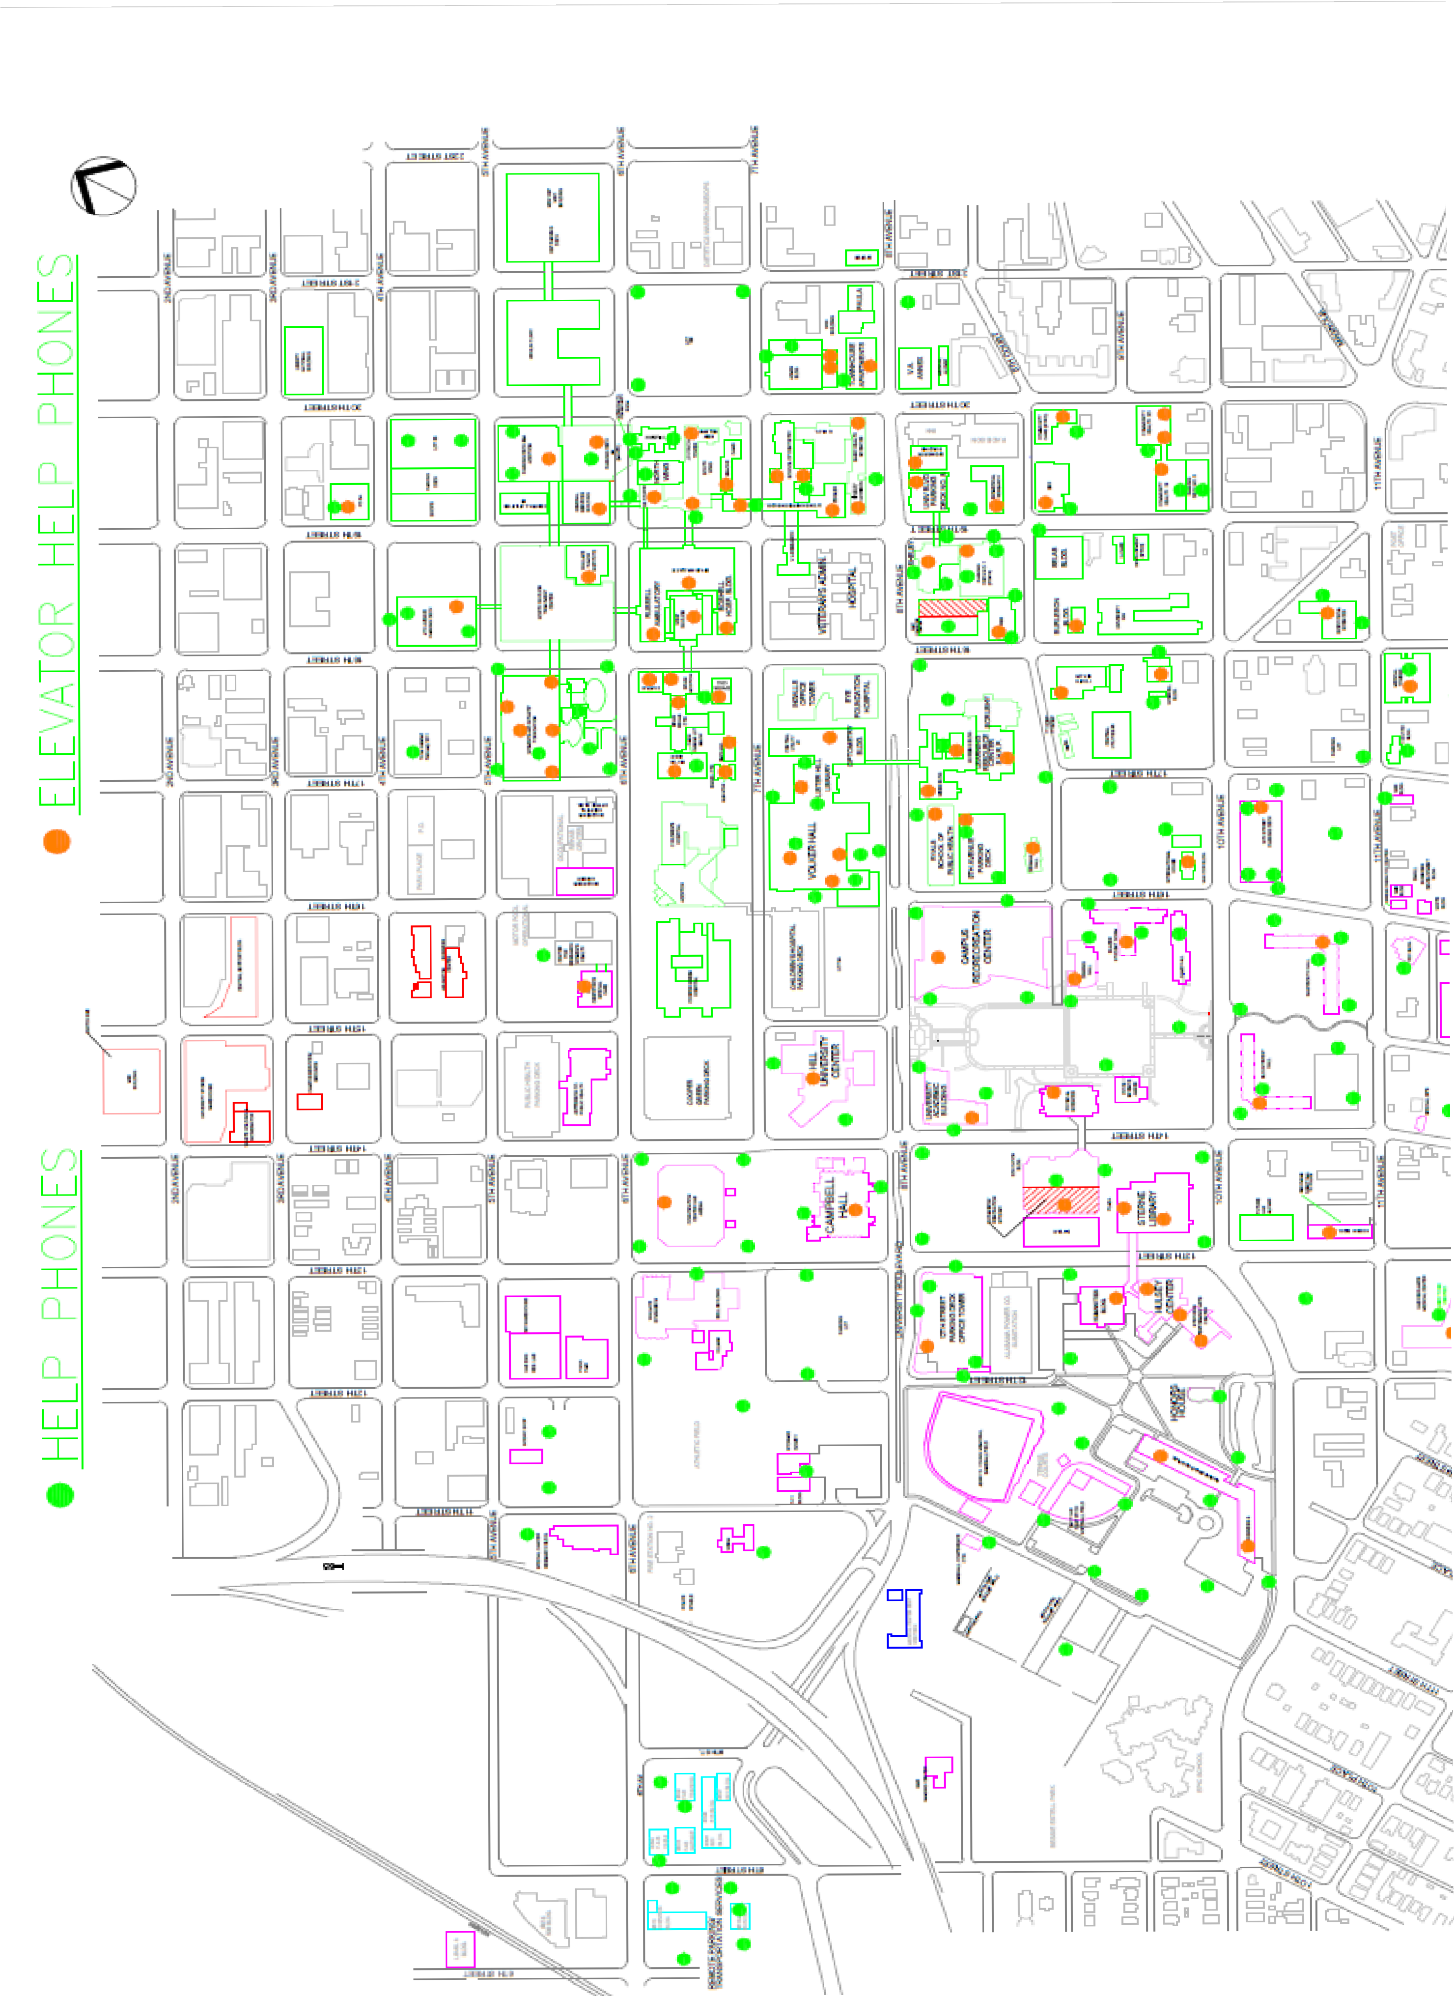
UAB HELP PHONE MAP

CAMPUS MAP WITH PATROL AND CORE CAMPUS BOUNDARIES

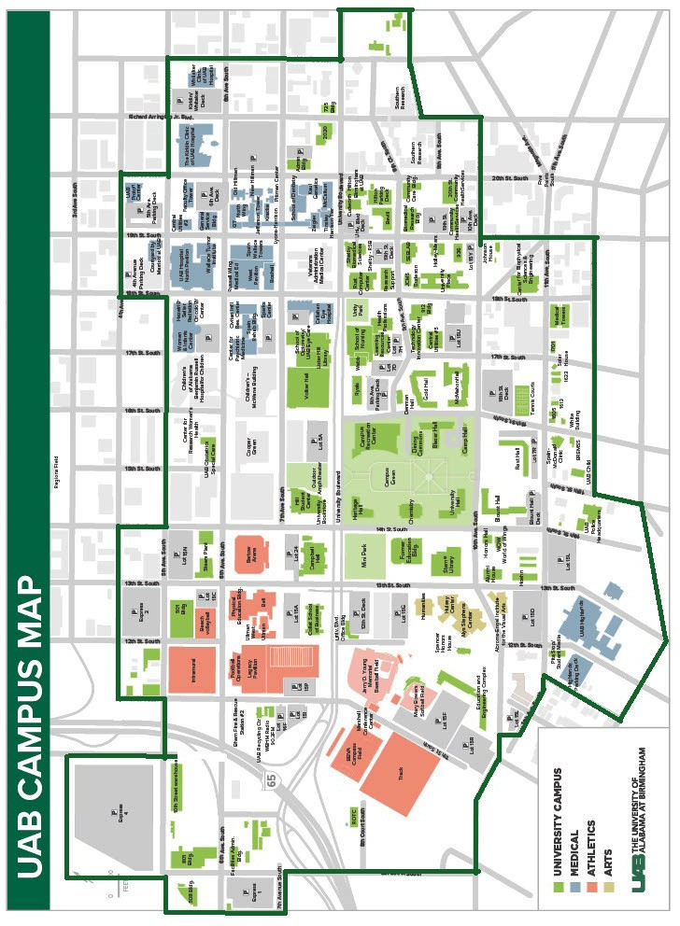

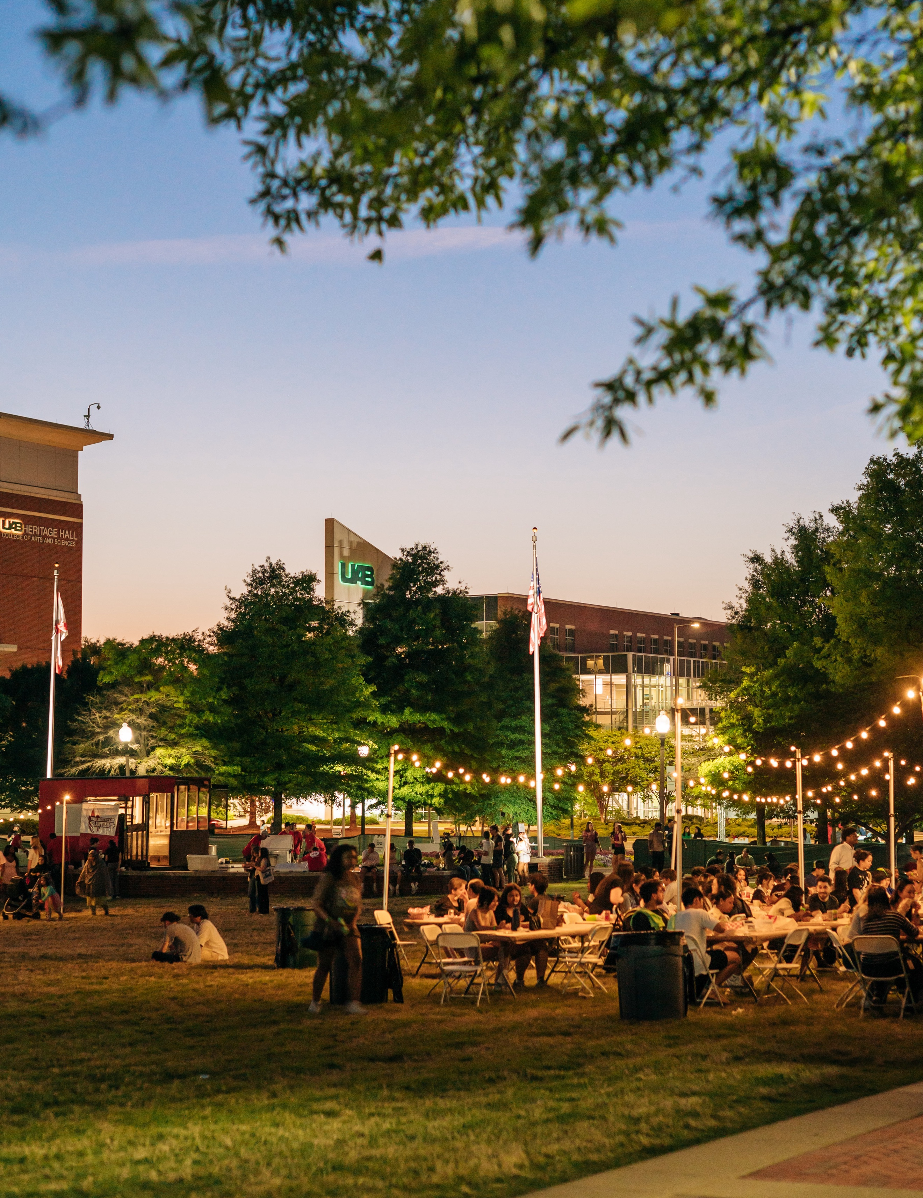
CAMPUS POLICE PHONE NUMBERS
72 | UAB Annual Security and Fire Safety Report
1117 14th Street South, Birmingham, Alabama 35205
Fire, Injuries, Accidents, and Other Police Information 24 hours per day
(205) 934-3535

Crime Prevention | Mon - Fri, 7:30 am - 4:30 pm | (205) 934-2409
Lost and Found/ Records | Mon - Fri, 8:00 am - 4:30 pm | (205) 934-4649
Criminal Investigation Division | Mon - Fri, 8:00 am - 4:30 pm | (205) 934-6860
Patrol Operations | Mon - Fri, 8:00 am - 5:00 pm | (205) 934-5315
Housing/Special Operations | Mon - Fri, 7:30 am - 4:30 pm | (205) 996-0871
Hospital Precinct Division | Mon - Fri, 7:30 am - 4:30 pm | (205) 934-8534
Office of Professional Standards | Mon - Fri, 7:00 am - 4:00 pm | (205) 996-2035
You can contact the following departments for more information about the topics covered in this report.
- UAB Police (205) 934-4434
- Student Health Services (205) 934-3580
- Office of Student Experience (205) 934-4175
- Student Housing and Residential Life (205) 996-0400
- Disability Support Services (205) 934-4205
- Financial Aid (205) 934-8223
- INTO UAB (205) 934-4686
- Office of Human Resources Management (205) 934-5321
- Employee Assistance Program (205) 934-2281
- Parking & Transportation (205) 934-3513
- Blazer Express: (205) 934-3514
- Veteran Services (205) 934-8804
- UAB Recreation Center (205) 934-8224
View this publication online. Go to the Crime Statistics section of the UAB Police Department's website located at: uab.edu/police.

