
Emergency Action Plan

Table of Contents
IMPORTANT NUMBERS 3
INTRODUCTION 3
ADMINISTRATIVE NOTIFICATION (IFC – 404.2.2, 1) 3
BOMB THREAT (IFC – 404.2.2, 1) 4
LOSS OF ELECTRICAL POWER (IFC – 404.2.2, 1) 5
LOSS OF COMMUNICATIONS (IFC – 404.2.2, 1) 5
ACTIVE SHOOTER (IFC – 404.2.2, 1) 6
INCLEMENT WEATHER 8
FIRE PREVENTION AND EVACUATION PLAN (IFC – 404.2.2, 1, 5) 12
MEDICAL EMERGENCY (IFC – 404.2.1, 6) 16
CHEMICAL SAFETY (IFC – 407.1-.7) 19
APPENDIX A – Designated Personnel (IFC – 404.2.1, 9), (IFC – 404.2.2, 6) 22
APPENDIX B – Departmental Responsibilities 23
APPENDIX C – Bomb Threat Procedures / Checklist 24
APPENDIX D – Inclement Weather Guidance 26
APPENDIX E – Corral Points 27
APPENDIX F – Severe Weather Gathering Areas ……………………………………………29
Record of Annual Review 30

IMPORTANT NUMBERS
- UAB Police Emergency – 205-934-3535 or 911 from a UAB phone
- UAB Police Non-Emergency – 205-934-4434
- Building Administrator – Bryan Jones / 205-281-7811
- Secondary Building Administrator – Heather Holmes / 205-401-3851
- Tertiary Building Administrator – Kim Hazelwood / 205-934-5644
- UAB Maintenance – 205-934-5353
- UAB EH&S Campus Safety – 205-934-2487
- UAB Telecommunications – 205-934-7777
- UAB Emergency Operation Center (EOC) – 205-975-1000
- UAB Weather/Emergency Status – 205-934-2165

INTRODUCTION
An emergency or disaster is any event that seriously disrupts the normal functions of the UAB Campus, regardless of the cause. Special detailed plans are included which address scenarios such as fire, bomb threat, loss of electrical power, dangerous person / active shooter, severe weather, and medical emergencies.

ADMINISTRATIVE NOTIFICATION (IFC – 404.2.2, 1)
In the event of any emergency, UAB Police should be contacted by dialing 911 from a UAB phone or by dialing 205-934-3535 from a cell or public phone.
UAB's official source of emergency management and inclement weather management is uab.edu/emergency/. Please see Appendix D for more information related to weather group designations.
B-Alert is the emergency notification system which is used to communicate via voice call, SMS text message, and email to the entire campus. This system also integrates with Facebook and Twitter. The following link can be used to register for B-Alert: uab.edu/emergency/.
Rave Guardian is also one of the best ways to improve your safety and protect your friends by building your private safety network. This free app can provide instant communications with friends, family, co-workers, UAB Police, and even 911 in the event of an emergency. You can download the application from the Apple App Store or Google Play.

BOMB THREAT (IFC – 404.2.2, 1)
The local police department is responsible for investigating all suspected bombs and reports of them being placed on campus property and coordinating evacuation, searches, and removal of suspected explosive devices. This shall be accomplished in cooperation with staff, fire department, and other agencies which may be called to assist.

If you receive a bomb threat, use the bomb threat check list to gather all pertinent information. (See attached Appendix C).

- Report the bomb threat and all available information to UAB Police by dialing 911 from any UAB phone or by dialing 205-934-3535 from a cell or public phone. Notify your supervisor immediately.
- Notify the Building Administrator (or designee) who will then communicate with the police department, obtain instructions, and make an evacuation determination based on the credibility of the threat.
- Do not advise the public.
Allow business to proceed as usual until directed otherwise.

- If evacuation is necessary, UAB Police, the Campus Safety Officer, the Building Administrator (or designee), and other building representatives will notify each floor of the need to evacuate. If the building fire alarm system is equipped with an "all call" feature for public addresses, the evacuation will be announced building-wide by UAB Police. The fire alarm may also be used to help speed evacuation. Do not make a general announcement that the reason for evacuation is a bomb. Only state there is an "emergency" and that everyone must evacuate and go to their designated gathering point for their department.

LOSS OF ELECTRICAL POWER (IFC – 404.2.2, 1)
Upon loss of power, remain calm and notify Campus Maintenance Dispatch immediately by calling 205-934-5353.
- Where available, the emergency generator will transfer power upon loss of electricity.
- All staff must be trained to understand that the switch to emergency power is not instant. There will be a brief delay. Also, not all areas will have emergency power.
- Light switches and electrical outlets on emergency generators are RED and are easily identifiable. Critical equipment should be plugged into these red outlets.
- All areas have egress lighting to provide adequate light to navigate corridors and stairs. This lighting is very dim compared to standard lighting, so it is important to keep evacuation routes and corridors clear of all clutter which could pose a hazard in dim light and slow or otherwise obstruct evacuation.
- All non-essential equipment should be turned off until power has been restored.

LOSS OF COMMUNICATIONS (IFC – 404.2.2, 1)
- If the telephone system is lost, avoid attempting to use the phone.
- The Building Administrator (or designee) will periodically check the phone.
- Use cell phones to maintain essential communications.

ACTIVE SHOOTER (IFC – 404.2.2, 1)
An “active shooter” is an individual who is engaged in killing or attempting to kill people in a confined and populated area. In most cases active shooters use firearms, and there is no pattern or method to their selection of victims. Victims are selected at random. The event is unpredictable and evolves quickly, so knowing what to do can save lives.

Guidance to all UAB Personnel
The following guidelines describe what to do during an active shooter event, and what to expect from responding law enforcement.
- Should a shooter or a person with a weapon appear on campus, call UAB Police (911 or 205-934-3535) as soon as it is safe to do so.
- The first officers to arrive on scene will not stop to help the injured. Expect rescue teams to follow the firsts wave of officers. These rescue teams will treat and remove the injured.
- Once you have reached a safe location, expect to be held in that area by law enforcement until the situation is under control, and all witnesses have been identified and questioned. Do not leave the area until law enforcement authorities have instructed you to do so.

The following procedures are recommended by the US Department of Homeland Security:

Information to provide to 911 operators:
- Location of the active shooter (e.g., name of building, floor, etc.).
- Number of shooters.
- Physical description of shooters.
- Number and type of weapons each shooter has.
- Number of potential victims at location.
When law enforcement arrives:
- Remain calm and follow instructions.
- Drop items in your hands (e.g., bags, jackets).
- Raise hands and spread fingers.
- Keep your hands visible.
- Avoid quick movements toward officers (i.e., holding on to them for safety).
- Avoid pointing, screaming, or yelling.
- Do not ask questions while evacuating.

Run, Hide, Fight
When an active shooter is in your vicinity, you must be prepared both mentally and physically to deal with the situation. You have three options:

Run
- Have an escape route and plan in mind.
- Leave your belongings behind.
- Evacuate regardless of whether others agree to follow.
- Help others escape, if possible.
- Do not attempt to move wounded people.
- Prevent individuals from entering an area where the active shooter may be.
- Keep your hands visible.
- Call UAB Police (911 or 205-934-3535) when you are safe.
Hide
- Hide in an area out of the shooters view.
- Lock doors or block entry to your hiding place.
- Silence your cell phone (including vibrate mode) and remain quiet.
Fight
- As a last resort, and only when your life is in imminent danger.
- Attempt to incapacitate the shooter.
- Act with as much physical aggression as possible.
- Improvise weapons or throw items at the active shooter.
- Commit to your actions ... your life depends on it.

Each situation is different, so no single protocol will work in all circumstances. You will have to make the best decision based on the situation. Always be aware of your surroundings as you determine how best to protect yourself.

INCLEMENT WEATHER
Each department should have a way of monitoring for inclement weather, such as a weather radio, weather app for your phone, B-Alert, weather.com, etc. Department leadership, in cooperation with the Building Administrator (or designee) will be responsible for monitoring weather updates for changes which may require an upgrade in readiness. The Building Administrator is also responsible - in consultation with Campus Safety - for helping departments determine specific actions that should be taken to protect UAB employees, students, visitors, and property. Please see Appendix D for further information regarding the instructions for inclement weather and closure instructions.
Emergency Sirens
There are 8 emergency sirens located strategically around campus to help alert the community in the event of a tornado warning or sighting (see below). These sirens are activated by the Jefferson County Emergency Management Agency in cooperation with the National Weather Service.
Heavy Rain
Campus Maintenance will be prepared to handle sewer back-up and other problems associated with flooding in known problem areas. Environmental and Building Services are responsible for making sure door mats and wet floor signs are deployed and to assist with any necessary cleanup.
Flash Flooding
Some roads, parking areas, sidewalks, etc. at UAB are prone to flash flooding during periods of severe downpours. These conditions can be exacerbated due to construction work in the area. Always remain aware of your surroundings.
- Never try to walk or swim through swiftly moving water.
- Never try to cross water in a vehicle, regardless of whether the water is moving, or if it seems to be shallow.
- If your vehicle stalls in rapidly rising water, abandon it immediately and move to higher ground.

Electrical Storms
While it is unlikely that electrical storms will result in severe damage to the campus, it is advisable to limit or cancel certain activities which may present or increase risks, Such activities may include, but are not limited to outdoor or rooftop activities or the use of equipment which could cause injury or be damaged by sudden power surges or interruptions in the power supply.

Many lightning fatalities or injuries occur at the beginning or end of a thunderstorm. Consider the following lightning safety guidelines:
- Keep an eye on the sky. Look for darkening skies, flashes of light, or increasing wind.
- If you can hear thunder, you are close enough to be struck by lightning.
- Count seconds from the time you see lightning until you hear thunder, then divide by five. The resulting number is the distance (in miles) from the lightning to your present location.

When a storm approaches:
- Seek shelter in a building or car. Keep car windows closed and avoid convertibles.
- Telephone lines and metal pipes are effective conductors of electricity. Avoid using the telephone or any electrical appliance and stay away from large metal objects or poles.

If someone is struck by lightning:
- People who have been struck by lightning carry no electrical charge and can be handled safely.
- If they have stopped breathing, perform CPR.

Watch, Advisory, Warning

Watch: A watch is used when the risk of a hazardous weather event has increased significantly, but its occurrence, location or timing is still uncertain. Each department should develop a call tree or other method of notifying personnel of the potential for severe weather. Since this is not an immediate threat and no specific action is required, e-mail notification or a group text is preferred. Be sure to include when the watch period will end. No specific action should be taken by employees during a watch except to stay alert to weather conditions and updates.

Advisory: An advisory is issued when a hazardous weather event is occurring, imminent or likely. Advisories are for less serious conditions than warnings, that cause significant inconvenience and if caution is not exercised, could lead to situations that may threaten life or property.

Warning: A warning is issued when a hazardous weather event is occurring, imminent or likely. A warning means weather conditions pose a threat to life or property. People in the path of the storm need to take protective action. Emergency sirens will sound. Everyone must remain alert for sudden changes in weather conditions and weather announcements and should seek shelter immediately in designated storm shelters. These are typically located along the interior walls and enclosed windowless staircases, or in a basement area of each building. See below.

Severe Weather Gathering Areas

UAB's Department of Environmental Health & Safety has evaluated CAS buildings and has recommended that ALL occupants of the College of Arts and Sciences Buildings move to designated locations (See Appendix F for locations) during a severe weather event. "Severe Weather Gathering Point" signs have been posted at various safe-zone gathering points. If a warning is issued and moving to a safe place is encouraged, you should report to the assigned area for your floor.

NOTE: Parking garages are NOT considered a safe place and should not be used during severe weather events.

DO NOT attempt to monitor conditions visually by standing near a window.
Once a warning has been issued for the Birmingham Metro area, someone should be appointed to monitor current conditions by using a weather radio, weather app, or by waiting for notification from the B-Alert system. A B-Alert will be issued when the initial warning is issued, and an “immediate threat has passed” message will be given when the current storm has passed the campus. This does not mean that another storm system may not be following, so evolving conditions should be monitored until all danger has passed.

FIRE PREVENTION AND EVACUATION PLAN (IFC – 404.2.2, 1, 5)

Fire Prevention
The following guidelines have been established to maintain a fire-safe environment for staff and visitors:
    - Free access to fire cabinets, fire extinguishers, and other firefighting equipment MUST be maintained AT ALL TIMES.
    - UAB’s campus-wide NO SMOKING policy must be enforced.
    - All use of candles and open flames is PROHIBITED in any UAB Building.
    - Keep all electrical equipment in good repair. Do not overload electrical circuits by using multiple plugs or unapproved extension cords. Only those extension cords labeled as “UL Listed” and in good condition should be used.
    - Only approved space heaters should be used. Never use an extension cord with space heaters.
    - Holiday decorations must be made of non-combustible or fire-retardant materials. Live Christmas trees are NOT ALLOWED. Do not block corridors with decorations. Fire doors shall not be covered with combustible materials (e.g. wrapping paper, garland, etc)

Fire Safety Inspections
Conducting systematic inspections to locate and eliminate fire hazards is an indispensable element of the Fire Safety Program. A Campus Safety Officer will conduct periodic, unannounced fire inspections as part of the hazard surveillance process. However, departments should periodically self-inspect to help identify any potential hazards, such as space heaters too close to combustibles, frayed electrical wires, excessive combustibles (boxes, paper, etc.), improperly stored flammables, presence of burning candles, blocked emergency equipment or obstructed corridors, etc.

NOTE: It is the responsibility of each employee to report conditions believed to be unsafe or a fire hazard as soon after discovery as possible. Report these concerns to the Building Administrator immediately.
Fire Drills
In the event of an actual fire, it is expected that there will be excitement and confusion. The confusion may be compounded by thick smoke and toxic gases. A normally well-marked exit route may appear unfamiliar and disorienting. For this reason, it is essential that fire response procedures be thoroughly practiced.
Training occupants to respond effectively in an emergency is a critical component of any fire safety program. Each person must know exactly what to do and should have enough practice to be able to perform quickly and efficiently. Fire drills should be conducted as follows:
- Drills should be conducted in a manner that ensures all personnel participate.
- Drills are to be conducted by the Campus Safety Officer and Building Administrator (or designee)
- Drills are to be initiated through verbal notification of an employee or by activating a fire alarm pull station. If a pull station is used, Campus Maintenance should be on hand to reset the alarm and Birmingham Fire and Rescue must be made aware of the exact time of the drill and notified when the system is back in service.
- The Campus Safety Officer and Building Administrator (or designee) will monitor and evaluate the fire drill response. Training will be held at that time if an employee is found to be unfamiliar with procedures.
- The “all clear” is only to be called by the Campus Safety Officer or Building Administrator (or designee).
General procedures
If you detect fire or smoke, no matter how minor it may appear to be, immediately follow these steps:
Remain calm. Others will depend on your actions. Use the C.A.R.E. response system.
- Confine the fire and smoke by closing the door. As you leave the room where the fire is located, close the room door and fire doors located in the corridors.
- Activate the fire alarm by pulling the handle.
- Report the fire. Dial 911 from any UAB phone or dial 205-934-3535 from a cell phone or public phone. Identify yourself and provide the exact location of fire or smoke and what is burning, if known.
- Evacuate staff and visitors immediately. Do not return to the building unless told to do so by the fire department, police, or the Campus Safety Officer.

Evacuation (Corral Points) (IFC – 403.5.3)
Evacuation of employees, students, and visitors will be carried out in a timely and orderly manner and will occur as follows:
All building occupants should proceed to the nearest exit, move away from the building.
See Appendix E for designated corral points for each CAS Building

Designated corral points provide a quick and easy way to account for all employees and visitors. It is also important that the fire department has clear and unobstructed access to the building. Do not gather in the driveway or in front of the building; move away from the building.

Do not return to the building unless told to do so by the fire department, police, or the Campus Safety Officer. It is sometimes difficult to know when all clear is given; however, UAB Police will be monitoring all exits and will blow their whistles and verbally notify groups in obvious gathering areas that it is safe to return to the building.

Provisions for Individuals with Disabilities (IFC – 404.2.1, 4), (IFC – 404.2.2, 2.3)
The landings inside of each stairwell are considered safe areas for individuals with disabilities. It is a routine procedure for emergency personnel to check these areas for individuals with disabilities or injuries. If the building must be evacuated, individuals with disabilities located above or below the ground floor should be escorted to the closest stairwell, and a designated person should remain with them until emergency personnel arrive.

Fighting Small Fires

If you are certain that a small or contained fire does not pose an immediate threat to you, your co-workers, visitors, students, or the surrounding area, you may be able to put it out with the appropriate fire extinguisher. The fire extinguishers located throughout the building are ABC type dry chemical extinguishers.

Fire Extinguisher Replacement

After an extinguisher has been used, regardless of how small the discharge, or if it found to be unserviceable for any reason, it should be immediately replaced. Notify the Building Administrator immediately.

Fire Extinguishers, Fire Hoses, And Sprinkler Systems

Campus Maintenance is responsible for the periodic inspection, servicing, recharging, maintenance, and adjustment of fire extinguishers. They are also responsible for the removal and replacement of discharged or unserviceable units, and the installation of new fire extinguishers, fire suppression equipment, and related systems as necessary.
Except for use in fighting a fire, fire extinguishers shall not be removed or relocated by any person except assigned maintenance or safety personnel.
Fire extinguisher inspection tags shall only be modified by the inspector and shall be removed by only the repair shop.
Fire extinguisher locations must be clearly indicated according to applicable codes and must NOT be obstructed by furnishings, equipment, supplies, boxes, carts, or any other material.

MEDICAL EMERGENCY (IFC – 404.2.1, 6)
UAB policy is to provide faculty, staff, students, visitors, and patients with a means by which they may report and be assisted with medical emergencies.
To facilitate the treatment of injuries and illness, and to minimize the potential impact on faculty, staff, students, visitors, and patients, follow these guidelines when responding to a medical emergency:
- Assess the patient’s condition by asking appropriate questions and observe their response.
  - Do you know where you are?
  - What’s your name?
  - Who is the president of the United States?
- Respond Contact (911 from a UAB phone) or 205-934-3535 (UAB emergency number). If the patient is unresponsive and is not breathing, a qualified person should begin Cardiopulmonary Resuscitation (CPR) and apply an Automatic External Defibrillator (AED) if one is available. Note that AEDs are located in all CAS Buildings.
- Create a safe space for the patient. Clear onlookers from the area, including unnecessary students and staff.
- Care for, monitor and communicate with the patient to continually observe the situation before medical responders arrive.
- Report details of the incident to the medical responders. Gather information to complete the Incident Report Form as soon as possible. Employee reporting and student reporting differ. Please see the Employee Injury and Student Injury sections below for further details.

Important Notes
- Remember that individuals cannot be compelled to seek medical care unless they consent or are unresponsive and unable to make decisions for themselves.
- At no point shall notification to dispatch or transport be delayed to obtain or complete paperwork.

Employee Injury

Campus employees include postdoctoral and graduate student employees, visiting scholars and scientists.

An incident or accident must be reported verbally by the employee to the employee's supervisor and the Director of Human Resources and Faculty Affairs as soon as possible, but no later than two calendar days following the incident / accident or following the onset of the illness or disease. Failure to verbally report an incident / accident within two calendar days of occurrence or within two calendar days of the onset of the illness or disease may result in denial of On-the-Job Injury/Illness (OJI) benefits.

Complete the Initial Medical Evaluation Authorization form and send the document with the employee to The Workplace if the injury occurs during The Workplace hours of operation. If outside their operating hours, send the completed form with the employee to UAB University Hospital Emergency Department or UAB Hospital-Highlands Emergency room.

Injured employees may use Blazer Express for transportation to and from The Workplace for the initial visit. The Workplace is located at UAB Hospital-Highlands, Suite 100. Their telephone number is: 205-933-5300. You should contact Brentwood Services Administrators (205-933-0373 or 1-800-524-0604) to coordinate transportation for any subsequent medical visits if needed.

Complete the Employee Incident Report Form as soon as possible. Submit a downloaded PDF copy of the form to HRM-OJI@uab.edu, or print it and deliver it to the OJI Administrator located in the Administration Building, room 215. Their extension is 205-934-5382.

Student/Visitor Injury

If a UAB student or visitor is injured, an immediate assessment should be made to determine the severity of injuries and the proper response required.

If the individual is unresponsive and not breathing, contact UAB dispatch immediately at 205-934-3535 or 911 from UAB phone. A qualified person should start Cardiopulmonary Resuscitation (CPR). Apply an Automatic External Defibrillator (AED).

If the individual is severely injured, notify UAB dispatch at 205-934-3535 or 911 from UAB phone. Dispatch will then send the appropriate response needed.

Be sure to fill out the proper form at the link provided below. Reporting instructions are detailed on the form. Incident Report Form for Visitors and Students.

If a student has minor injuries and an emergency response is not needed, then the student should be directed to Student Health and Wellness Center. It will be up to the student whether or not to seek medical attention. UAB faculty cannot force a student to seek medical attention. The form listed above shall be completed and submitted regardless of treatment.

Needle Sticks and/or Other Exposures
For needle sticks and/or other exposures (including blood, fluid or tissue, biologic agent, chemical agent, radiation, laser, animal), call Employee Health at 205-934-3675 during normal business hours. After normal business hours and on weekends or holidays, report by calling the Call Center at 205-934-3411 and asking them to page the person on call for the Needle Stick and Exposure Team. You will be triaged to care depending on exposure.

CHEMICAL SAFETY (IFC – 407.1-.7)

Safety Data Sheets
The UAB Hazard Communication Program requires all employees who work with chemicals to be familiar with the hazards associated with those chemicals. A Safety Data Sheet (SDS) provides information on specific hazards, health effects, handling and storage, spill response, disposal, and personal protective equipment required for a particular substance. UAB subscribes to the online service ChemWatch for Safety Data Sheets. Safety Data Sheets may be obtained from the chemical supplier or from the Environmental Health & Safety (EH&S) website at this link: ChemWatch. It is recommended for chemical users to keep a readily available hard copy of the safety data sheets for strong acids and bases, flammable chemicals, very toxic chemicals, or chemicals used in large quantity (over 4L).

Chemical Spills and Accidents
It is UAB’s policy to have procedures in place to address the specific problems involved in a chemical spill or accident.
To reduce the likelihood of injury to faculty, staff, patients, and students, and damage to property because of a spill or accident involving chemicals, personnel should be trained to safely handle the chemicals present in their areas before beginning work with them.

Small Chemical Spills
Promptly clean up small spills (generally less than 500ml) using appropriate protective apparel and equipment. Small spills can generally be absorbed using paper towels, spill pillows or vermiculite. Absorbent materials must be disposed of as chemical waste. All areas should have a spill kit containing an appropriate amount and type of absorbent for the chemicals used in the area. Contact EH&S at 205-934- 2487 for assistance with spill kit selection if needed.

Large Chemical Spills

In case of a large spill (more than 500ml) of a known hazardous chemical, contain the spill, if possible, warn others and evacuate the area. Contact EH&S at 205-934-2487 immediately and provide your name, extension, location of spill, quantity and name of the spilled chemical. Decontaminate personnel that may have been splashed with the chemical and take anyone injured to the University Hospital Emergency Department. An On-the-Job Injury form should be completed, and a copy forwarded to Occupational Medicine.

Personal Injury
Prior to using any chemical, the SDS should be read for first aid information as the procedure for each chemical may differ greatly. Listed are standard examples of first aid procedures.

Eye Contact: Promptly flush eyes with water for 15 minutes and seek medical attention.

Ingestion: Call the Poison Control hotline at 1-800-222-1222 or utilize WEB POISON CONTROL online.

Skin Contact: Promptly flush the affected area with water and remove any contaminated clothing. Soap may be necessary for non-water-soluble compounds. If symptoms persist after washing, seek medical attention.

Inhalation: Move the victim to fresh air. If the victim is unconscious or not breathing, seek emergency medical attention immediately. Death or permanent injury can occur within three to five minutes.
Report all chemical exposures or injuries to your supervisor as soon as possible. When a spill occurs:

- Restrict the area. Allow no one to enter the room except for urgent treatment of patients and/or containment of the spill.
- Contact EH&S at 205-934-2487 to report the spill. Give your name and contact information, location of the spill, material spilled, approximate amount, and any injuries or damage that resulted from the spill.
- EH&S will contact the Spill Response Team (SRT), which will have full authority over the clean-up operation. The SRT has been specially trained to handle hazardous chemical spills. Anyone deliberately breaching the authority of the SRT at the site of a spill, thereby jeopardizing the health and safety of others, may be subject to disciplinary action. The Chemical Safety Officer or their designee will be responsible for calling any additional personnel needed at the site of the spill, such as UAB Police.

APPENDIX A

Designated Personnel (IFC – 404.2.1, 9), (IFC – 404.2.2, 6)
Building Administrator – Bryan Jones / 205-281-7811
Secondary Building Administrator – Heather Holmes / 205-401-3851
Tertiary Building Administrator – Kim Hazelwood / 205-934-5644

Department Captains and Alternates
Coordinate evacuation of faculty, staff, students, and visitors of your department. Lead people to the designated assembly area. Report any missing people and any injuries to emergency personnel. Participate in emergency and disaster drills. If the captain is not present or available, the designated Alternate will carry out the responsibilities of the captain.

Classroom Instructors
Coordinate evacuation of students in your class. Keep your class roster with you. Lead people to the designated assembly area. Report any missing people to emergency personnel; report any injuries to emergency personnel.
NOTE: Specific procedures are placed on lecterns in the classrooms.

APPENDIX B

Departmental Responsibilities

The CAS Communications Team in collaboration with the Building Administrator and CAS Dean’s Office will:
- Ensure that any relevant emergency messages posted by UAB are noted on the CAS website and information kiosks / signage located throughout the building.
- Communicate any additional instructions for students, faculty, or staff by posting on the front page of the College of Arts and Sciences website and via email utilizing the CAS email distribution group, and / or other methods as appropriate.

Each department captain and alternate shall:
- Maintain a list of all employees assigned under your supervision in your department as appropriate.
- Know the designated evacuation procedure and route to the assembly area and be prepared to carry out your responsibilities.
- Maintain a call tree or other method of notifying or connecting with personnel in the event a need to contact them following a severe weather event or another emergency.

Supervisory personnel shall train employees in:
- Who are the designated personnel, and those assigned to individuals with disabilities who may need assistance in the event of an evacuation.
- Evacuation procedures.
- Headcount procedures.

APPENDIX C
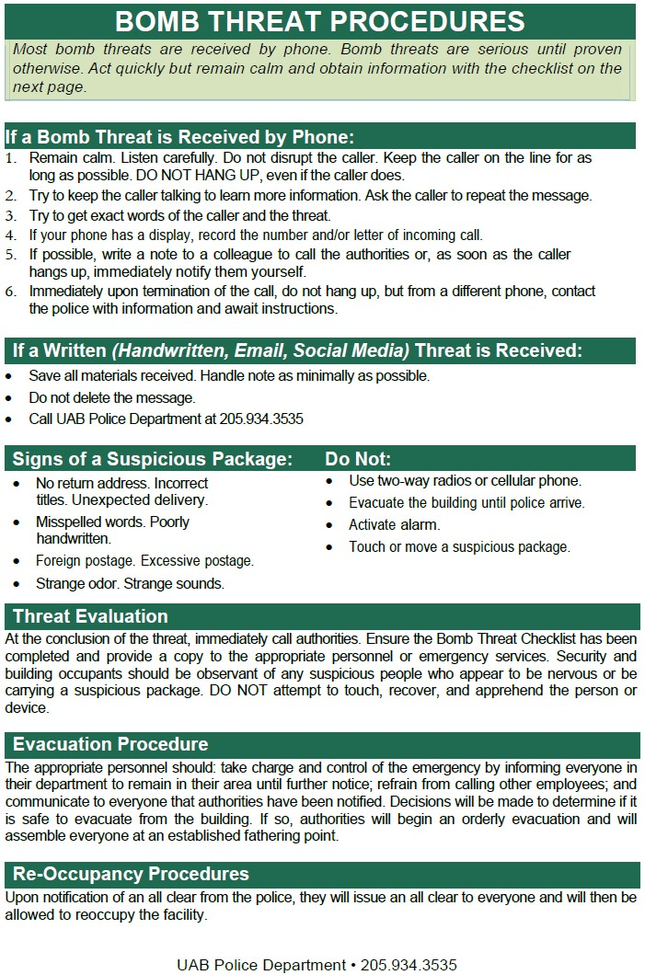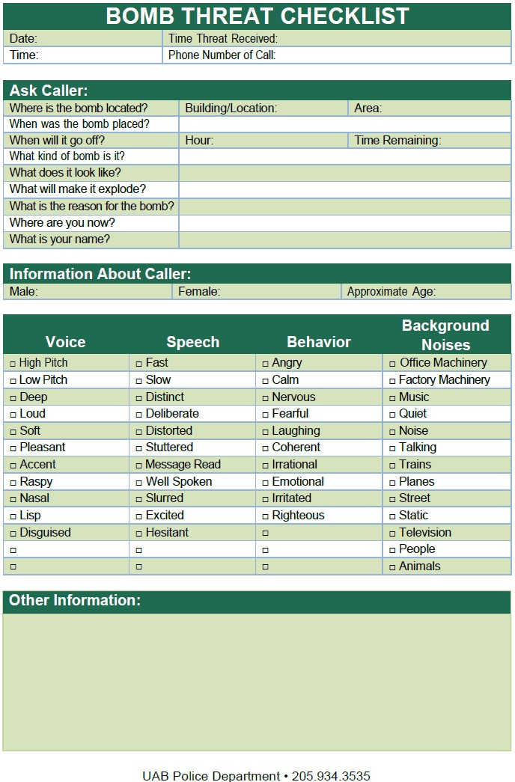

APPENDIX D
Inclement Weather Guidance
UAB has improved the process for severe weather closings, and you need to know your group assignment.
Closing the campus for severe weather is not a simple process and can be frustrating for students, faculty, staff, patients, and guests, waiting to know what to do. When severe weather is anticipated, decisions must be made for many different entities on campus, and announcements can be delayed or complicated, as closing does not mean the same thing for all entities across a complex academic, research and health care organization like UAB.
Leaders in areas across the university and Health System have developed a system to improve the process. The new process — outlined here — will inform the campus community in a more clear and timely manner.
When UAB closes — announced via B-Alert with details at www.uab.edu/emergency — GREEN, YELLOW and RED groups will be referenced.

Group Assignments
When UAB closes for severe weather, decisions must be made and communicated for many entities/functions that react differently to a closing. Assigning students, faculty, and staff to dedicated groups (GREEN, YELLOW and RED) will improve clarity around the process:
UAB Human Resources has worked with entities across the enterprise to assign units and/or job functions/titles to the GREEN, YELLOW or RED group. Every UAB student, faculty and staff member is responsible for knowing his or her assignment in the GREEN, YELLOW or RED group, and learning your group assignments is easy. Simply click on the WEATHER GROUP tile in the UAB app, or visit the Check My Group feature at www.uab.edu/emergency. Your group assignment(s) will display.

Multiple group assignments
Group assignments are specific to one’s responsibilities. While most in the UAB community will be assigned one group, some will have two group assignments — one might require attendance, and one might be closed. Follow the instructions for each assignment.

APPENDIX E

Building | Emergency Corral Point
450A Building | Parking Lot to the west of the building
501 Building | South end of the Parking Lot on the corner of 6th Ave S / 13th St
916 Building | Parking lot of BMR 2 (9th Ave and 19th Street
2300 Building | Parking lot on corner of 23rd St. & 6th Ave. alley (NW corner of building)
Abroms-Engel Institute (AEIVA) | Parking lot 15D at rear (South) of the building.
Alys Stephens Center (ASC) | Parking lot 15M to the (West) of the building and also large green area to the (Northwest).
Bevill Biomedical Research Bldg (BBRB) | Parking lot of BMR2 (9th Ave and 19th Street). Please do not gather in the courtyard of BBRB.
Campbell Hall (CH) | North side of the building towards Bartow arena
Center for Biophysical Sciences and Engineering (CBSE) | Parking lot 15W (West) of the building and parking lot to the (east).
Center for Psychiatric Medicine (CPM) | Surface lot on 6th Avenue
Chemistry Building (CHEM) | Campus Green
Civitan Building (CIRC) | Front parking lot of Spain Rehab on 6th Avenue.
Community Health Services Bldg 19th (CH19) | Parking lot of BMR 2 (9th Ave and 19th Street). Please do not gather in the parking deck of CH-19.
East and South Science Halls | UAB Mini Park and green space east of Sterne Library
Hansell/Hulsey Center (HC) | To the west side of the building facing the baseball field.
Heritage Hall Building (HHB) | To the center area of the campus green
Holley-Mears Building (HMB) | Parking lot of BMR 2 (9th Ave and 19th Street
Lyons-Harrison (LHRB) | Because of the layout of this building, there are (2) Corral points. East side gather in front of the Kracke building.  West side gather in the back loading dock of of LHRB, THT, & MCLM.
Research Support Building (RSB) | 18th Street sidewalk and 9th Ave. sidewalk
Russell Ambulatory Center (RAC) | Parking lot in front of building
Spain Rehab (SRC) | Front parking lot of Spain Rehab on 6th Avenue.
University Boulevard Office Bldg (UBOB) | Across 12th street towards the baseball field
University Hall (UH) | Campus green
Volker Hall (VH) | SOM Tower occupants should gather in the Children’s surface lot on University Blvd.  Lecture Tower occupants should gather in the back loading dock of VH.  Research Tower occupants should gather in the Children’s surface lot on University Blvd.

APPENDIX F

Building | Storm Shelter Location
450A Building | Restrooms and adjacent corridor
501 Building | Copy Room 141 and restrooms
508 Building | 1st Floor restrooms
916 Building | The women’s restroom and the office space located closest to the front desk.
2300 Building | Restrooms and the storage area towards the back of the building.
Abroms-Engel Institute (AEIVA) | 1st floor restrooms and the storage/office area towards the back of the building, where you have access to the loading dock.
Alys Stephens Center (ASC) | Basement: All areas except mechanical rooms.  1st Floor: Corridor from room 150 to 168, inside room 119 &171, Backstage and under balcony of Jemison Theatre,  the Odess Theatre, Men’s room outside Odess Theatre, Corridor outside Sirote Theatre, 2nd Floor: Corridor from room 251 to 261 and from 281 to 289, inside rooms 253,  271 and 273.
Bevill Biomedical Research Bldg (BBRB) | Basement area: All areas except mechanical rooms. 1st floor area: All areas except mechanical rooms. All stairwells from the 2nd floor down.
Campbell Hall (CH) | 1st and 2nd floor restrooms and stairwells
Ctr Biophysical Sciences and Engineering (CBSE) | Basement level area: All areas except mechanical rooms. Ist floor areas from rooms 107 to 113, 117C to 118, and 180 to 188 and inside restrooms. Stairwells from the 2nd floor down.
Center for Psychiatric Medicine (CPM) | Stairwell Corridors
Chemistry Building (CHEM) | 1st floor corridor between rooms 121-153 2nd floor corridor between rooms 214-246; inside rooms 217, 250, 254, 256, 260, 262, 266, 277, 281, 283, 289 and  291
Civitan Building (CIRC) | Located on each floor (posted outside and inside of stairwells)
Community Health Services Bldg 19th (CH19) | Basement: All corridors (except by loading dock rollup door), elevator lobby and inside room B01. First floor corridor from room 104 to 137.
East and South Science Halls (ESH and SSH) | Designated Storm Shelter on First Floor
Hansell/Hulsey Center (HC) | 1st floor, room 108-Recital Hall; corridor outside Recital Hall from room 117 to the restrooms and inside restrooms  2nd floor, corridor from rooms 233-249 or from rooms 208- 219; inside rooms 208, 208A, 209 and 209A
Heritage Hall Building (HHB) | 1st and 2nd floor restrooms and stairwells
Holley-Mears Building (HMB) | 1st floor corridors from rooms 101, 130-139,167-184, 192-197. The restrooms numbered 103, 133, and 178.
University Boulevard Office Building (UBOB) | Located on each floor (posted outside and inside of stairwells)
University Hall (UH) | Designated Storm Shelter (UH 2100)

Record of Annual Review

Reviewer / Organization | Date
Bryan Jones / CAS Facilities | April 2026

